

Project- Comparative Analysis and Implementation of NoSQL Databases

NoSQL Databases



Completed by

Bhavin Patel (2300584974)

Kunj Kansara (200584153)

**Project: Comparative Analysis and Implementation of NoSQL Databases**

**Objective:**

To gain hands-on experience with different NoSQL databases (Neo4j, DynamoDB, Google Bigtable, and MongoDB) by setting up, configuring, and performing CRUD operations. The project will also include a comparative analysis of these databases based on various factors such as performance, scalability, ease of use, and use cases.

**Part 1: Setup and Configuration**

1. **Neo4j**
   * **Exercise 1:** Install Neo4j Desktop on your local machine and create a new project. Document the installation and setup process with screenshots.

**Installation and Setup**

**Step 01: Install Neo4j on your local machine using Neo4j Desktop.**

1. Download Neo4j installation file from official website:

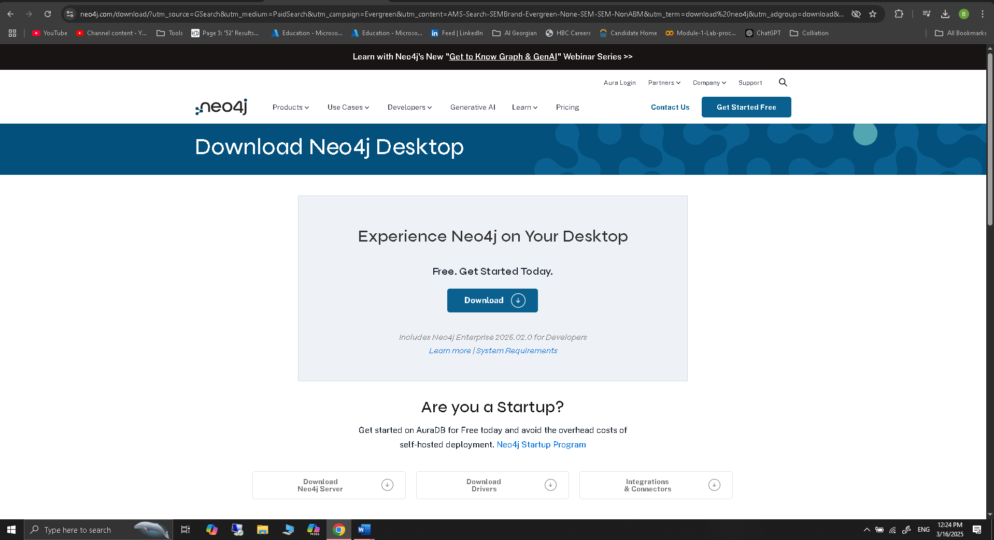

1. Copy Desktop activation key to clipboard

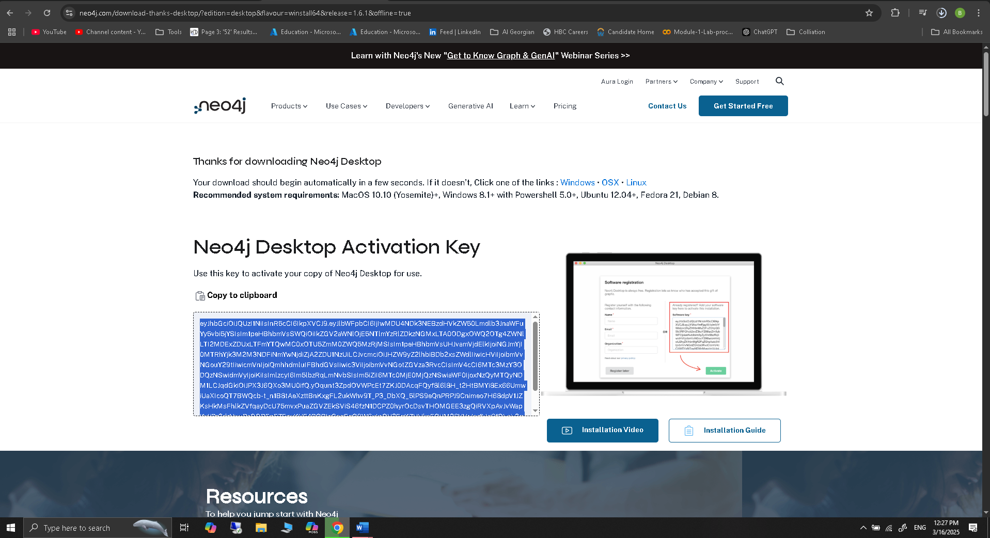

1. Start/open installation file (Neo4j Desktop Setup 1.6.1.exe) after downloading complete. After opening I am installing it only for my user named (krish)

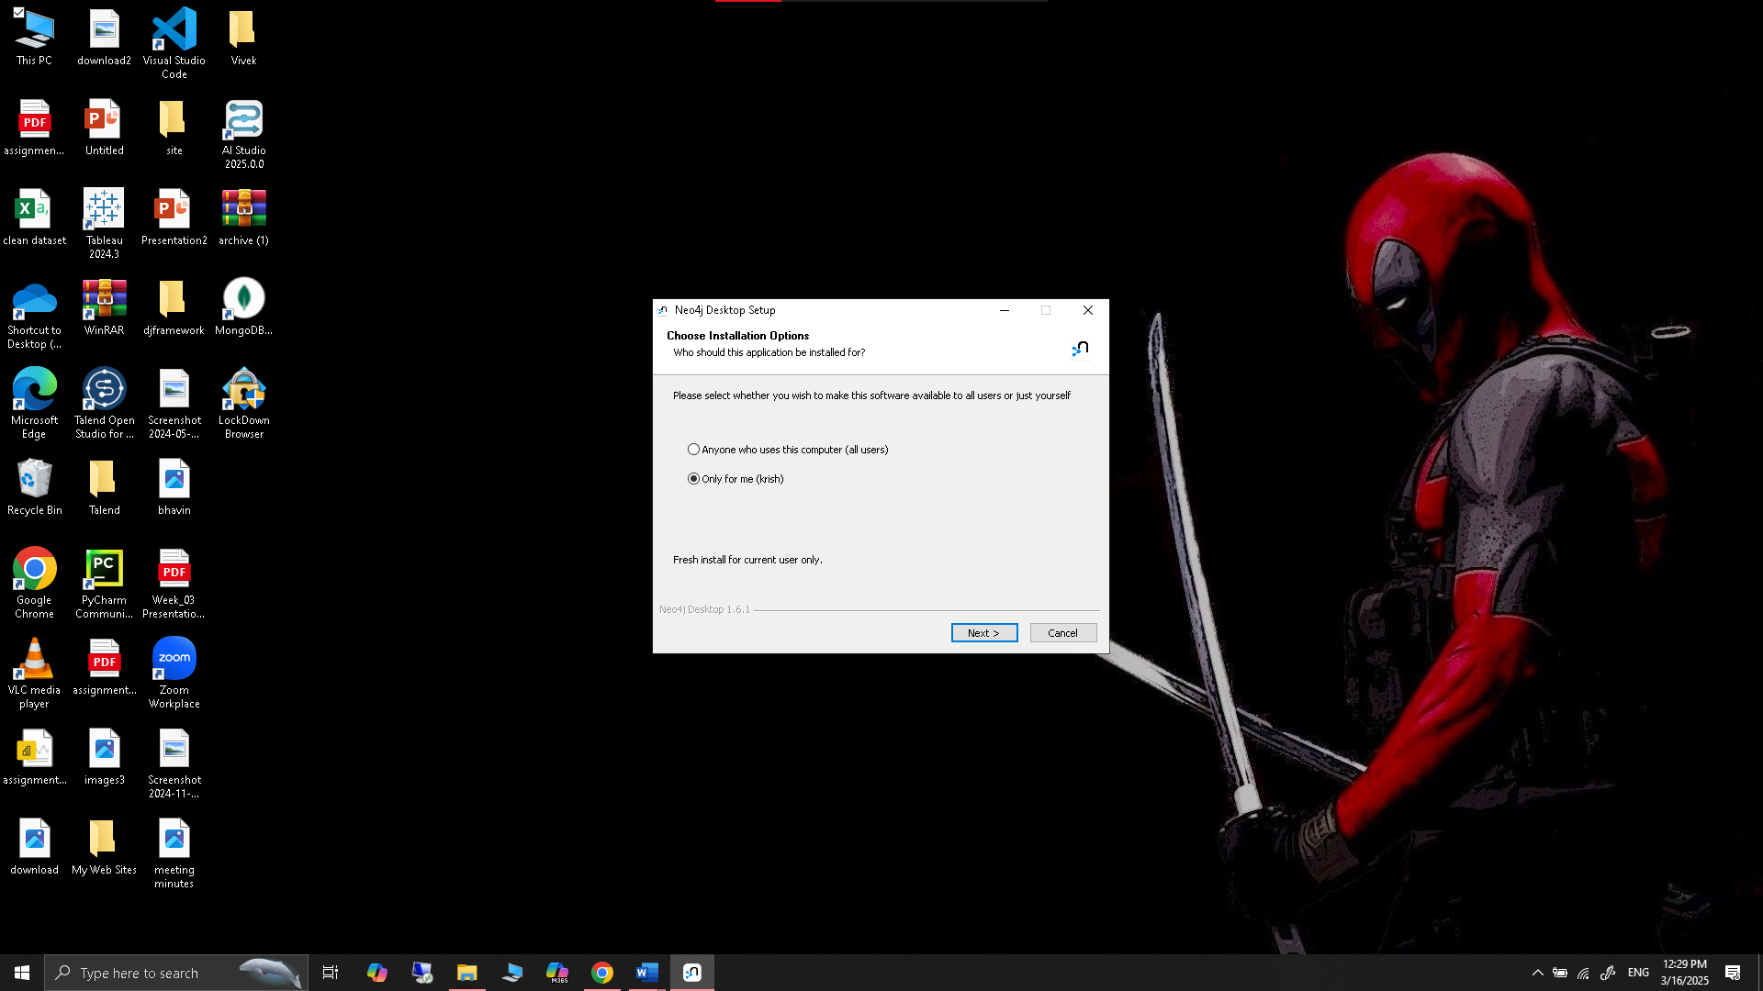

1. Choose the location for installation and install

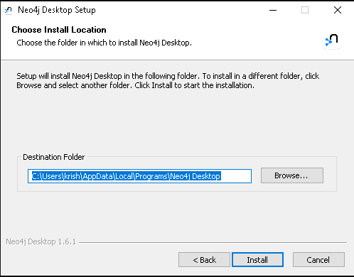

1. Installation Completed

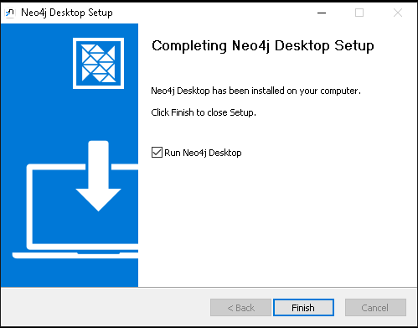

1. Grant permission to the windows defender because database need the ports access.

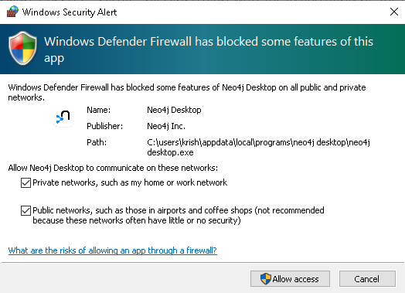

1. Please agree to the following license to continue...

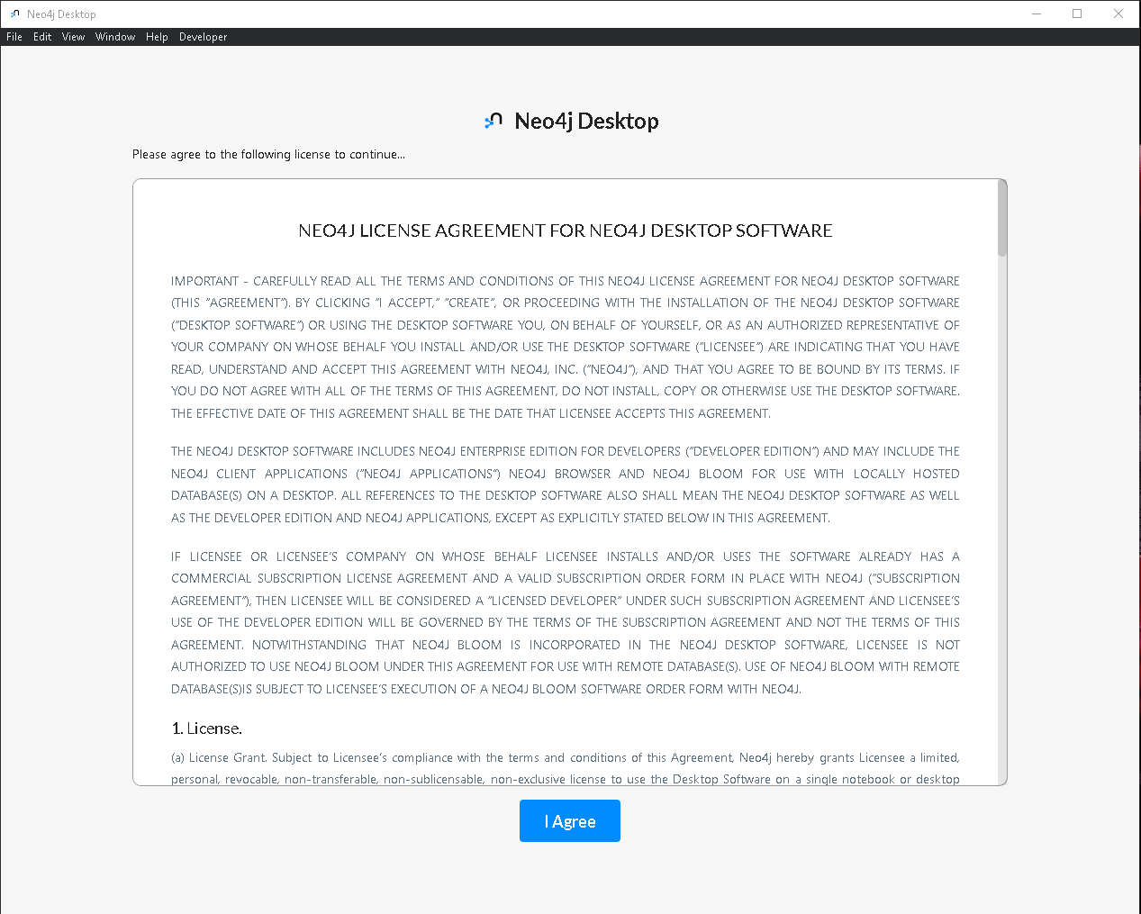

1. Select the path to store the application data

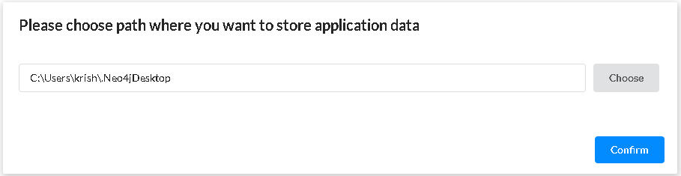

1. Software registration

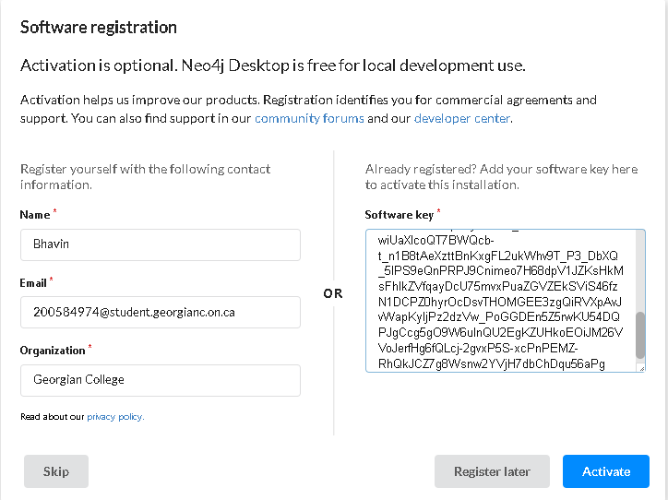

1. Getting all things ready

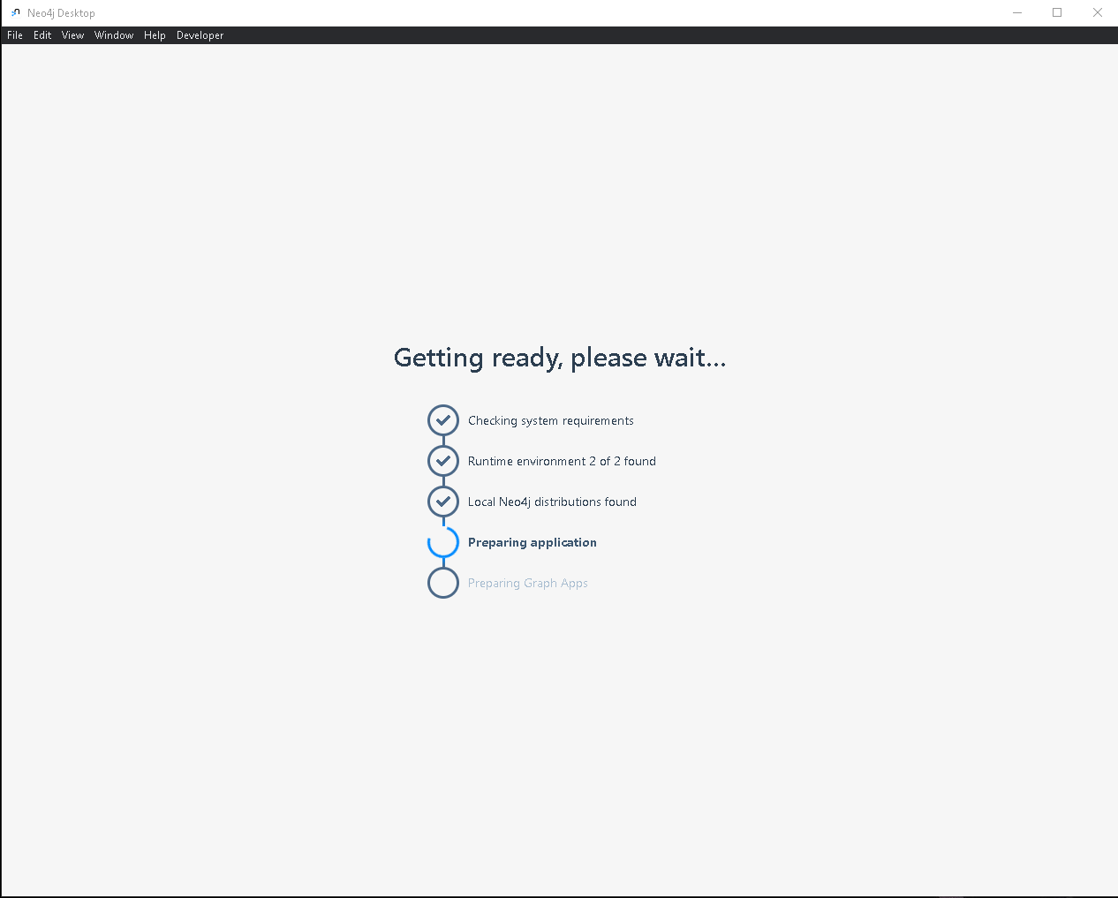

1. Anonymous Reporting review the setting and then press (OK)

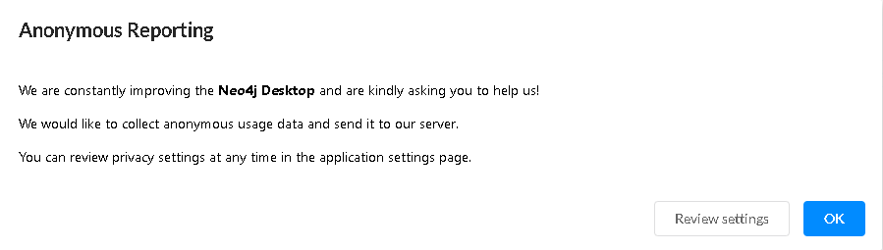

1. Graph App Risks (Accept the risk and continue)

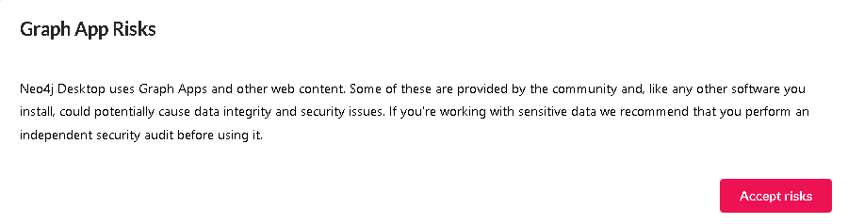

1. Neo4j Desktop – Dashboard

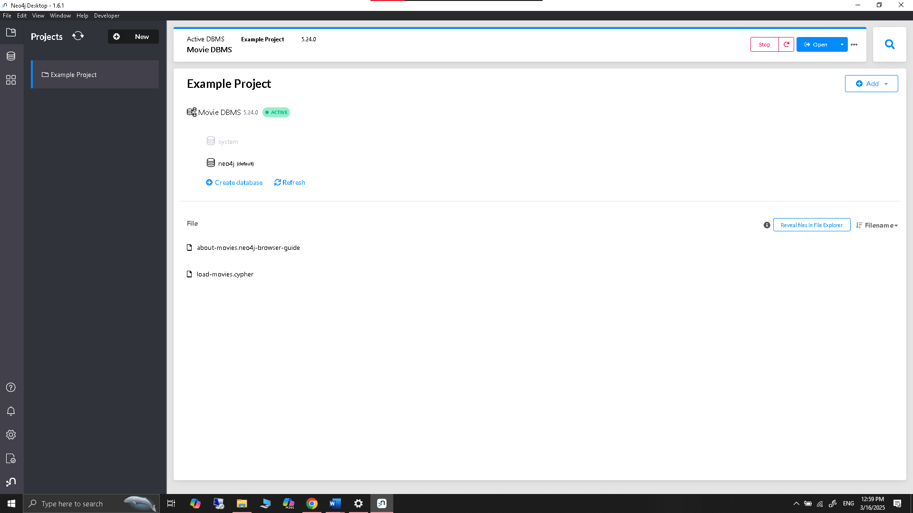

* + **Exercise 2:** Create a database named CompanyDB and import the following nodes and relationships:
    - Nodes: Employees, Departments, Projects
    - Relationships: WORKS_IN, MANAGES, ASSIGNED_TO

**Creating a New Project and Database**

1. Click on (plus icon with NEW) then click on create project.

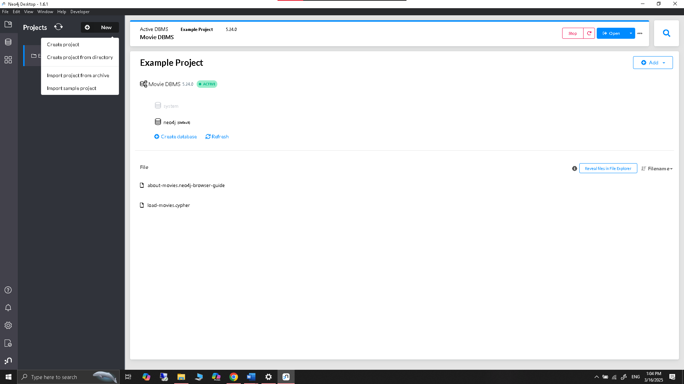

1. Created new project named **Neo4j CompanyDB Project**

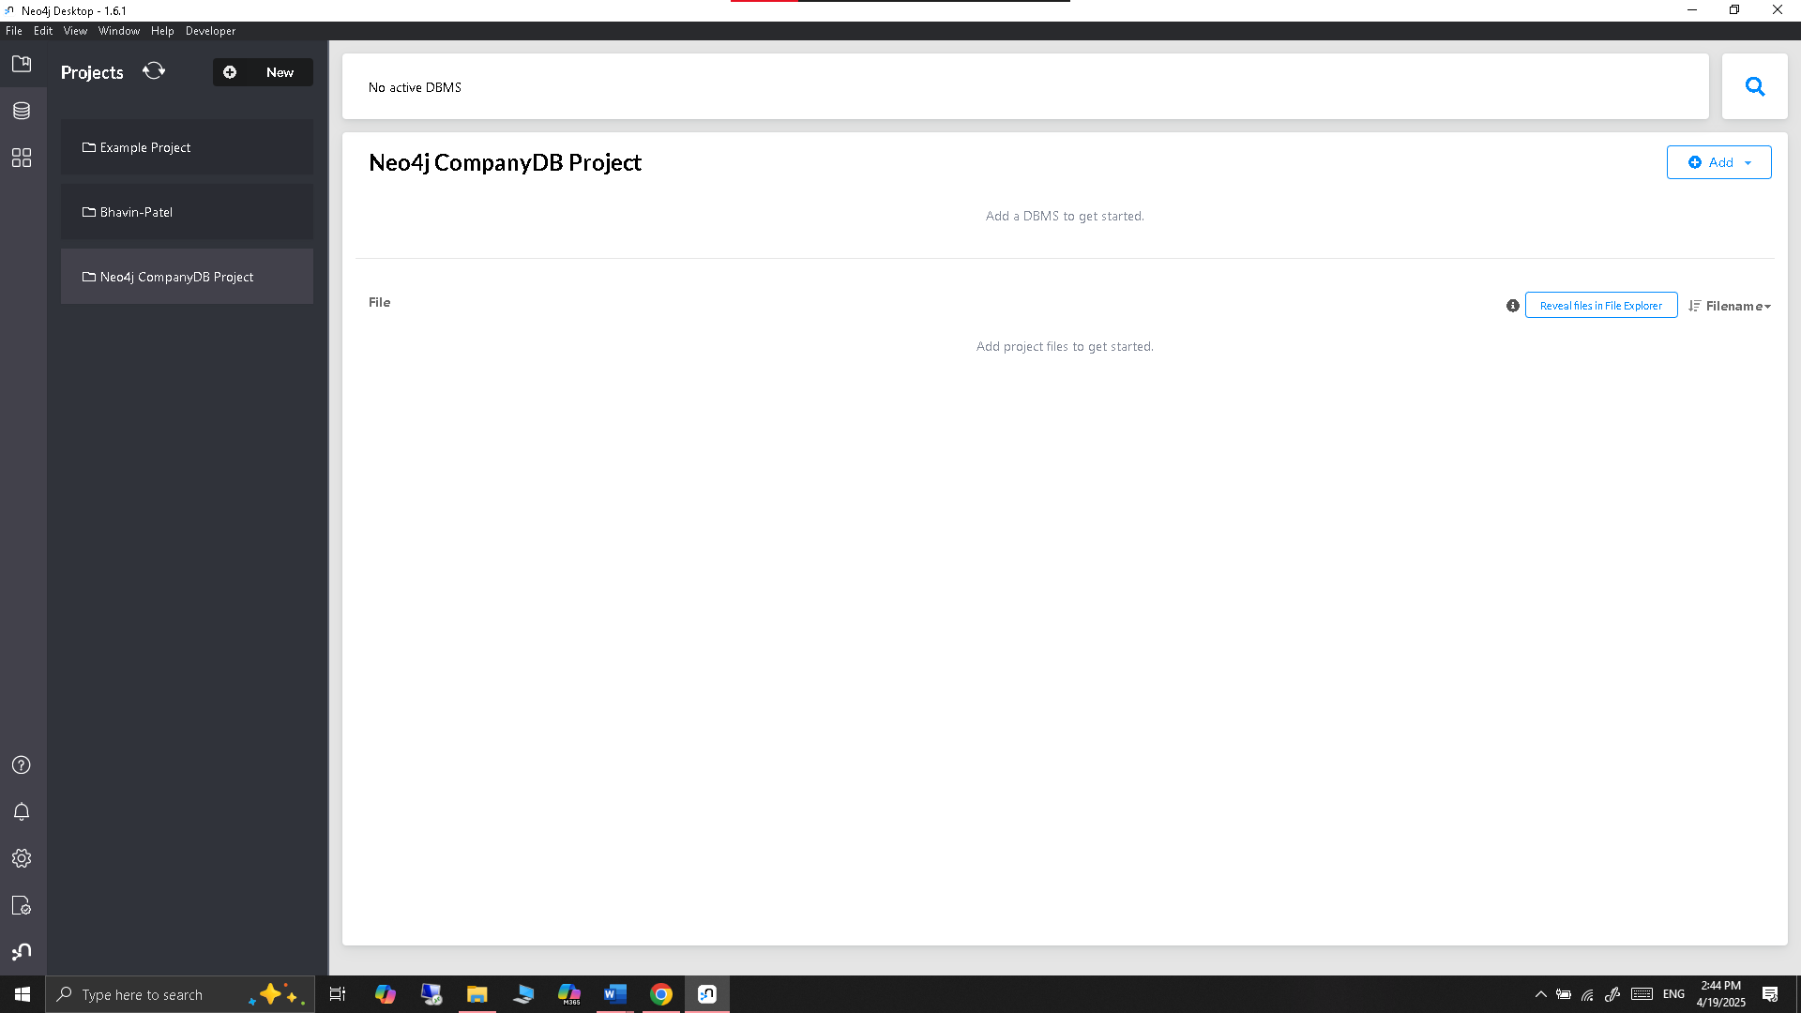

1. Creating local DBMS named **CompanyDB (Password- 12345678).**

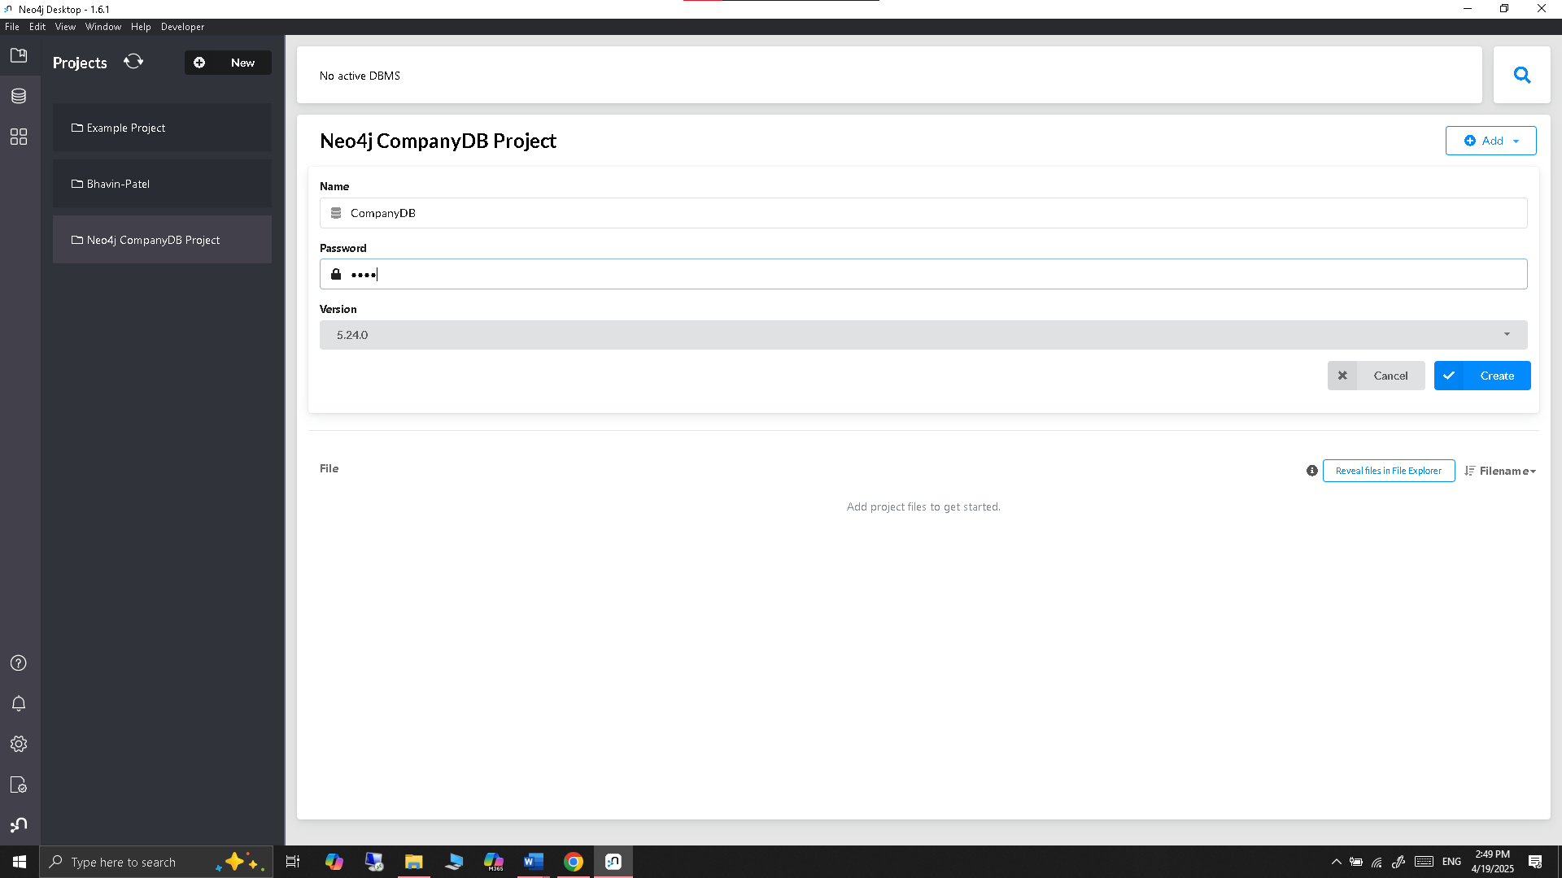

1. Created and started database successfully

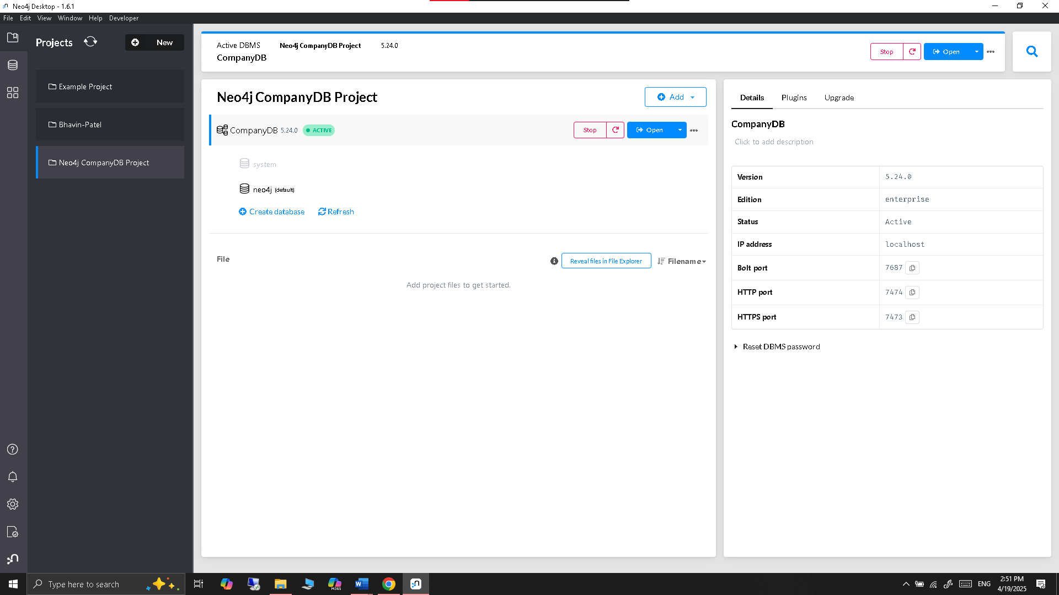

1. Open neo4j browser for building the database and relationship

**Nodes: Employees, Departments, Projects**

1. Create Employee Nodes

*CREATE (:Employee {name: 'Alice', emp_id: 1, position: 'Software Engineer'});*

*CREATE (:Employee {name: 'Bob', emp_id: 2, position: 'Engineering Manager'});*

*CREATE (:Employee {name: 'Charlie', emp_id: 3, position: 'HR Specialist'});*

*CREATE (:Employee {name: 'Diana', emp_id: 4, position: 'Data Scientist'});*

*CREATE (:Employee {name: 'Eve', emp_id: 5, position: 'DevOps Engineer'});*

1. Create Department Nodes

*CREATE (:Department {name: 'Engineering', dept_id: 'D1'});*

*CREATE (:Department {name: 'Human Resources', dept_id: 'D2'});*

*CREATE (:Department {name: 'Data Analytics', dept_id: 'D3'});*

1. Create Project Nodes

*CREATE (:Project {name: 'Project Alpha', project_id: 'P1'});*

*CREATE (:Project {name: 'Project Beta', project_id: 'P2'});*

*CREATE (:Project {name: 'Project Gamma', project_id: 'P3'});*

**Result:**

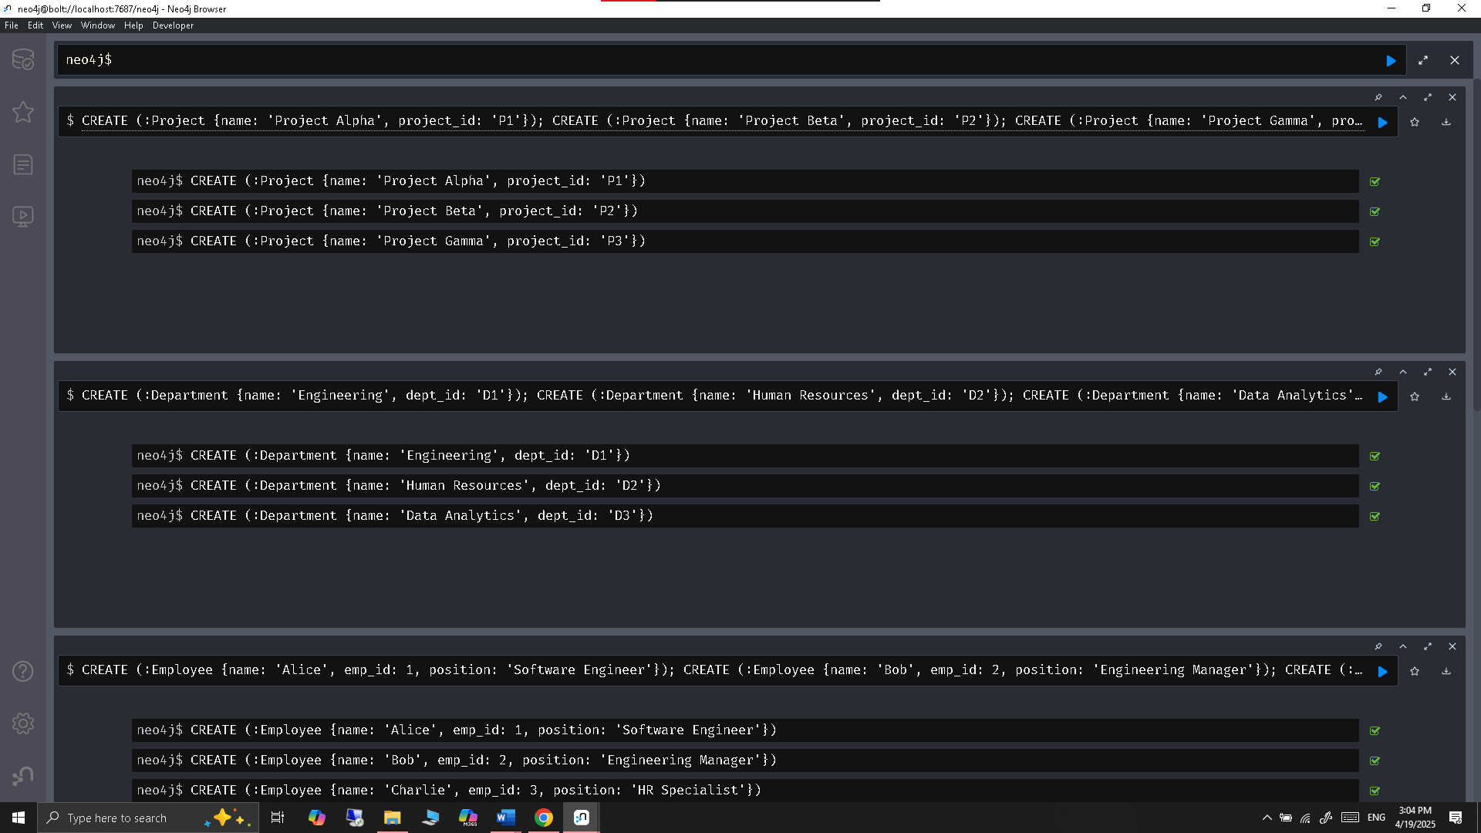

**Relationships: WORKS_IN, MANAGES, ASSIGNED_TO**

**Create Relationships**

1. WORKS_IN

*MATCH (e:Employee {name: 'Alice'}), (d:Department {name: 'Engineering'}) CREATE (e)-[:WORKS_IN]->(d);*

*MATCH (e:Employee {name: 'Bob'}), (d:Department {name: 'Engineering'}) CREATE (e)-[:WORKS_IN]->(d);*

*MATCH (e:Employee {name: 'Charlie'}), (d:Department {name: 'Human Resources'}) CREATE (e)-[:WORKS_IN]->(d);*

*MATCH (e:Employee {name: 'Diana'}), (d:Department {name: 'Data Analytics'}) CREATE (e)-[:WORKS_IN]->(d);*

*MATCH (e:Employee {name: 'Eve'}), (d:Department {name: 'Engineering'}) CREATE (e)-[:WORKS_IN]->(d);*

1. MANAGES

*MATCH (e:Employee {name: 'Bob'}), (d:Department {name: 'Engineering'}) CREATE (e)-[:MANAGES]->(d);*

*MATCH (e:Employee {name: 'Charlie'}), (d:Department {name: 'Human Resources'}) CREATE (e)-[:MANAGES]->(d);*

1. ASSIGNED_TO

*MATCH (e:Employee {name: 'Alice'}), (p:Project {name: 'Project Alpha'}) CREATE (e)-[:ASSIGNED_TO]->(p);*

*MATCH (e:Employee {name: 'Eve'}), (p:Project {name: 'Project Alpha'}) CREATE (e)-[:ASSIGNED_TO]->(p);*

*MATCH (e:Employee {name: 'Diana'}), (p:Project {name: 'Project Beta'}) CREATE (e)-[:ASSIGNED_TO]->(p);*

*MATCH (e:Employee {name: 'Bob'}), (p:Project {name: 'Project Gamma'}) CREATE (e)-[:ASSIGNED_TO]->(p);*

*MATCH (e:Employee {name: 'Charlie'}), (p:Project {name: 'Project Gamma'}) CREATE (e)-[:ASSIGNED_TO]->(p);*

**Result:**

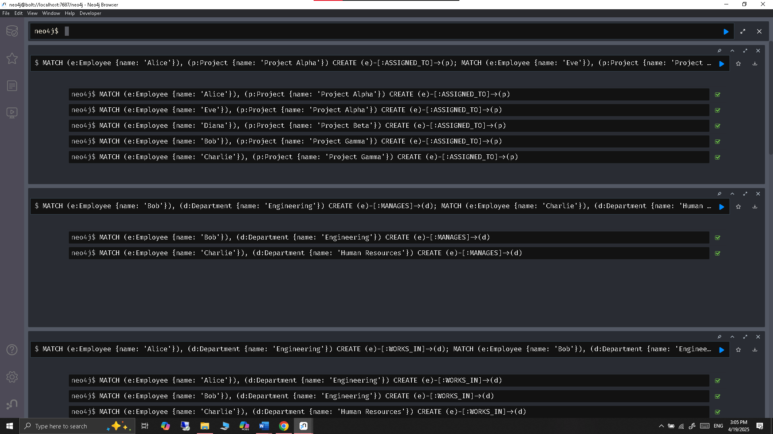

**Verify Everything**

*MATCH (n) RETURN n;*

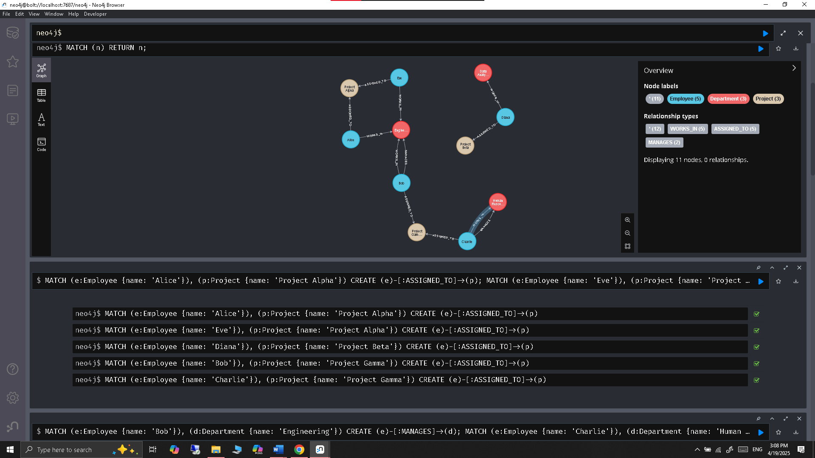

**Optional Query for Deeper Exploration**

*// Show all employees and their projects*

*MATCH (e:Employee)-[:ASSIGNED_TO]->(p:Project)*

*RETURN e.name AS Employee, p.name AS Project;*

*// Find departments managed by each employee*

*MATCH (e:Employee)-[:MANAGES]->(d:Department)*

*RETURN e.name AS Manager, d.name AS Department;*

**Graph views to explore the data visually**

*// See all employees and their relationships*

*MATCH (e:Employee)-[r]->(x) RETURN e.name, type(r), x.name;*

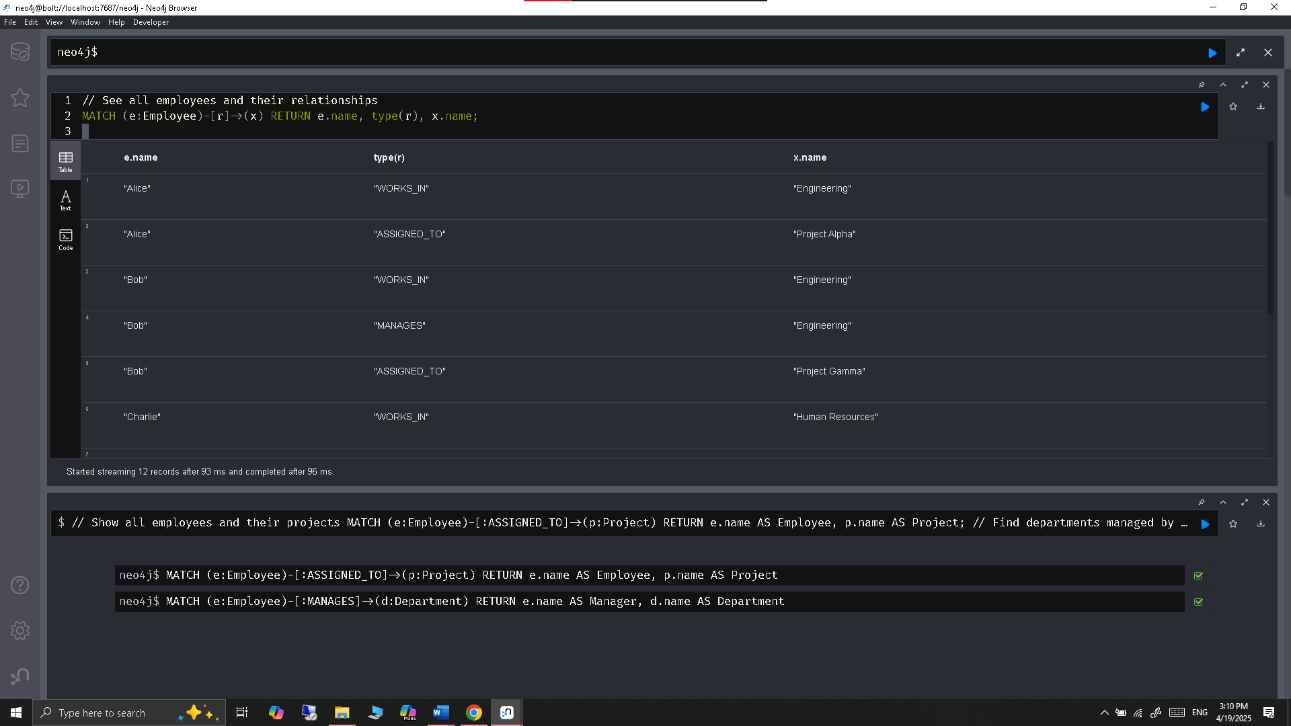

1. **DynamoDB**
   * **Exercise 3:** Create an AWS Free Tier account and navigate to the DynamoDB service in the AWS Management Console. Document the steps with screenshots.

**Already have an AWS free Tire account**

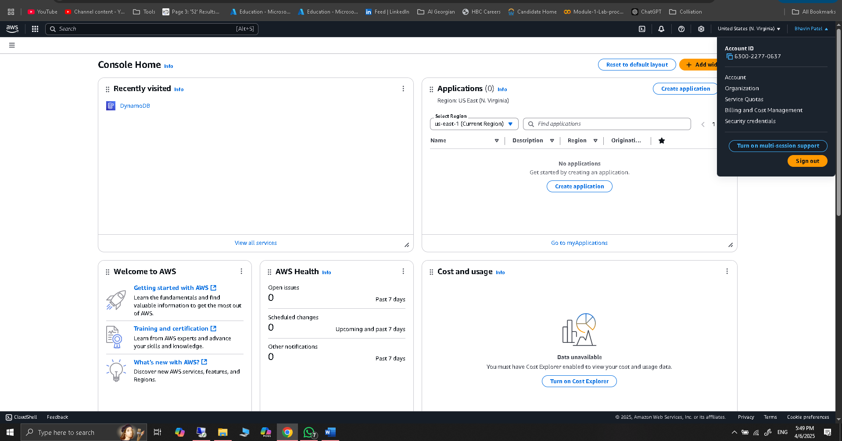

* + **Exercise 4:** Create a table named Products with ProductID as the partition key. Use both the AWS Management Console and AWS CLI to create the table and document the process.

**Creating the table in DynamoDB using AWS management console:**

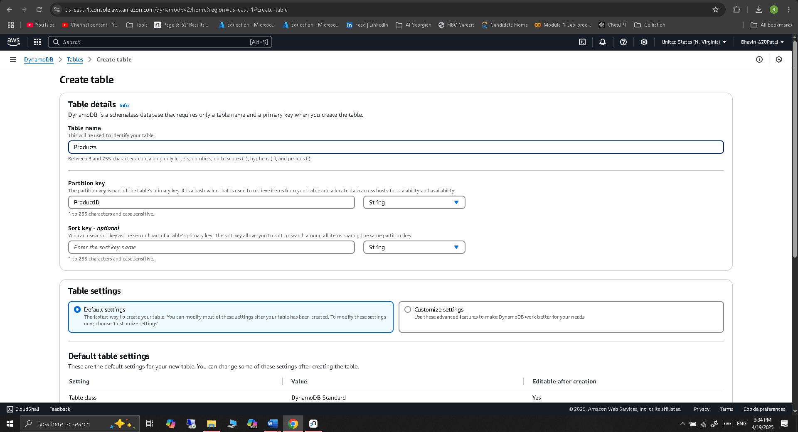

**Table Created successfully:**

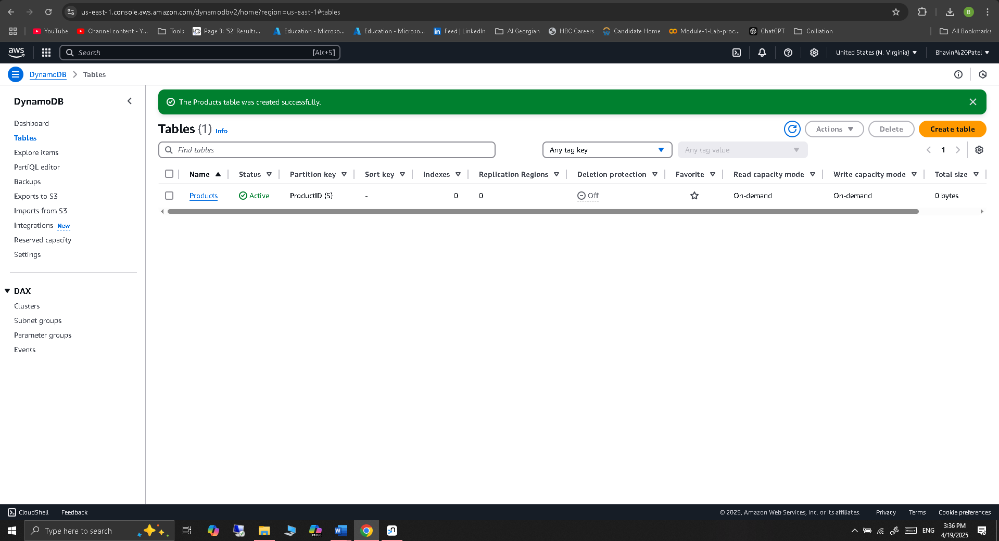

**Creating the table in DynamoDB using AWS CLI:**

For Creating table using CLI need to configure the ASW CLI:

To configure the AWS CLI, we need following details-

* Access Key

1. On the top-right, click your username → **Security Credentials.**
2. Scroll to **Access keys and click Create access key**.
3. Choose Command Line Interface (CLI) as the use case.
4. Click Next → Download or copy the keys securely.

* Secret Key
* Region: us-east-1 (or your choice)
* Output format: json

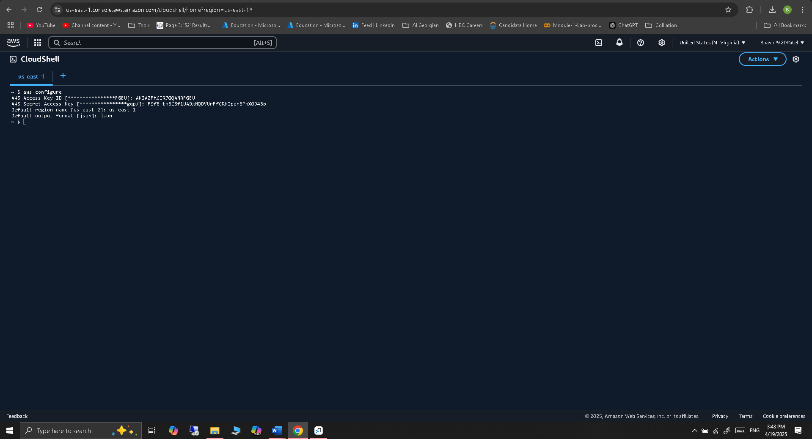

**So here is the output but we have already created product table using AWS management console so while creating a same name table using CLI got error that table already exist so created table names Products_CLI instead of Products.**

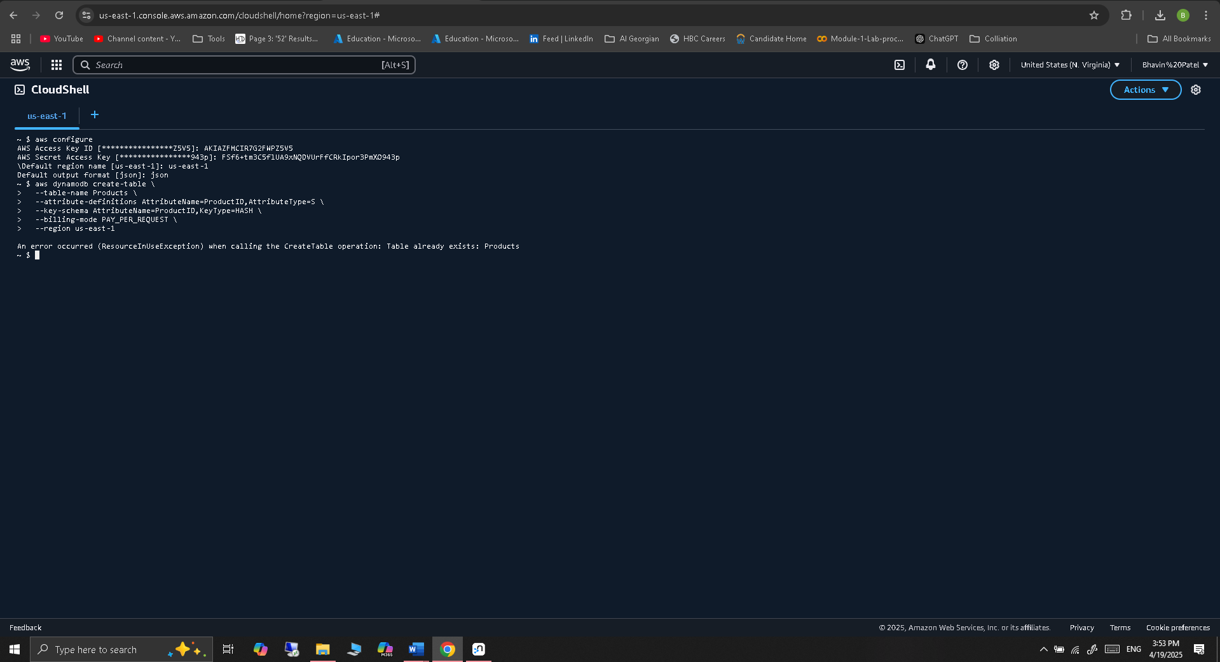

**Table Created successfully:**

*aws dynamodb create-table *

*--table-name Products_CLI *

*--attribute-definitions AttributeName=ProductID,AttributeType=S *

*--key-schema AttributeName=ProductID,KeyType=HASH *

*--billing-mode PAY_PER_REQUEST *

*--region us-east-1*

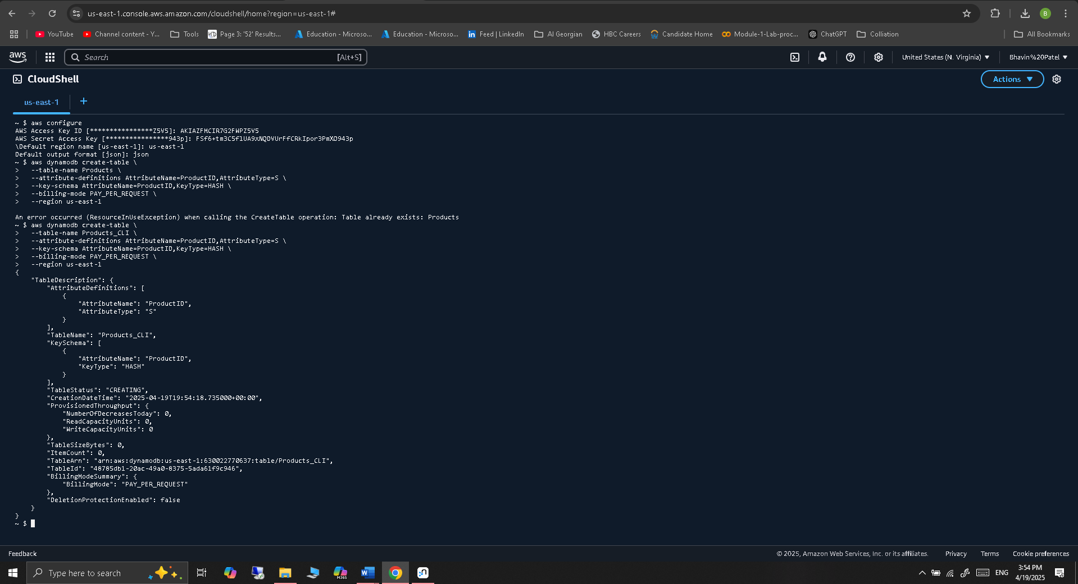

1. **Google Bigtable**
   * **Exercise 5:** Set up a Google Cloud Platform (GCP) account and navigate to the Bigtable service. Document the setup process with screenshots.

**Already have a Google Cloud Platform Account**

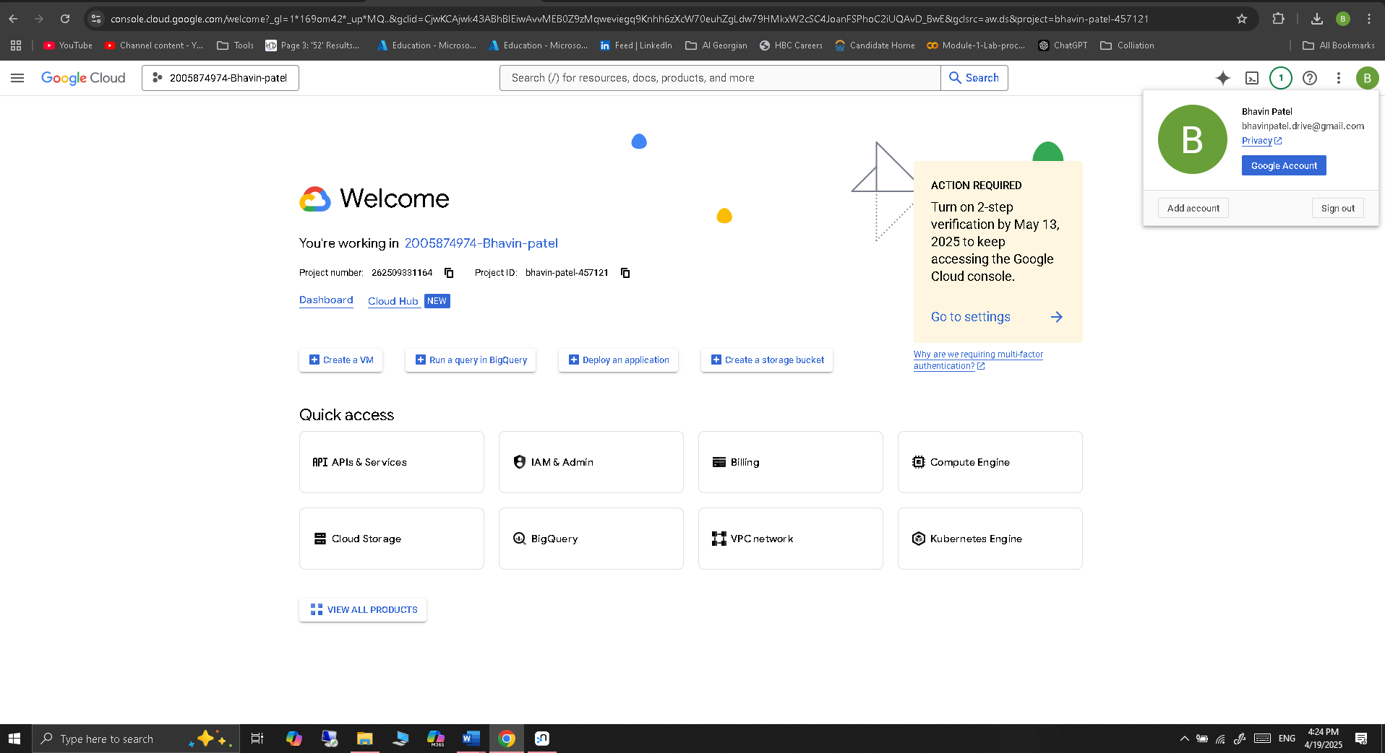

**Navigating to Bigtable services**

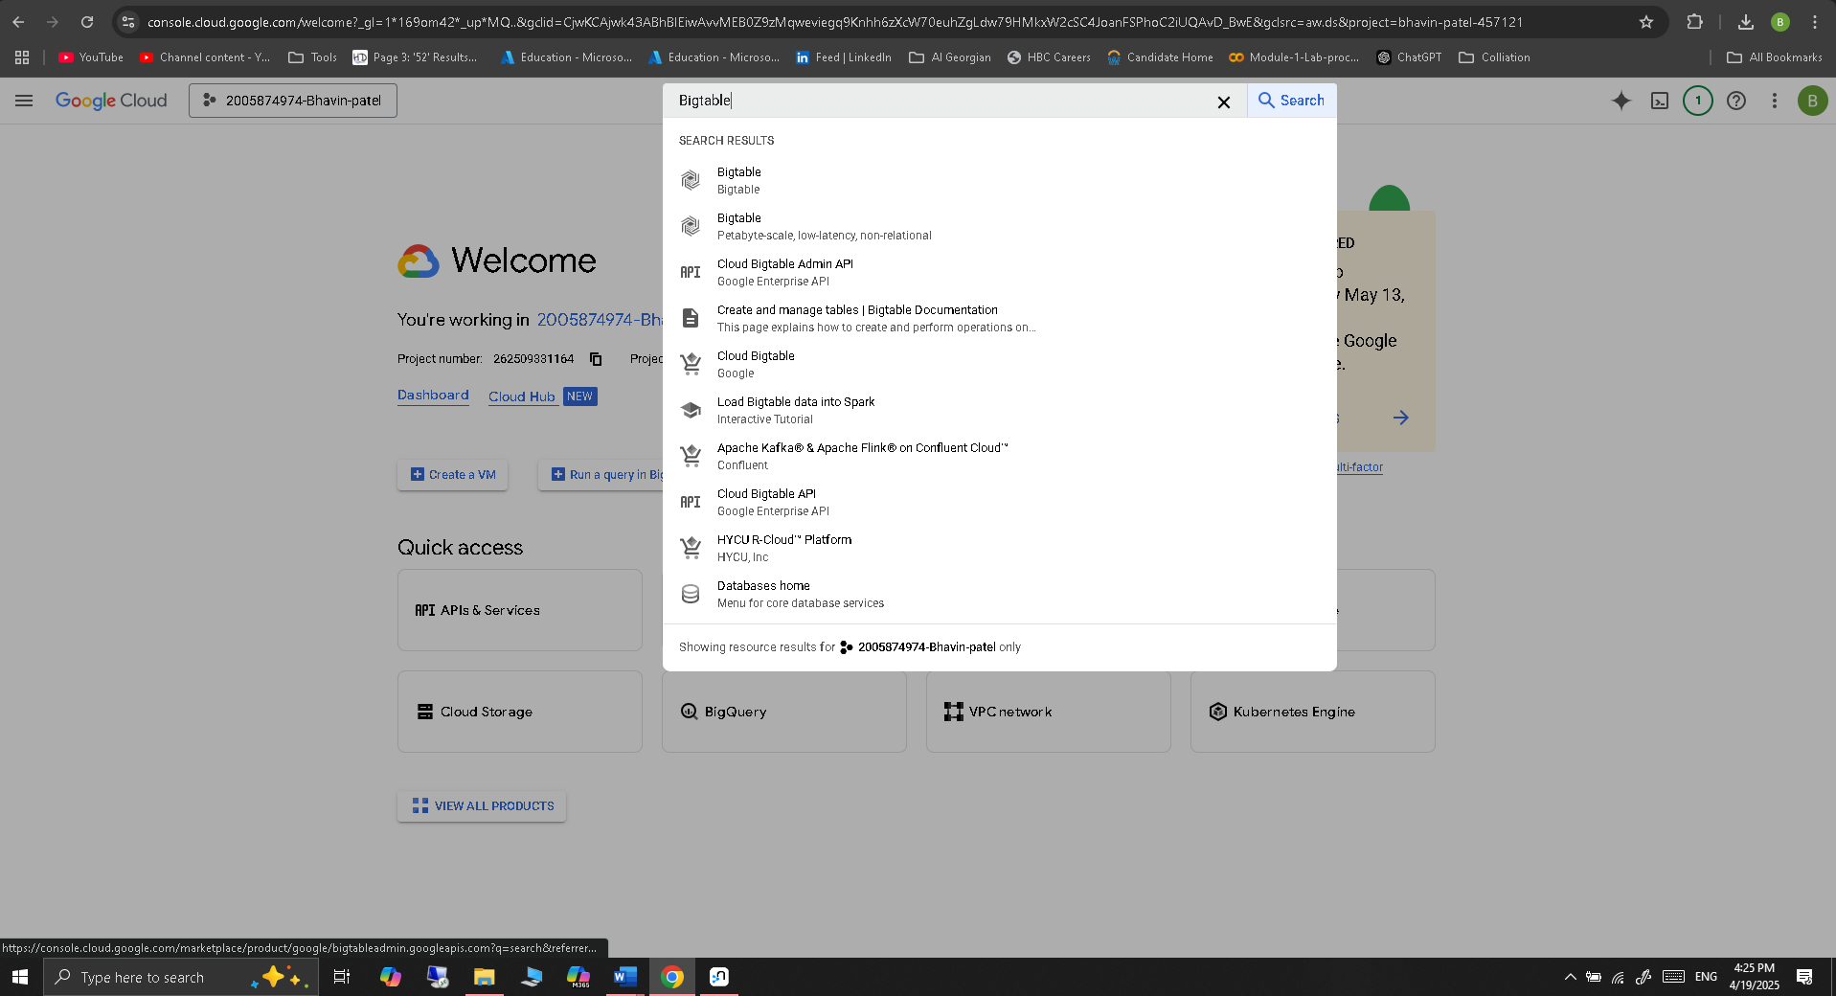

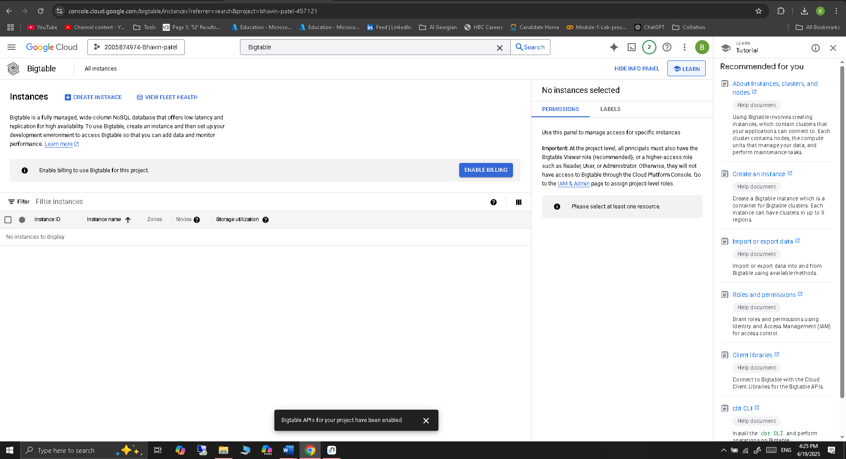

* + **Exercise 6:** Create a Bigtable instance named CustomerData and create a table with the following schema:
    - Row Key: CustomerID
    - Column Families: Info (Name, Email), Orders (OrderID, OrderDate, OrderAmount)

**Creating instance named CustomerData**

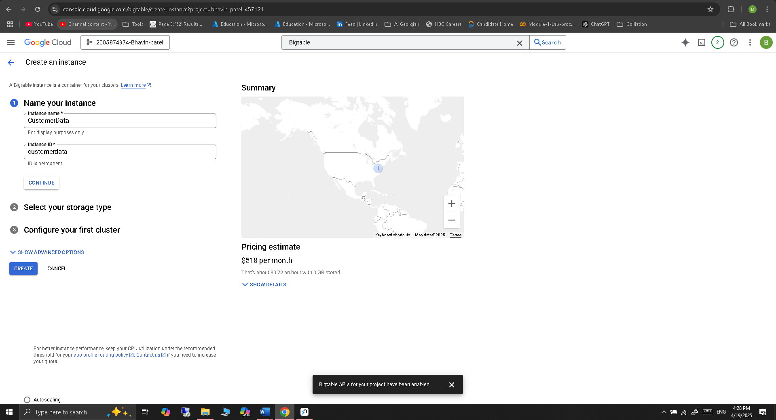

**Storage Type HHD low cost and to perform simple tasks like CURD operations:**

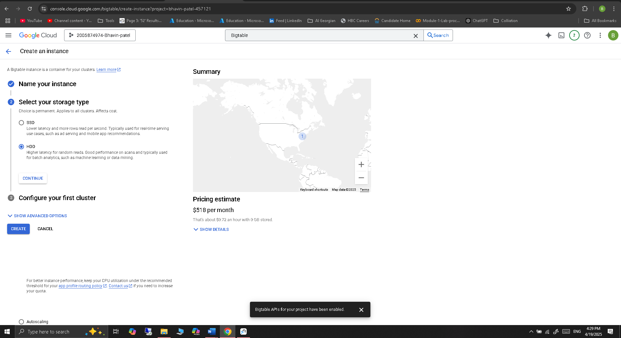

**Selecting the Region and the create instance:**

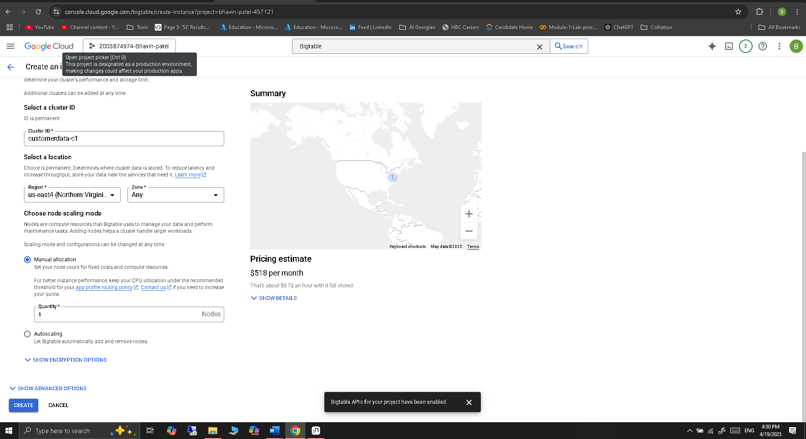

**Instance created successfully:**

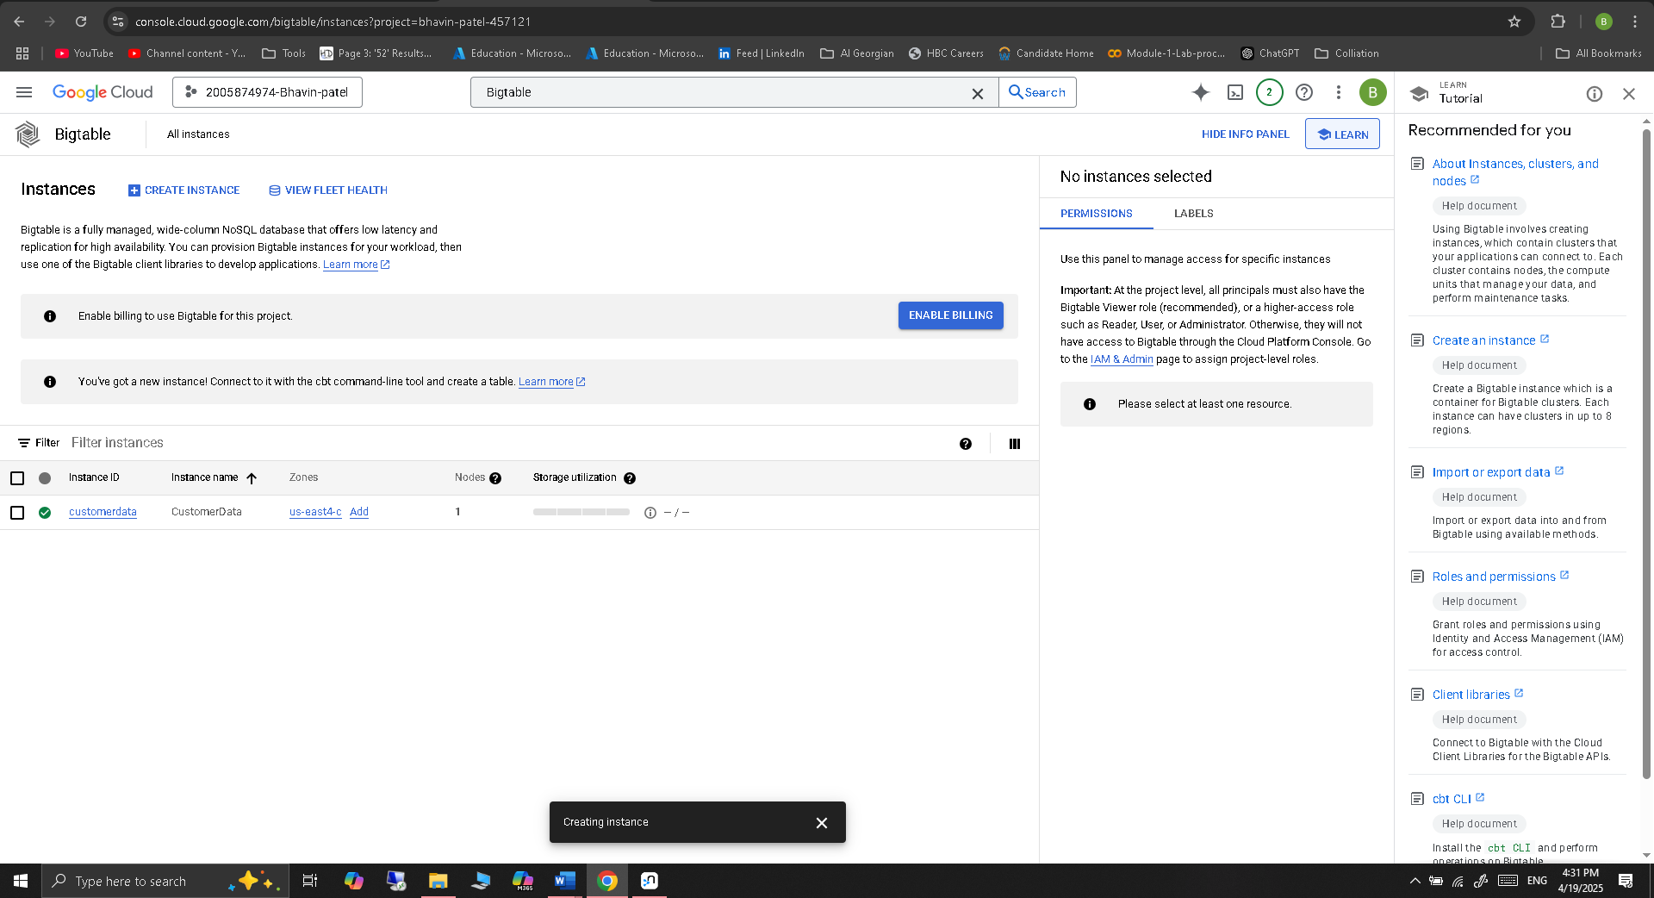

**Creating a Table with Schema**

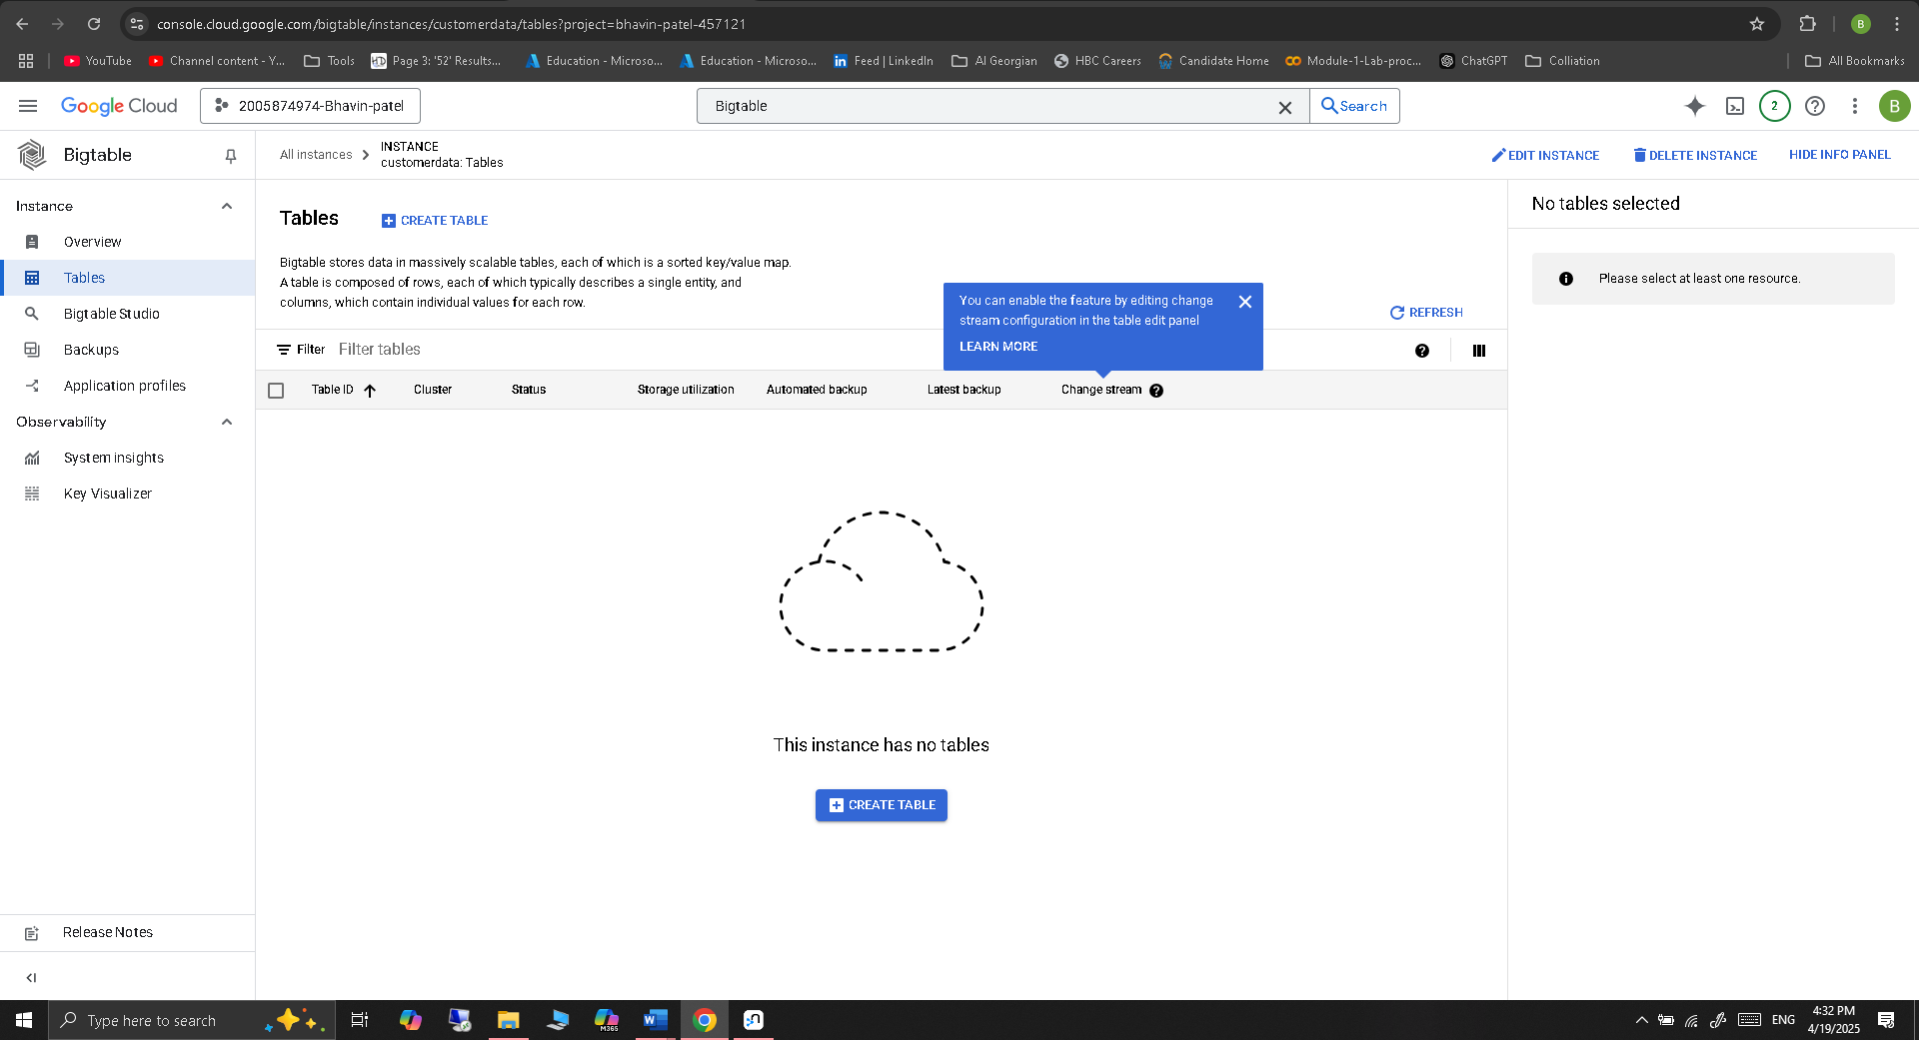

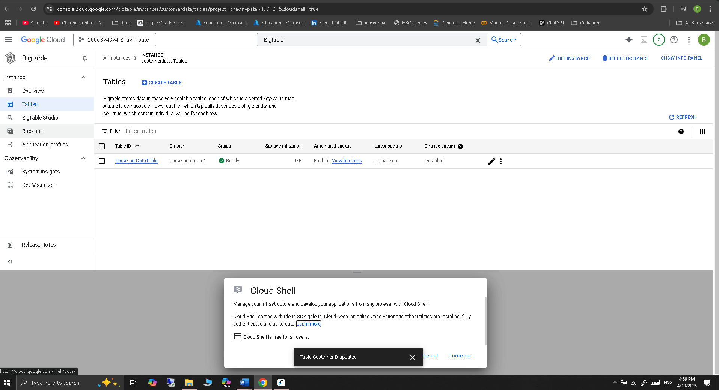

1. **MongoDB**
   * **Exercise 7:** Install MongoDB on your local machine or use MongoDB Atlas for a cloud-based solution. Document the installation and setup process with screenshots.

Install MongoDB Locally (Recommended for Offline Use)

1. Go to MongoDB official website: <https://www.mongodb.com/try/download/community>

* Download & Install MongoDB Community Edition
* Choose your OS (e.g., Windows/macOS/Linux)
* Follow the installation wizard
* Ensure “MongoDB Compass” is selected (optional GUI)

1. Start MongoDB Service

* On Windows: net start MongoDB

Open MongoDB Shell (mongosh) : enter the “mongosh” in terminal

We already have installed MangoDB in my local, so I have not followed the installation process:

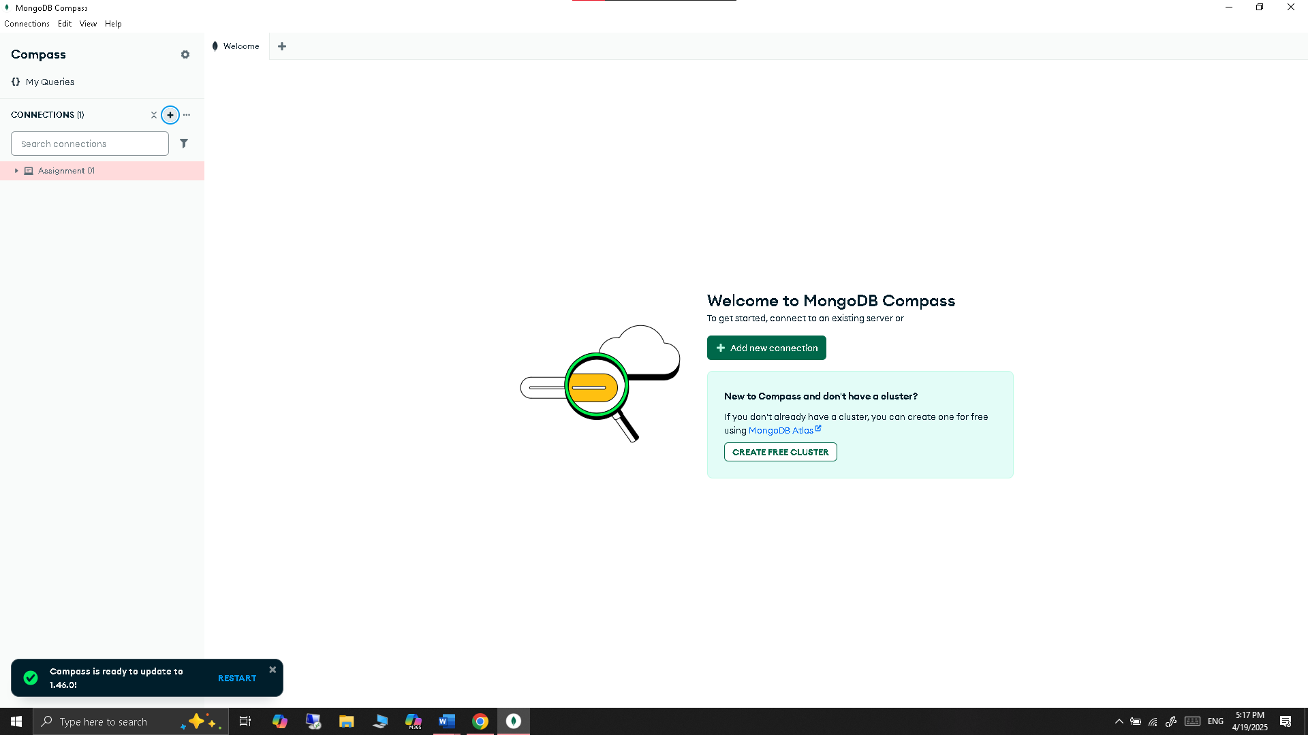

* + **Exercise 8:** Create a database named Library and create collections for Books, Authors, and Borrowers.

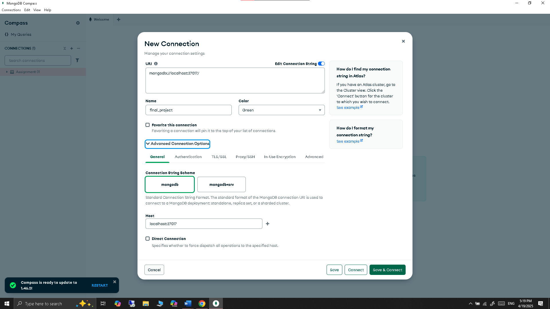

Created Library Database:

Created collection name Books in library database:

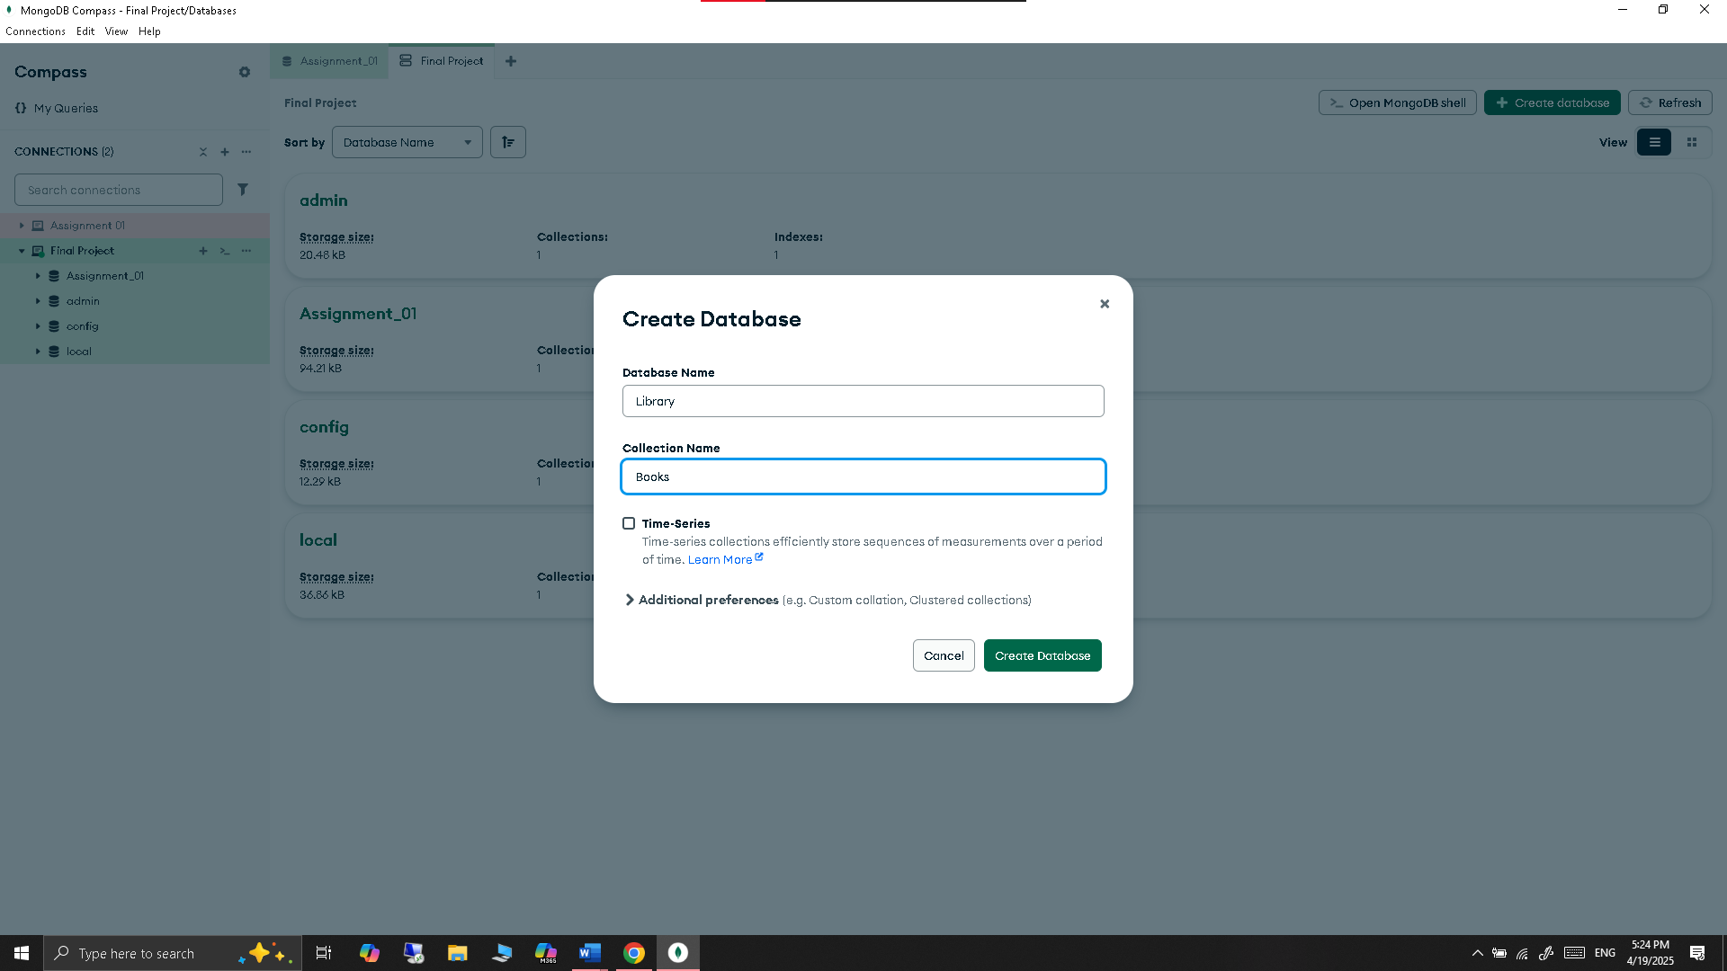

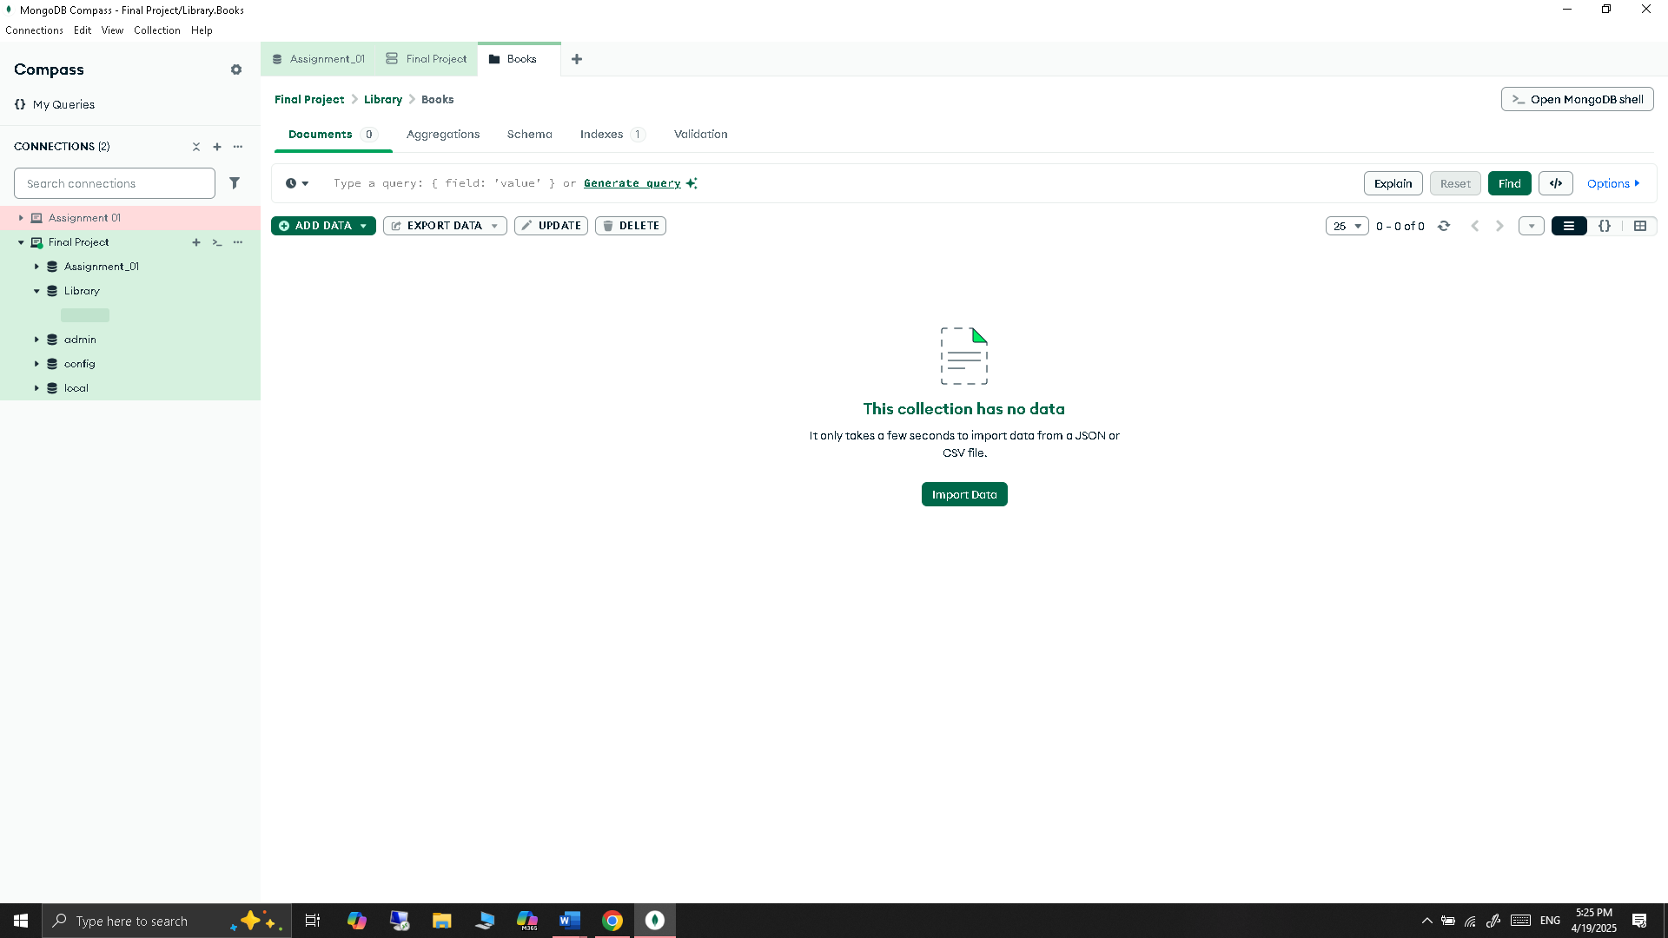

Created Collection name Authors in library database



Created Collection name Borrowers in library database

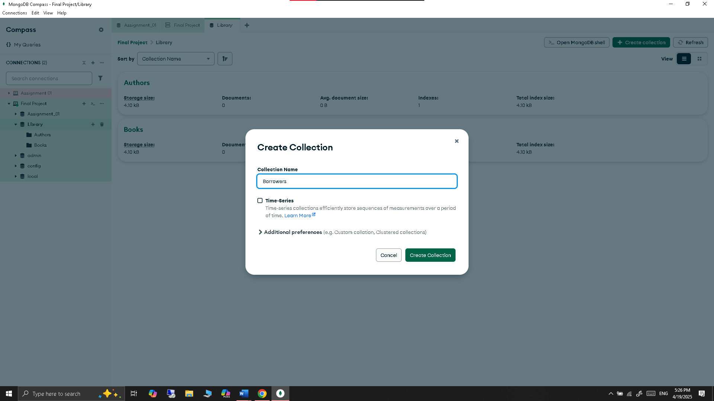

Result: Successfully created “Library” and with 3 collection.

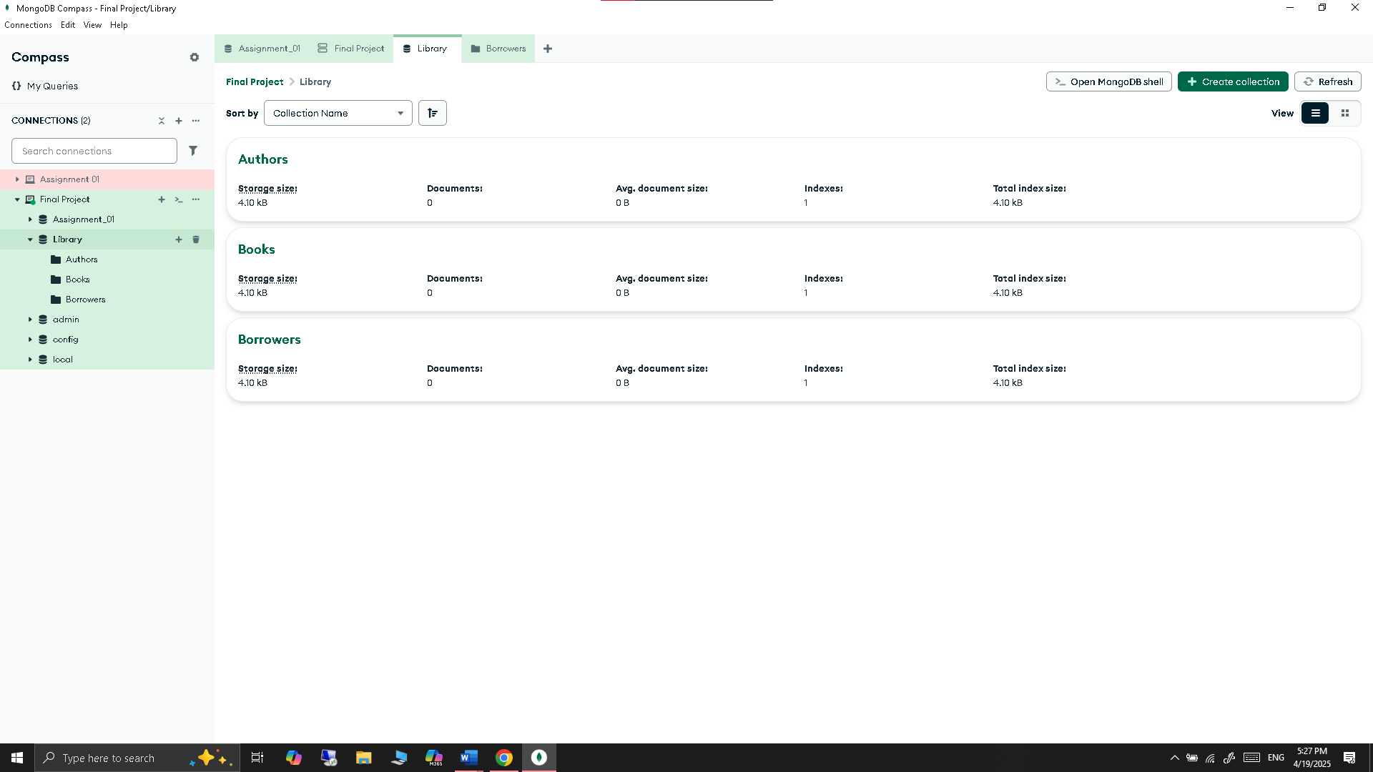

**Part 2: CRUD Operations**

1. **Neo4j**
   * **Exercise 9:** Perform the following operations using Cypher queries:
     + Add nodes for employees, departments, and projects.

*// Add new employee*

*CREATE (:Employee {name: 'Frank', emp_id: 6, position: 'UX Designer'});*

*// Add new department*

*CREATE (:Department {name: 'Design', dept_id: 'D4'});*

*// Add new project*

*CREATE (:Project {name: 'Project Delta', project_id: 'P4'});*

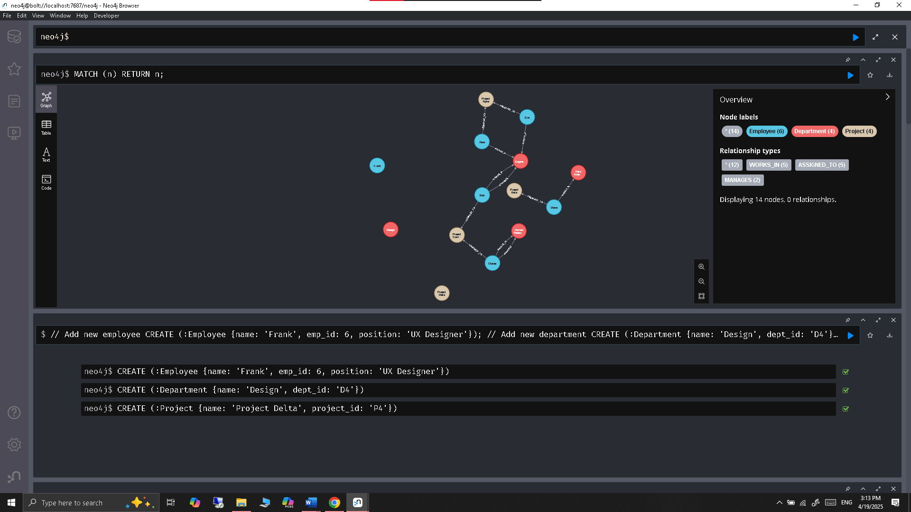

* + - Create relationships between the nodes.

*// Frank works in Design*

*MATCH (e:Employee {name: 'Frank'}), (d:Department {name: 'Design'})*

*CREATE (e)-[:WORKS_IN]->(d);*

*// Frank is assigned to Project Delta*

*MATCH (e:Employee {name: 'Frank'}), (p:Project {name: 'Project Delta'})*

*CREATE (e)-[:ASSIGNED_TO]->(p);*

*// Frank manages Design*

*MATCH (e:Employee {name: 'Frank'}), (d:Department {name: 'Design'})*

*CREATE (e)-[:MANAGES]->(d);*

**Result:**

*MATCH (e:Employee {name: 'Frank'})-[r]->(n) RETURN e, r, n;*

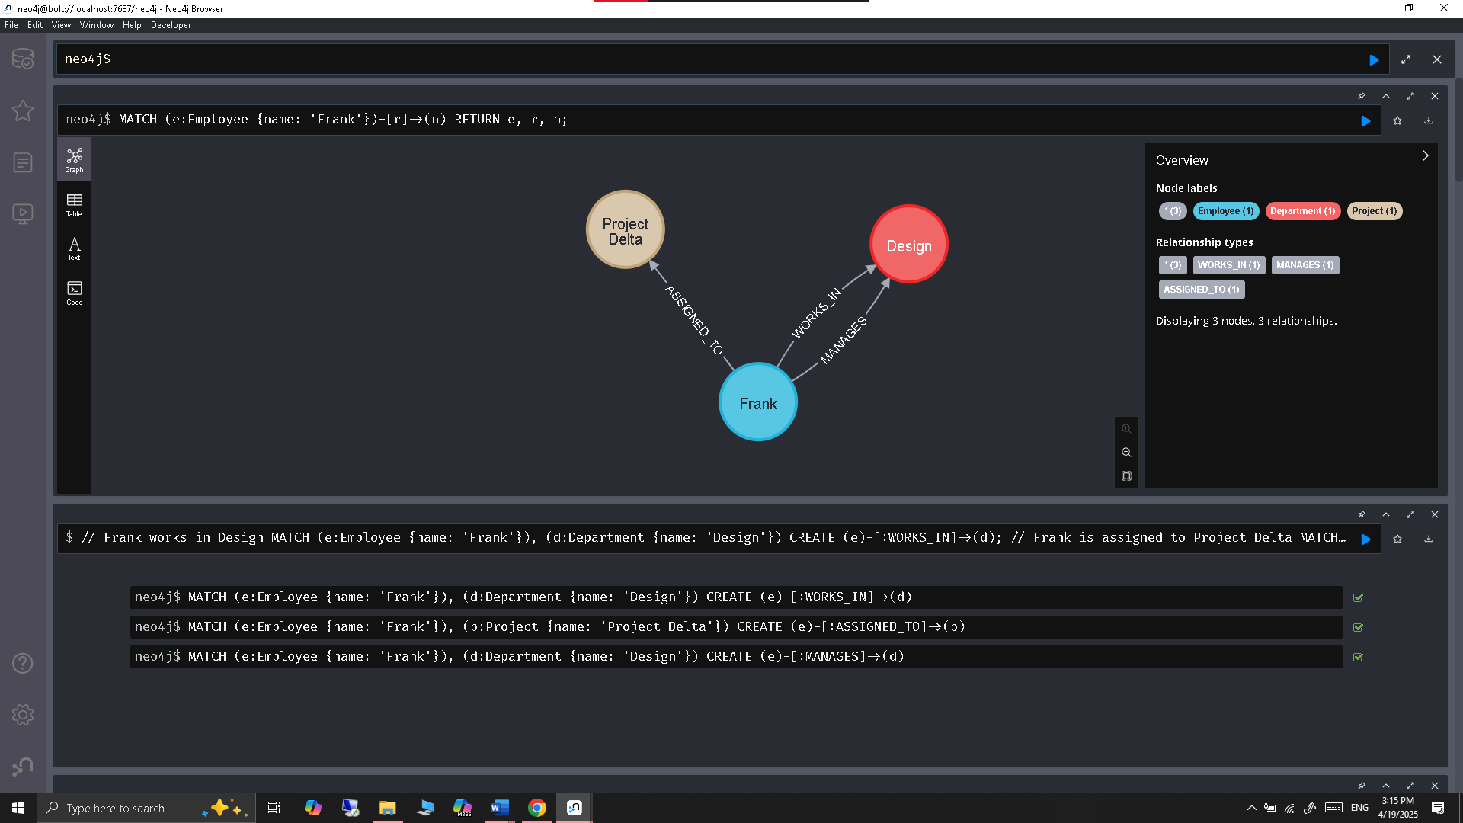

* + - Update node properties.

*// Update Frank’s role title*

*MATCH (e:Employee {name: 'Frank'})*

*SET e.position = 'Senior UX Designer'*

*RETURN e;*

**Result:**

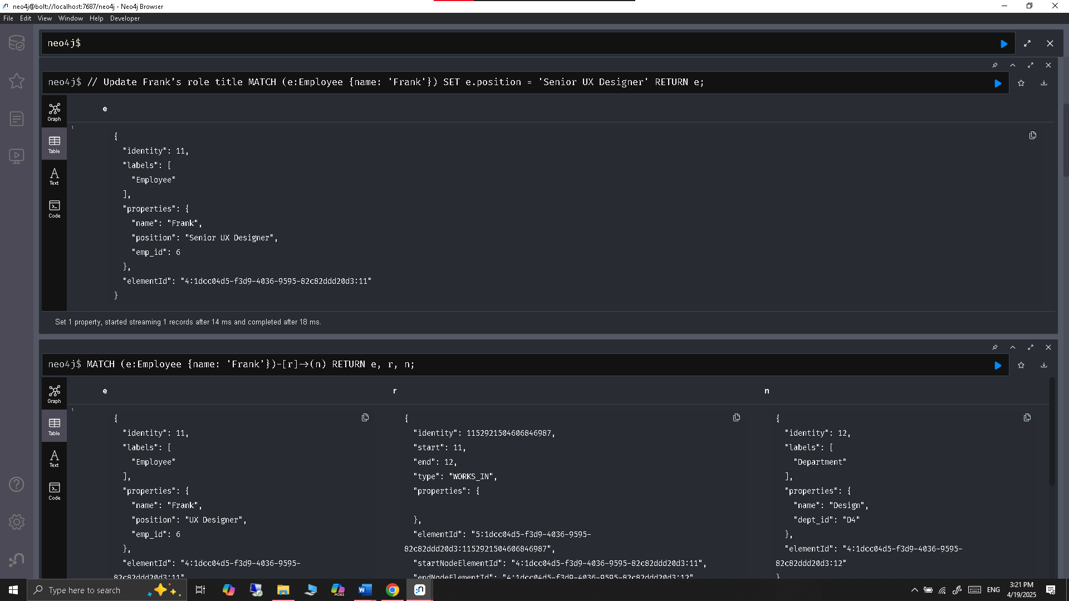

* + - Delete specific nodes and relationships.

Delete a relationship:

*// Delete Frank’s assignment to Project Delta*

*MATCH (e:Employee {name: 'Frank'})-[r:ASSIGNED_TO]->(p:Project {name: 'Project Delta'})*

*DELETE r;*

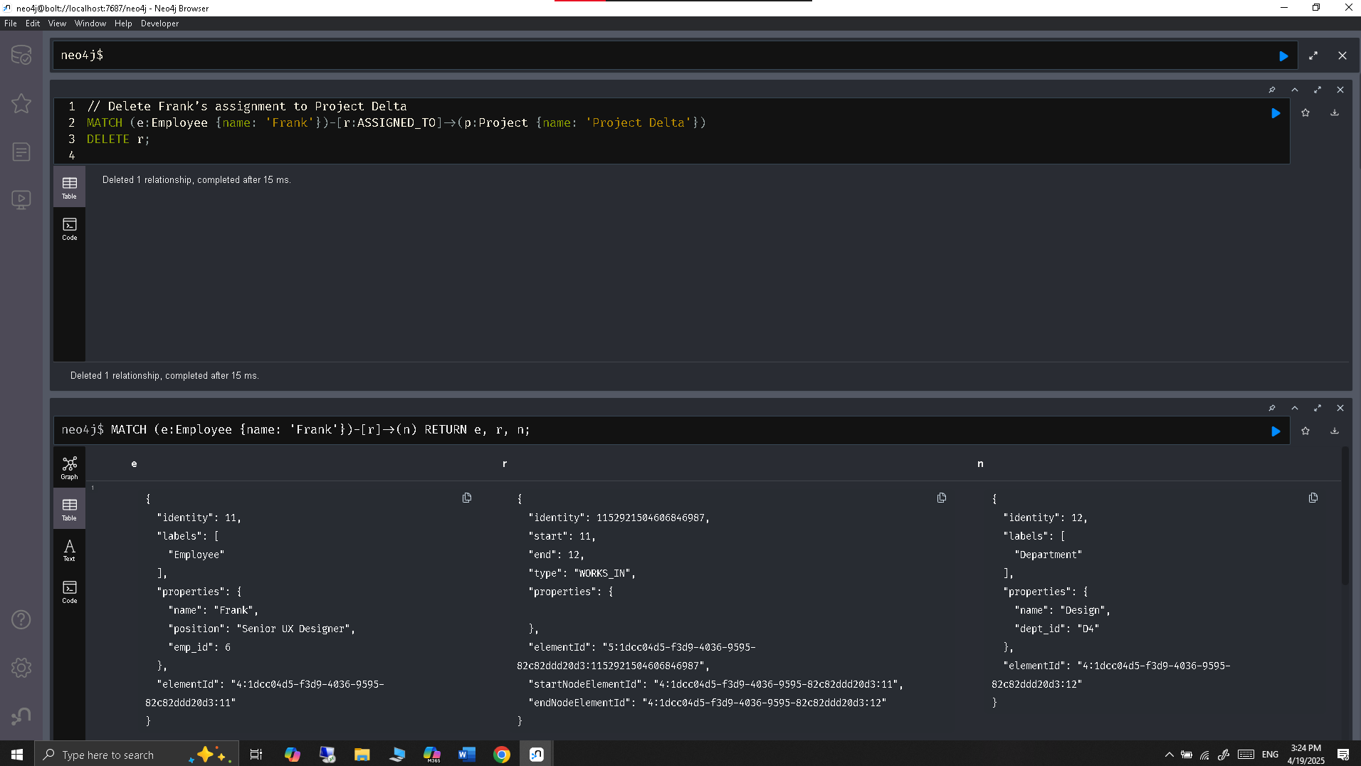

Delete a node:

*// Delete the project "Project Delta" along with its relationships*

*MATCH (p:Project {name: 'Project Delta'})*

*DETACH DELETE p;*

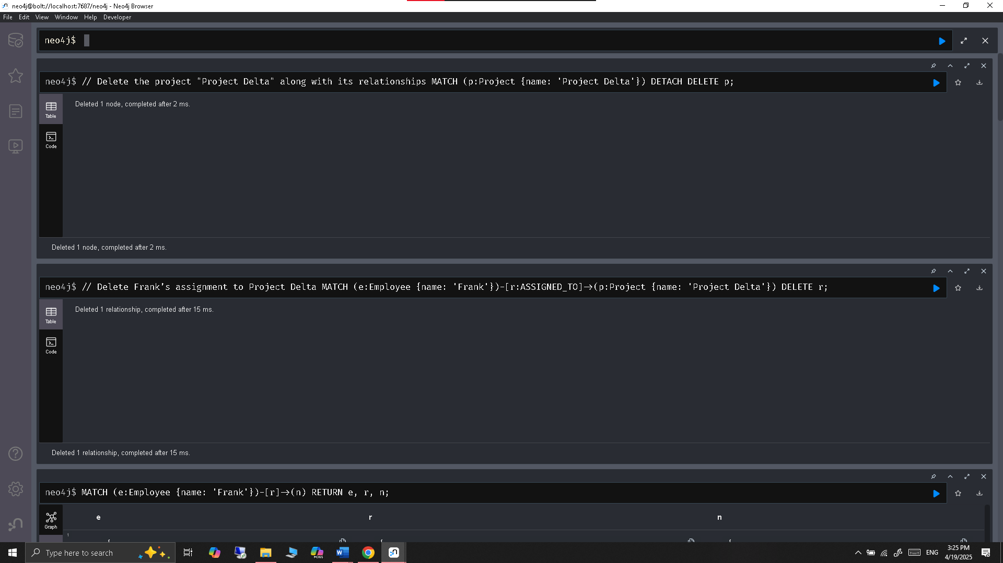

**Final observation table of the database:**

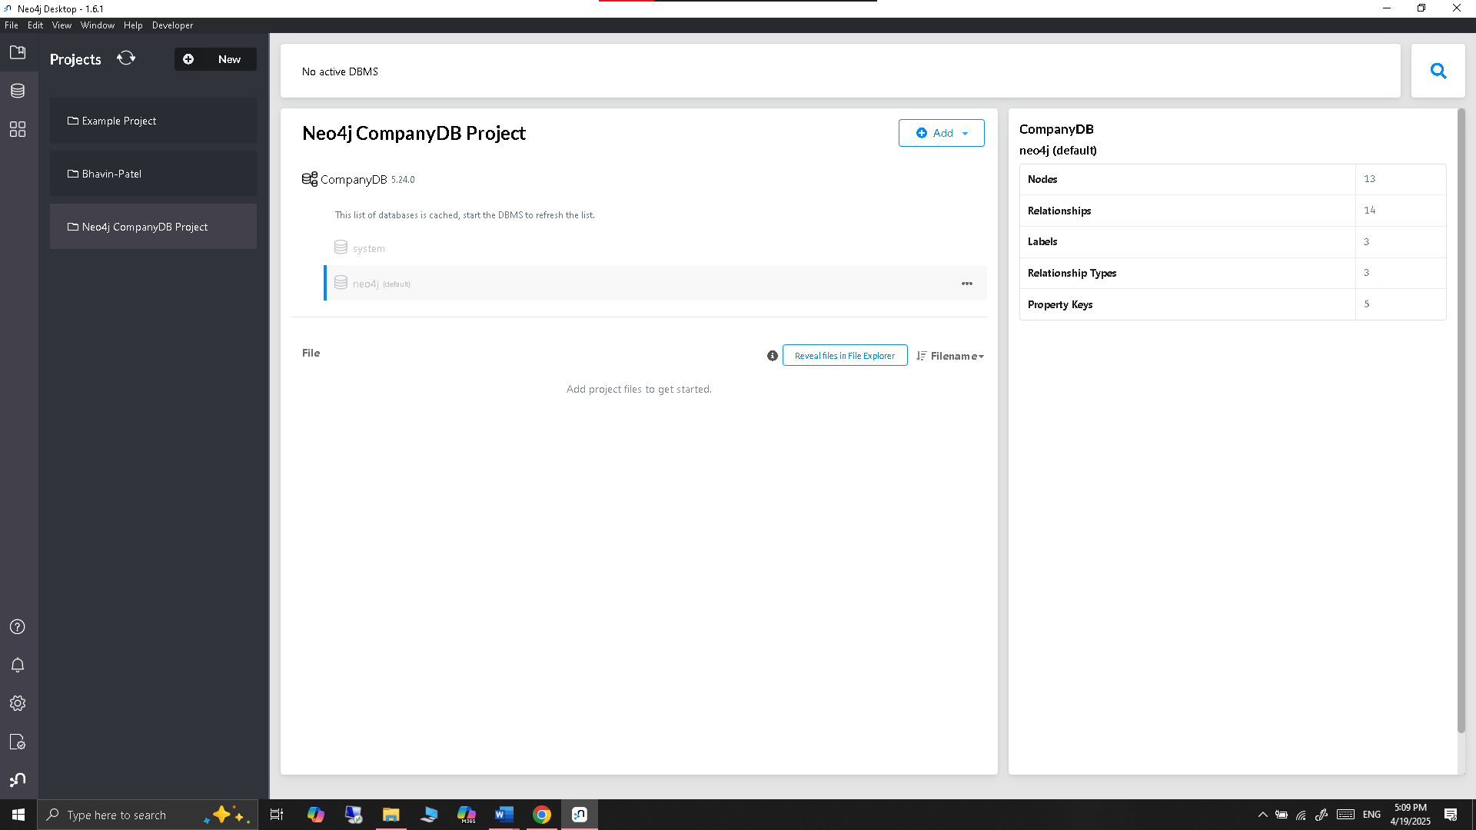

1. **DynamoDB**
   * **Exercise 10:** Perform the following operations using AWS CLI:
     + Insert items into the Products table.

Created the json file using - nano products-batch.json

So, I can add data to the table

*aws dynamodb batch-write-item *

*--request-items file://products-batch.json *

*--region us-east-1*

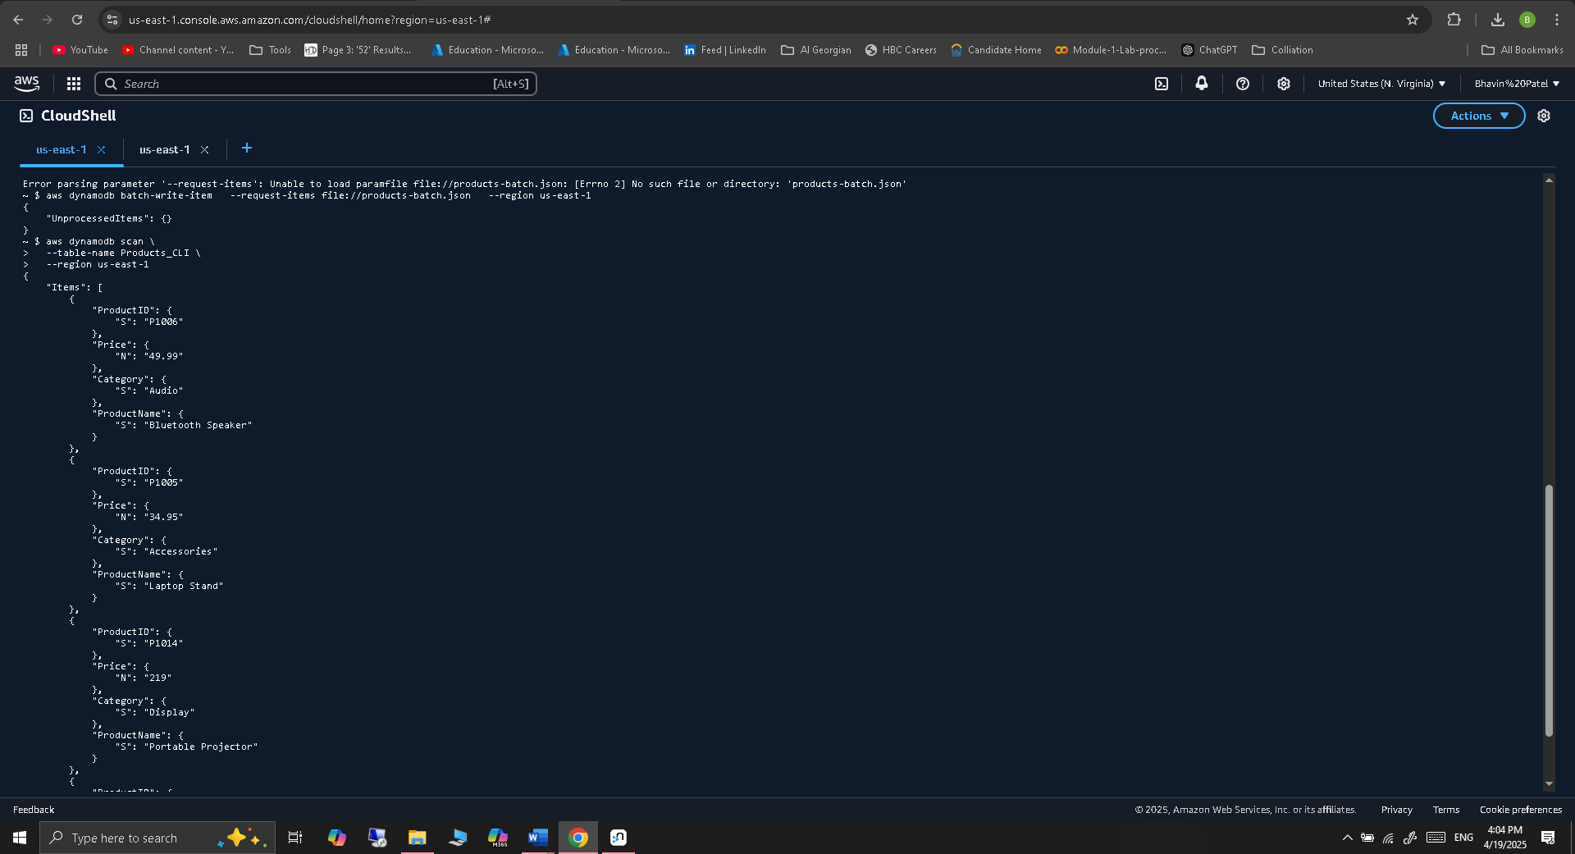

* + - Query and scan the table to retrieve items based on specific conditions.

**Scan with a filter condition (e.g., price less than 50):**

*aws dynamodb scan *

*--table-name Products_CLI *

*--filter-expression "Price < :price" *

*--expression-attribute-values '{":price":{"N":"50"}}' *

*--region us-east-1*

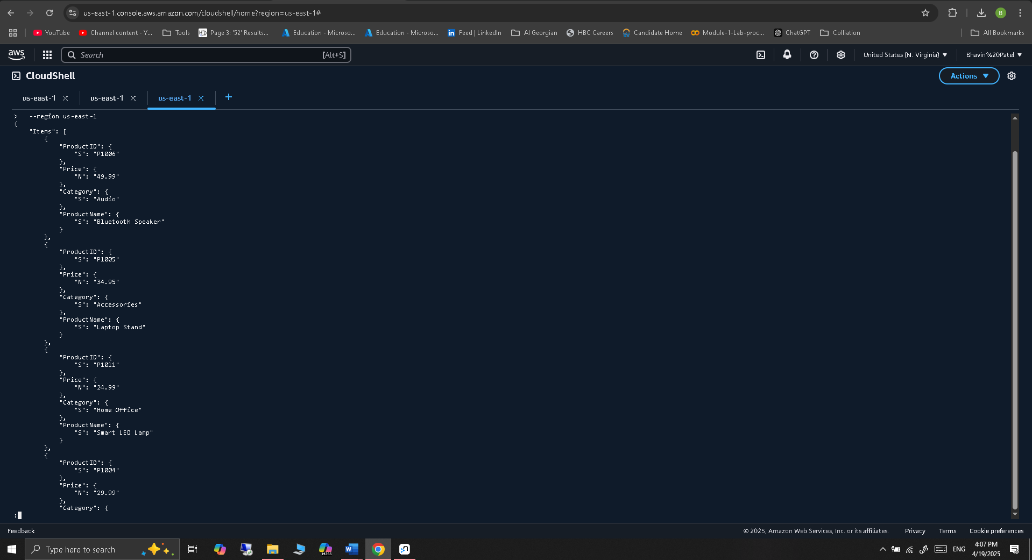

**Query based on ProductID (note: works only with exact partition key match):**

*aws dynamodb query *

*--table-name Products_CLI *

*--key-condition-expression "ProductID = :pid" *

*--expression-attribute-values '{":pid":{"S":"P1002"}}' *

*--region us-east-1*

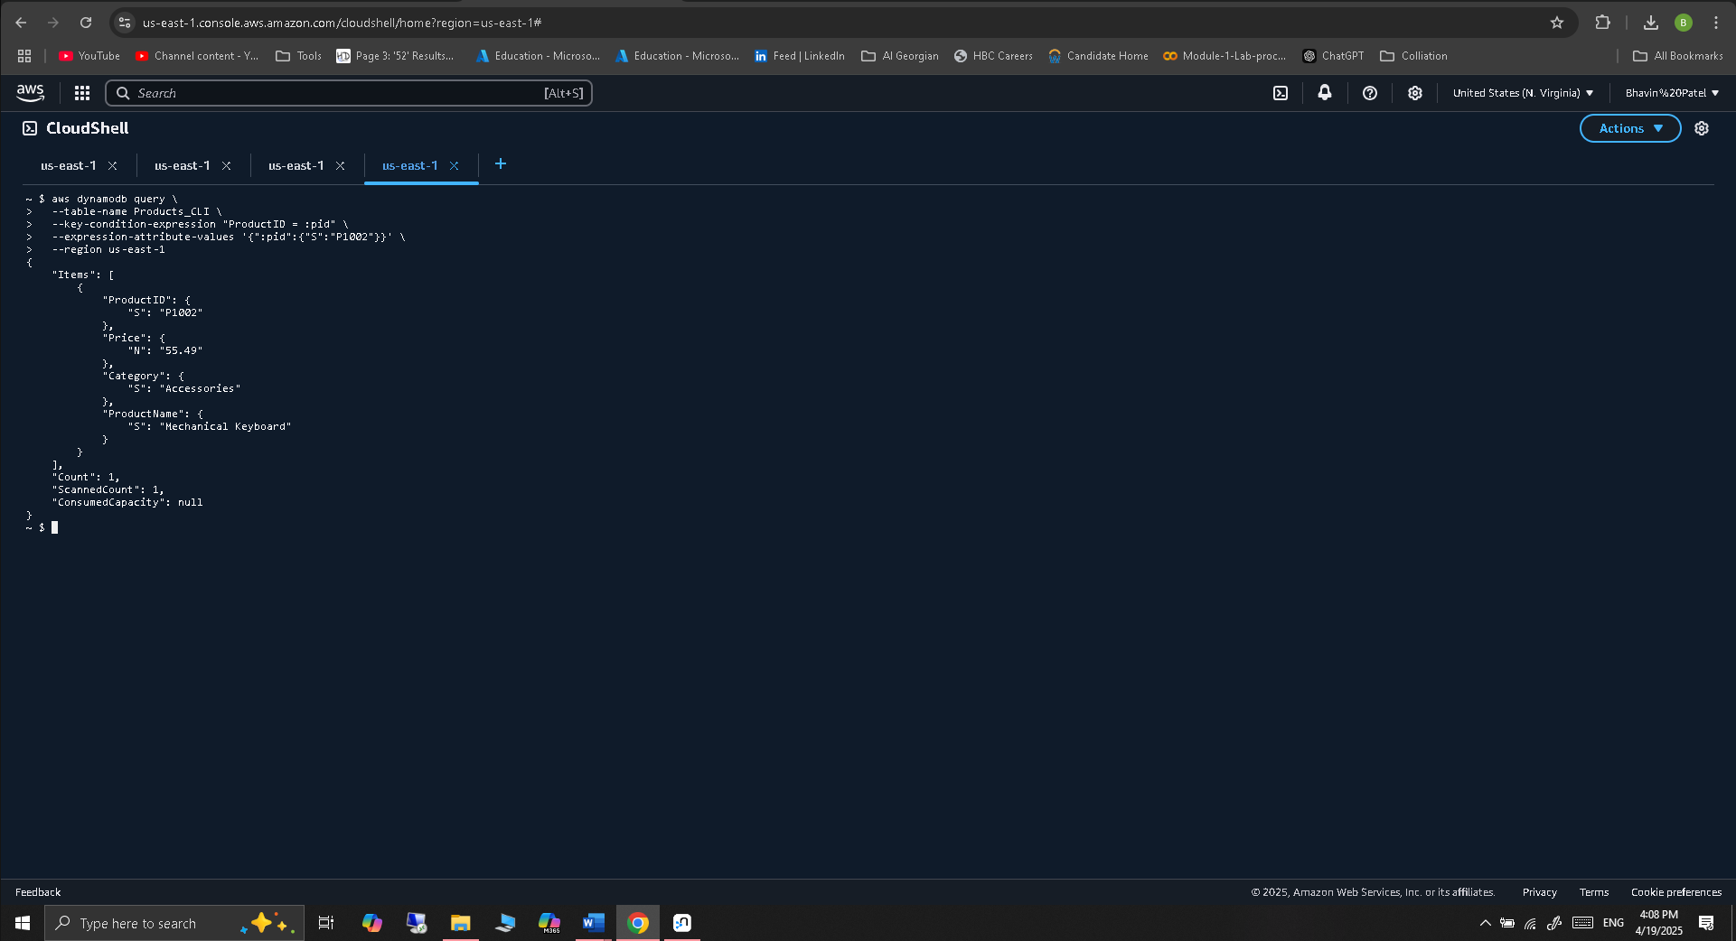

* + - Update and delete items in the table.

**Update the price of P1002 (59.99 to 148.59)**

*aws dynamodb update-item *

*--table-name Products_CLI *

*--key '{"ProductID": {"S": "P1002"}}' *

*--update-expression "SET Price = :newprice" *

*--expression-attribute-values '{":newprice": {"N": "148.59"}}' *

*--return-values ALL_NEW *

*--region us-east-1*

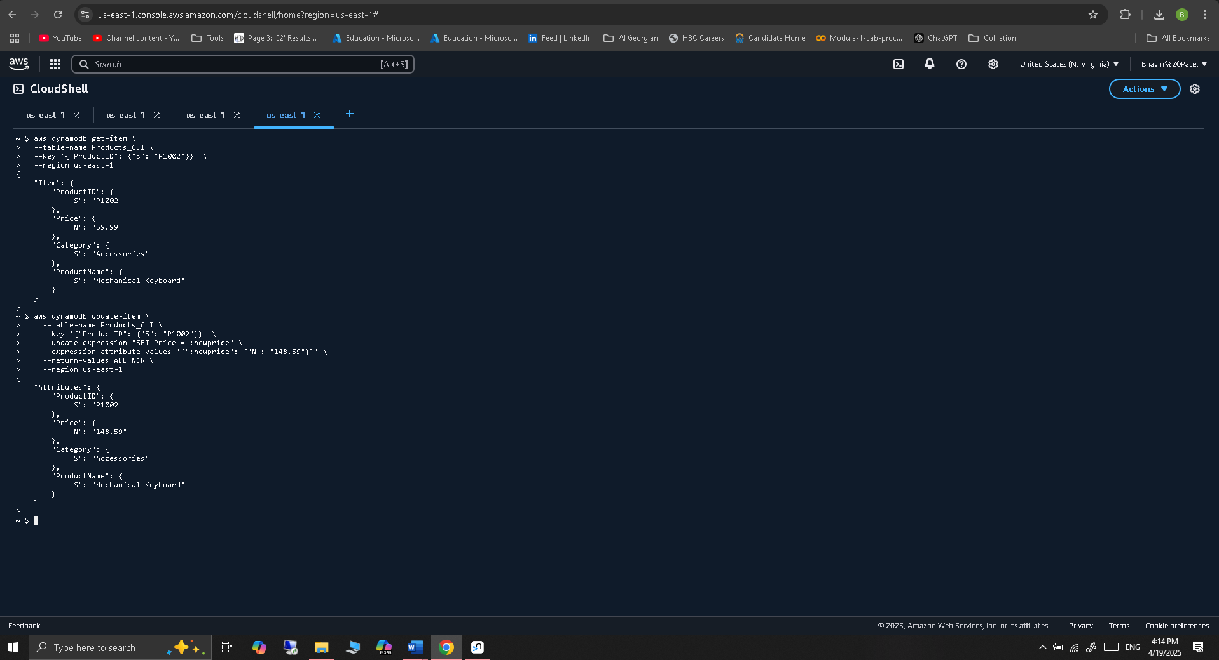

**Delete item with ProductID = P1005**

*aws dynamodb delete-item *

*--table-name Products_CLI *

*--key '{"ProductID": {"S": "P1005"}}' *

*--region us-east-1*

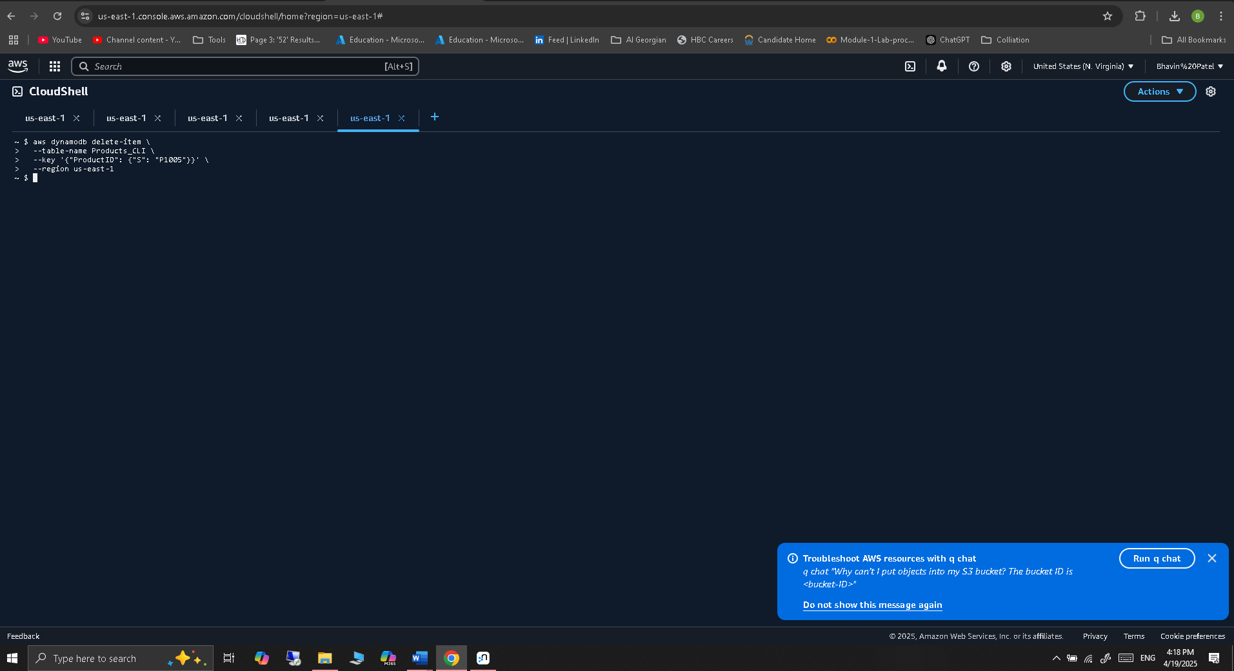

1. **Google Bigtable**
   * **Exercise 11:** Perform the following operations using the GCP Console and Bigtable API:
     + Insert rows into the CustomerData table.

As a first step open the cloud session, in google cloud platform.

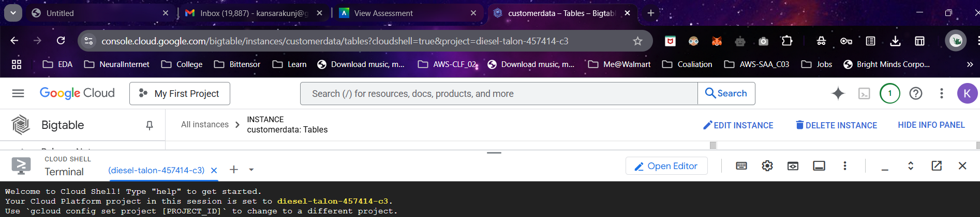

Then it has already built in tool named as cbt for cloud Big Table.

Here is its version: 1.23.1 2a2ef85 2025-01-10 22:18:56

Created .cbtrc file with below content.

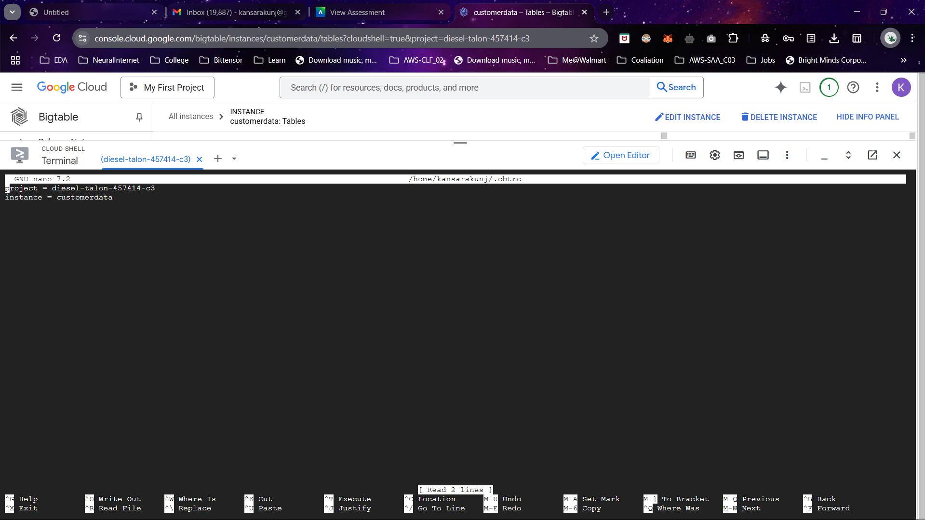

Now the table is listed with cbt ls

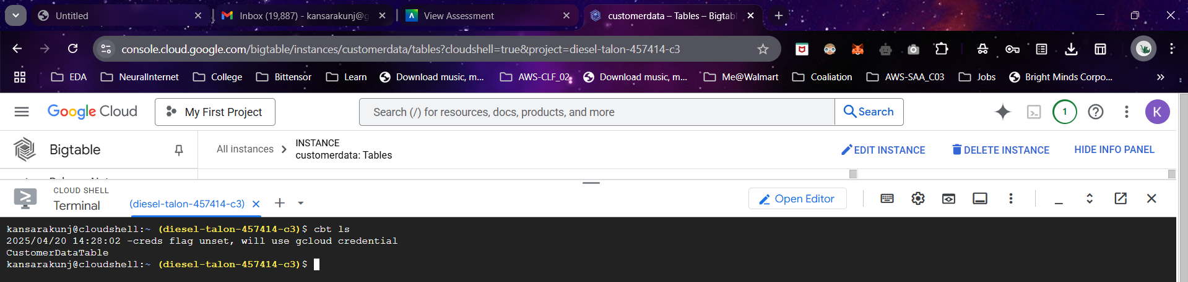

This are the Table configuration , in which I created column family named as cf

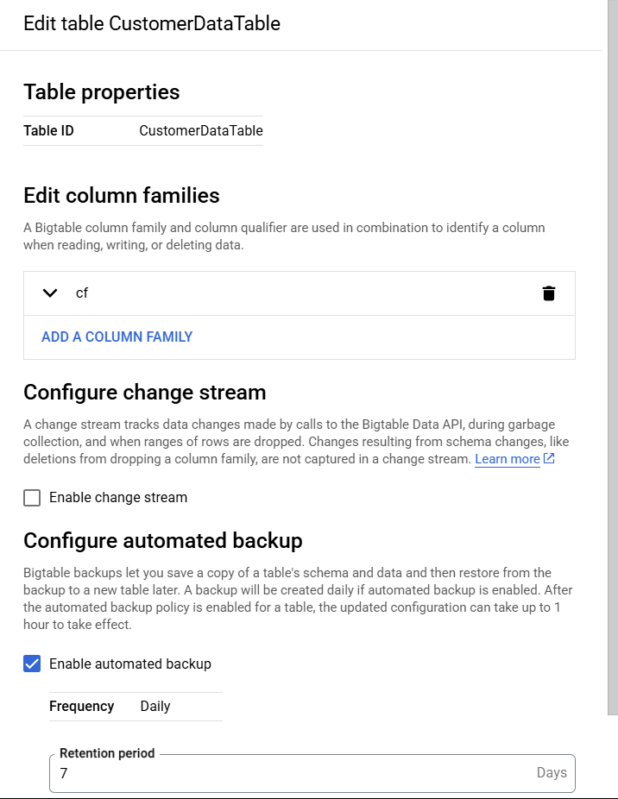

Insert the first data by column family cf and cbt tool

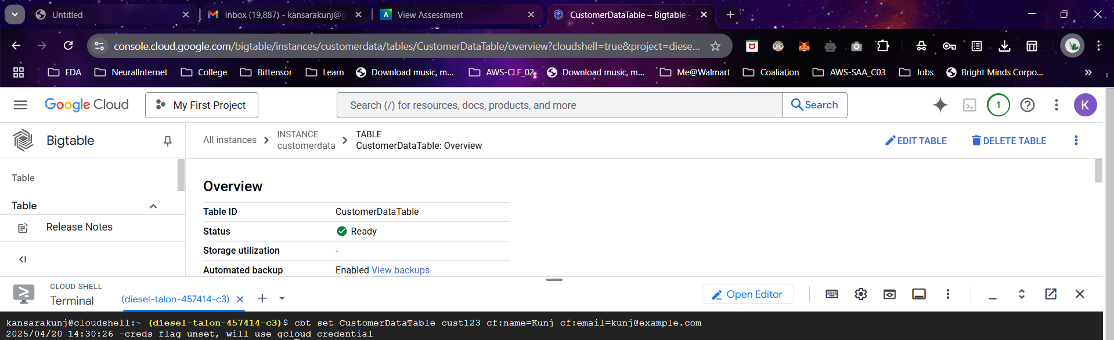

* *--cbt set CustomerDataTable cust123 cf:name=Kunj cf:email=kunj@example.com*

Now Insert the another row



* *-- cbt set CustomerDataTable cust124 cf:name=Bhavin cf:email=bhavin@example.com*
  + - Read and filter rows based on column values.

Here is the read of whole table

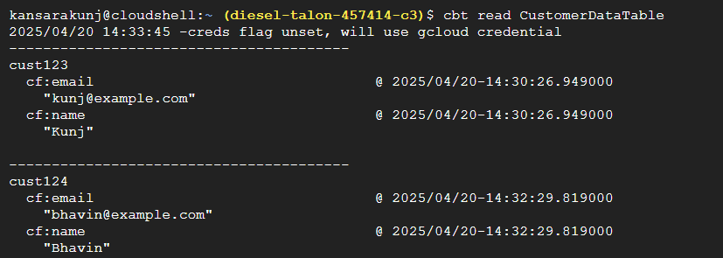

* -- *cbt read CustomerDataTable*

Reading data with Big Table Studio

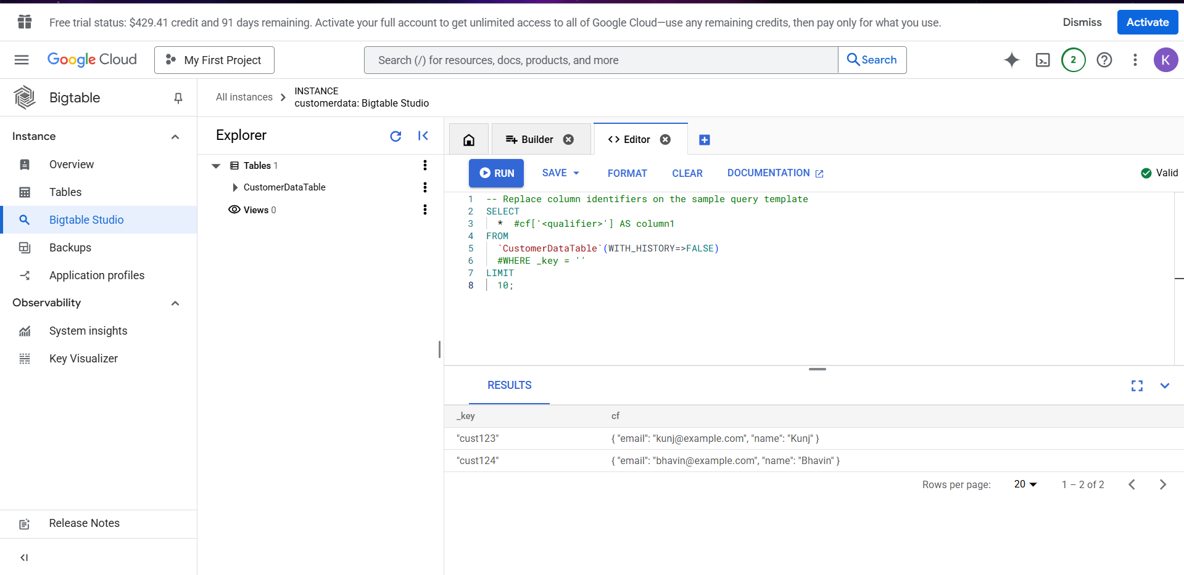

* *-- SELECT * FROM ‘CustomerDataTable’(WITH_HISTORY=>FALSE) LIMIT 10*

Reading specific qualifiers

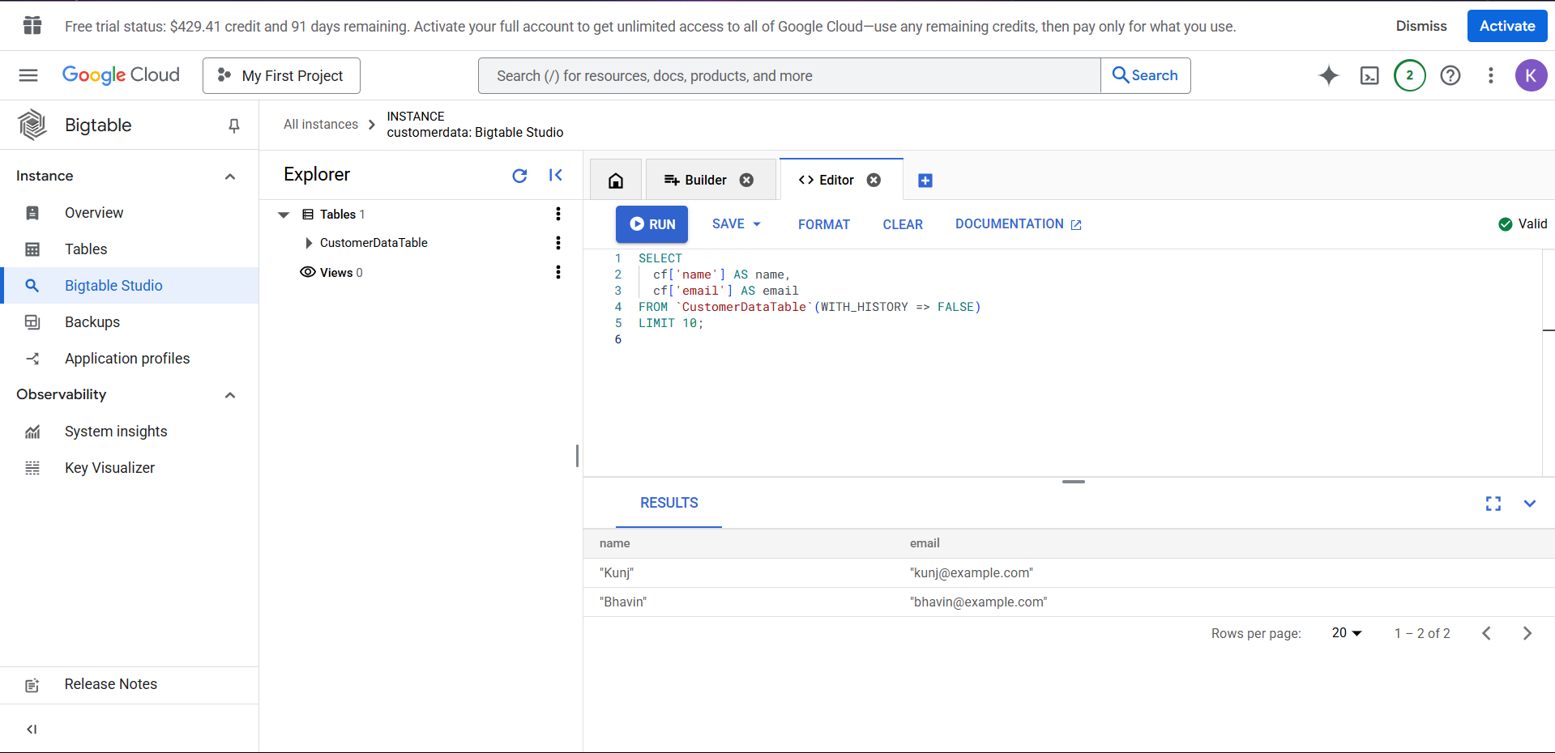

* *-- SELECT cf['name'] AS name, cf['email'] AS email FROM `CustomerDataTable`(WITH_HISTORY => FALSE) LIMIT 10;*

Filtering based on some qualifiers

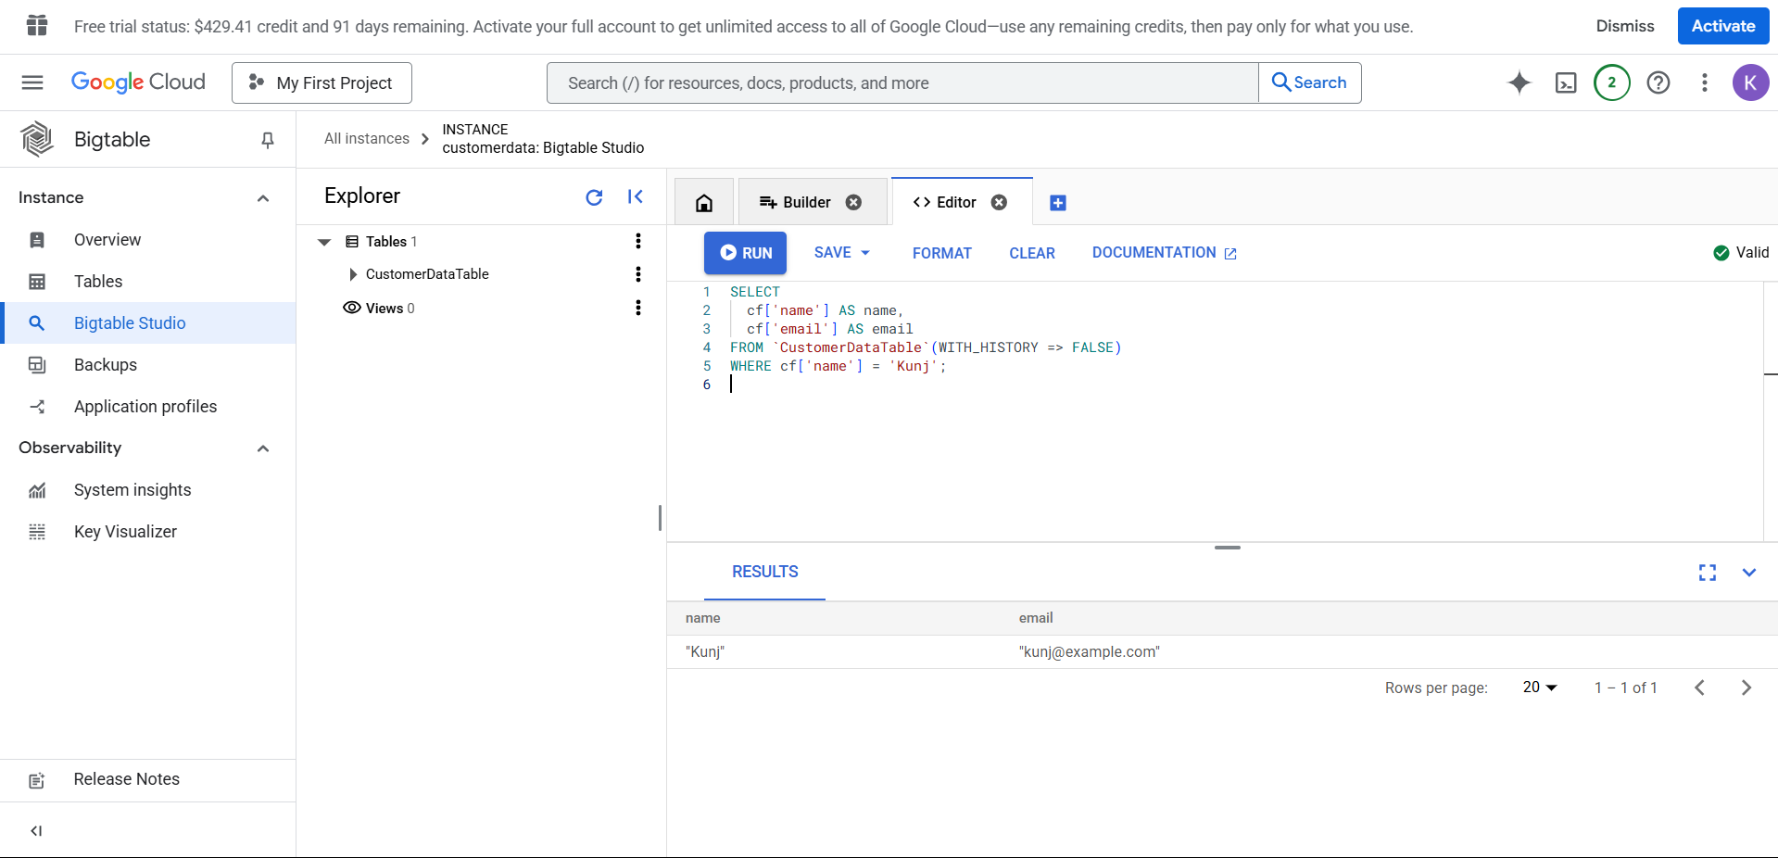

* *-- SELECT  cf['name'] AS name,  cf['email'] AS email FROM CustomerDataTable`(WITH_HISTORY => FALSE) WHERE cf['name'] = 'Kunj';*
  + - Update and delete specific rows.

Updating the rows with cbt tool that we installed in google cloud

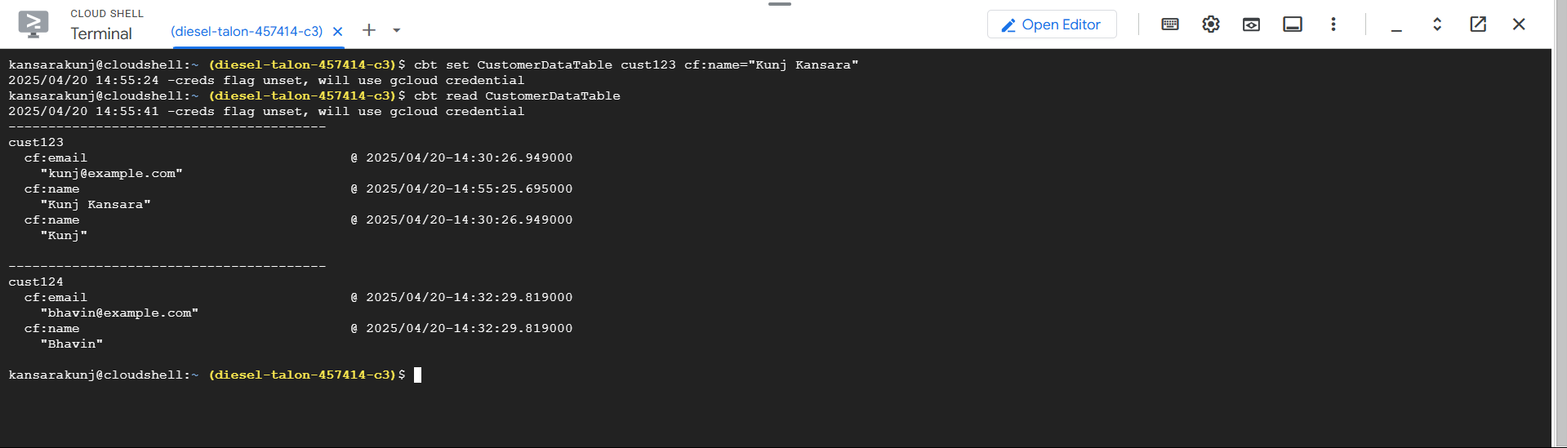

* *-- cbt set CustomerDataTable cust123 cf:name=”Kunj Kansara”*

Deleting rows with cbt tool

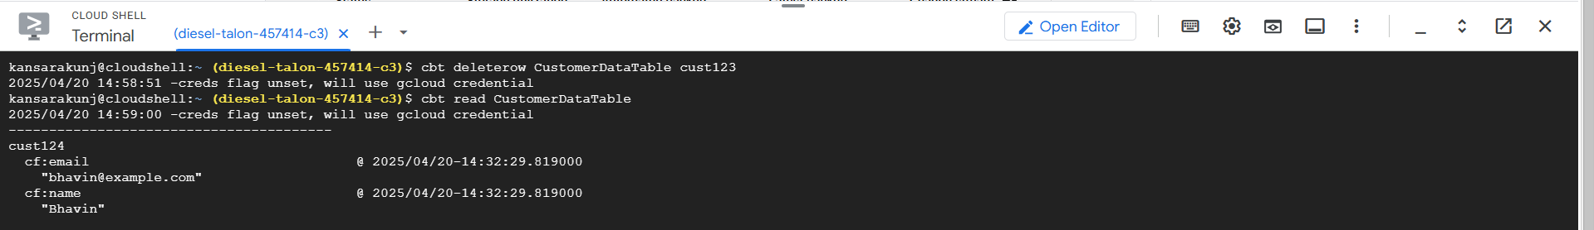

* *-- cbt deleterow CustomerDataTable cust123*

1. **MongoDB**
   * **Exercise 12:** Perform the following operations using MongoDB shell or MongoDB Compass:
     + Insert documents into the Books, Authors, and Borrowers collections.
2. Inserting document in Books collection:

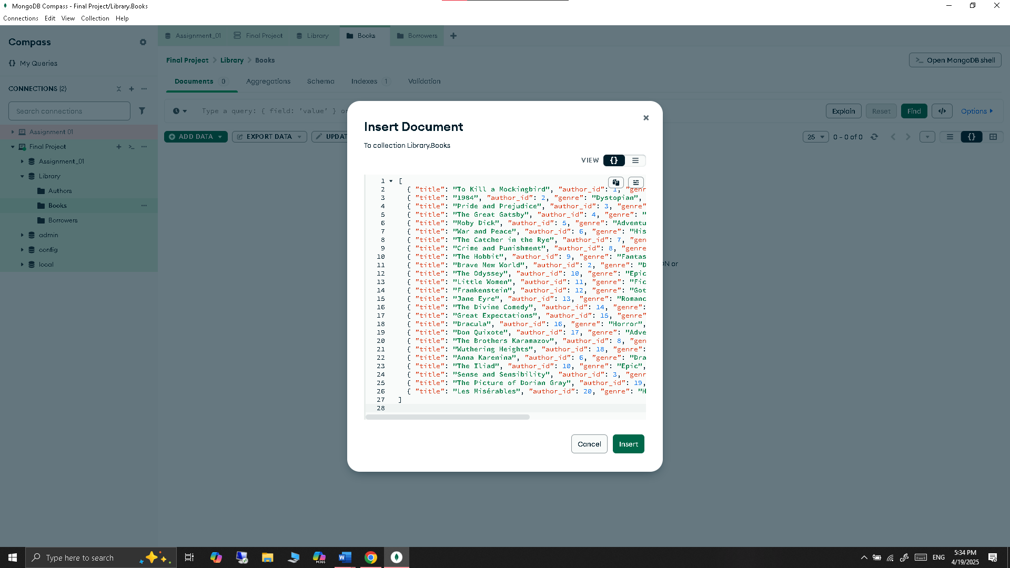

**Inserted document successfully:**

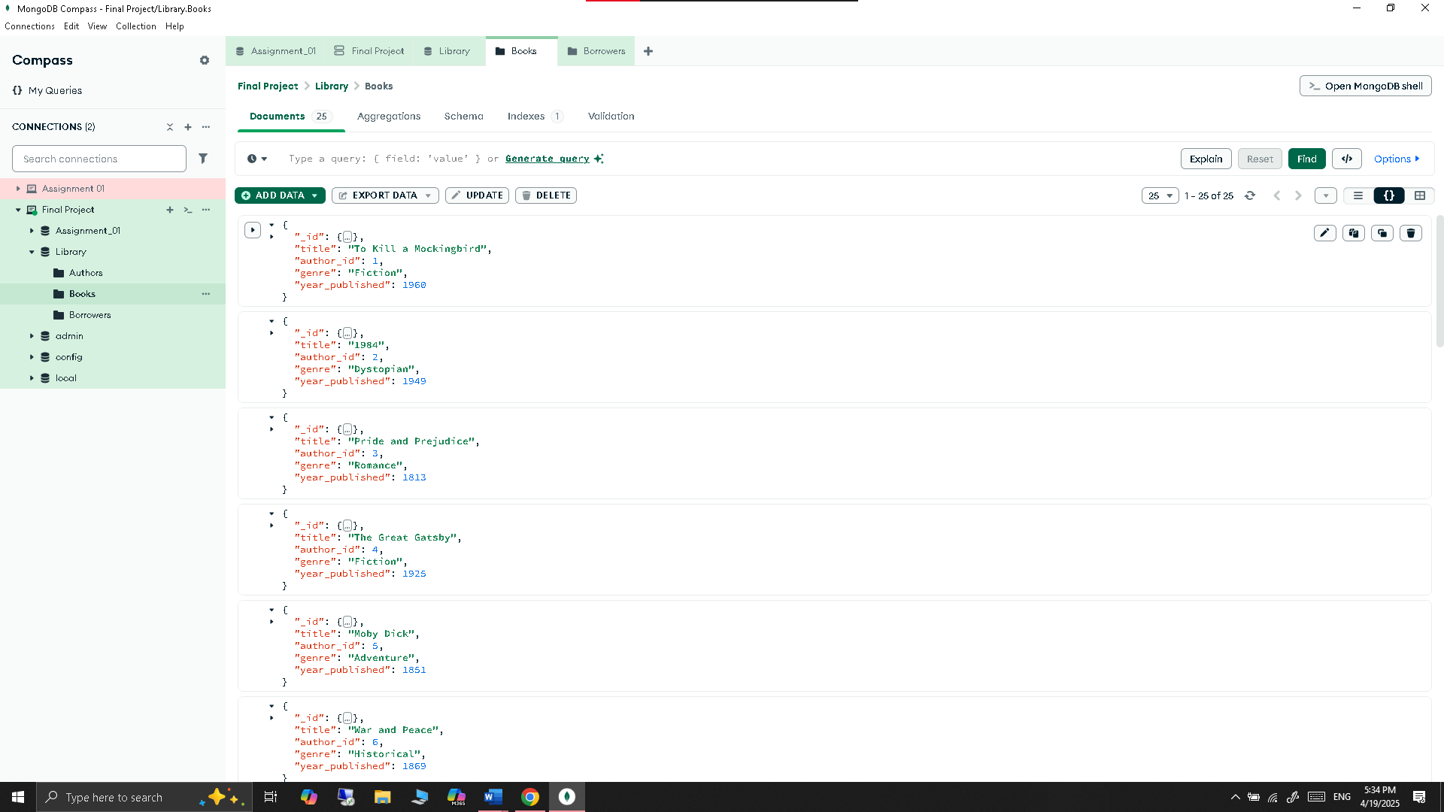

1. Inserting document in Authors collection:

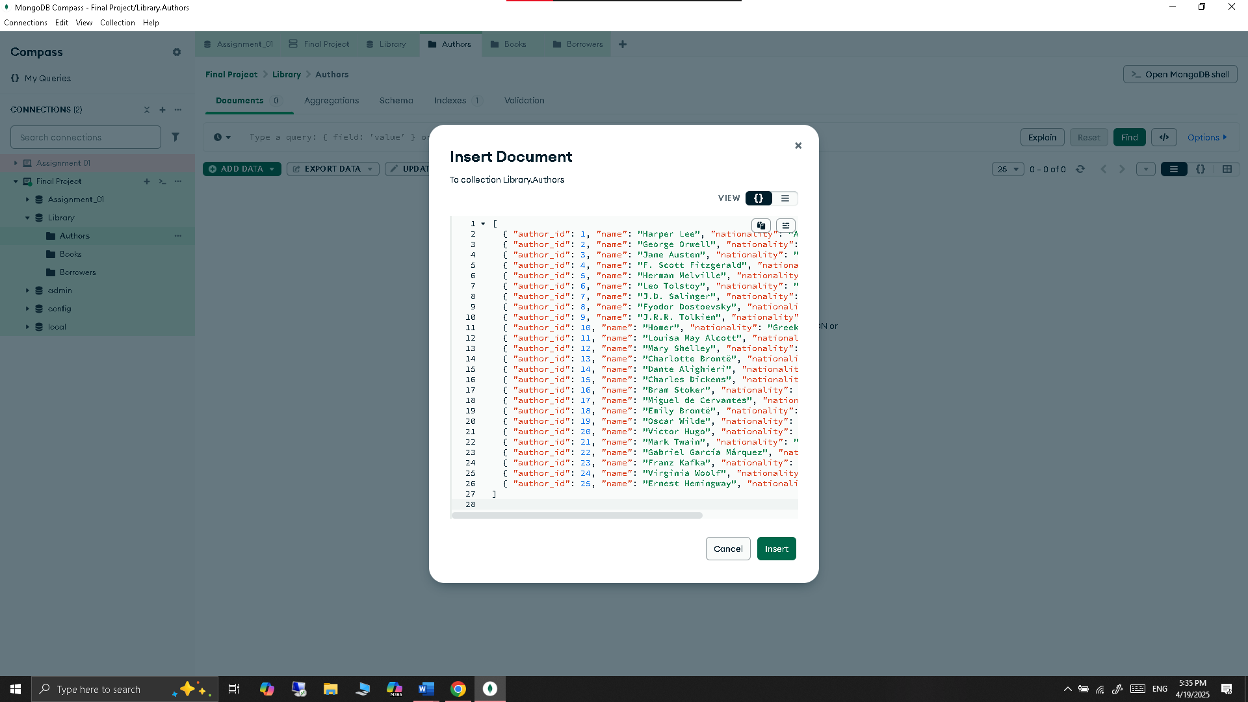

**Inserted document successfully:**

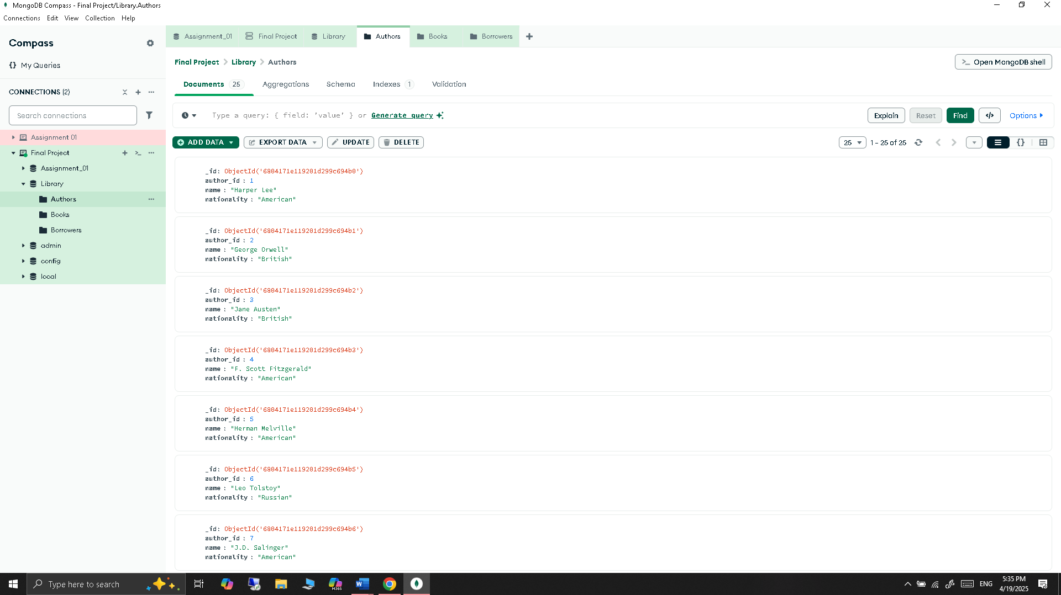

1. Inserting document in Borrowers collection:

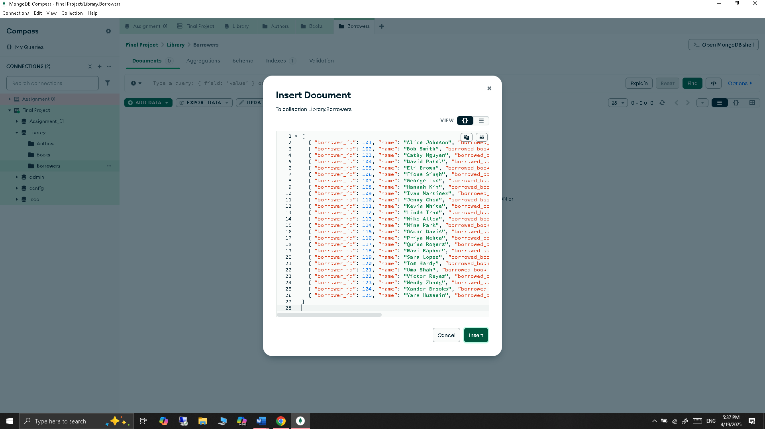

**Inserted document successfully:**

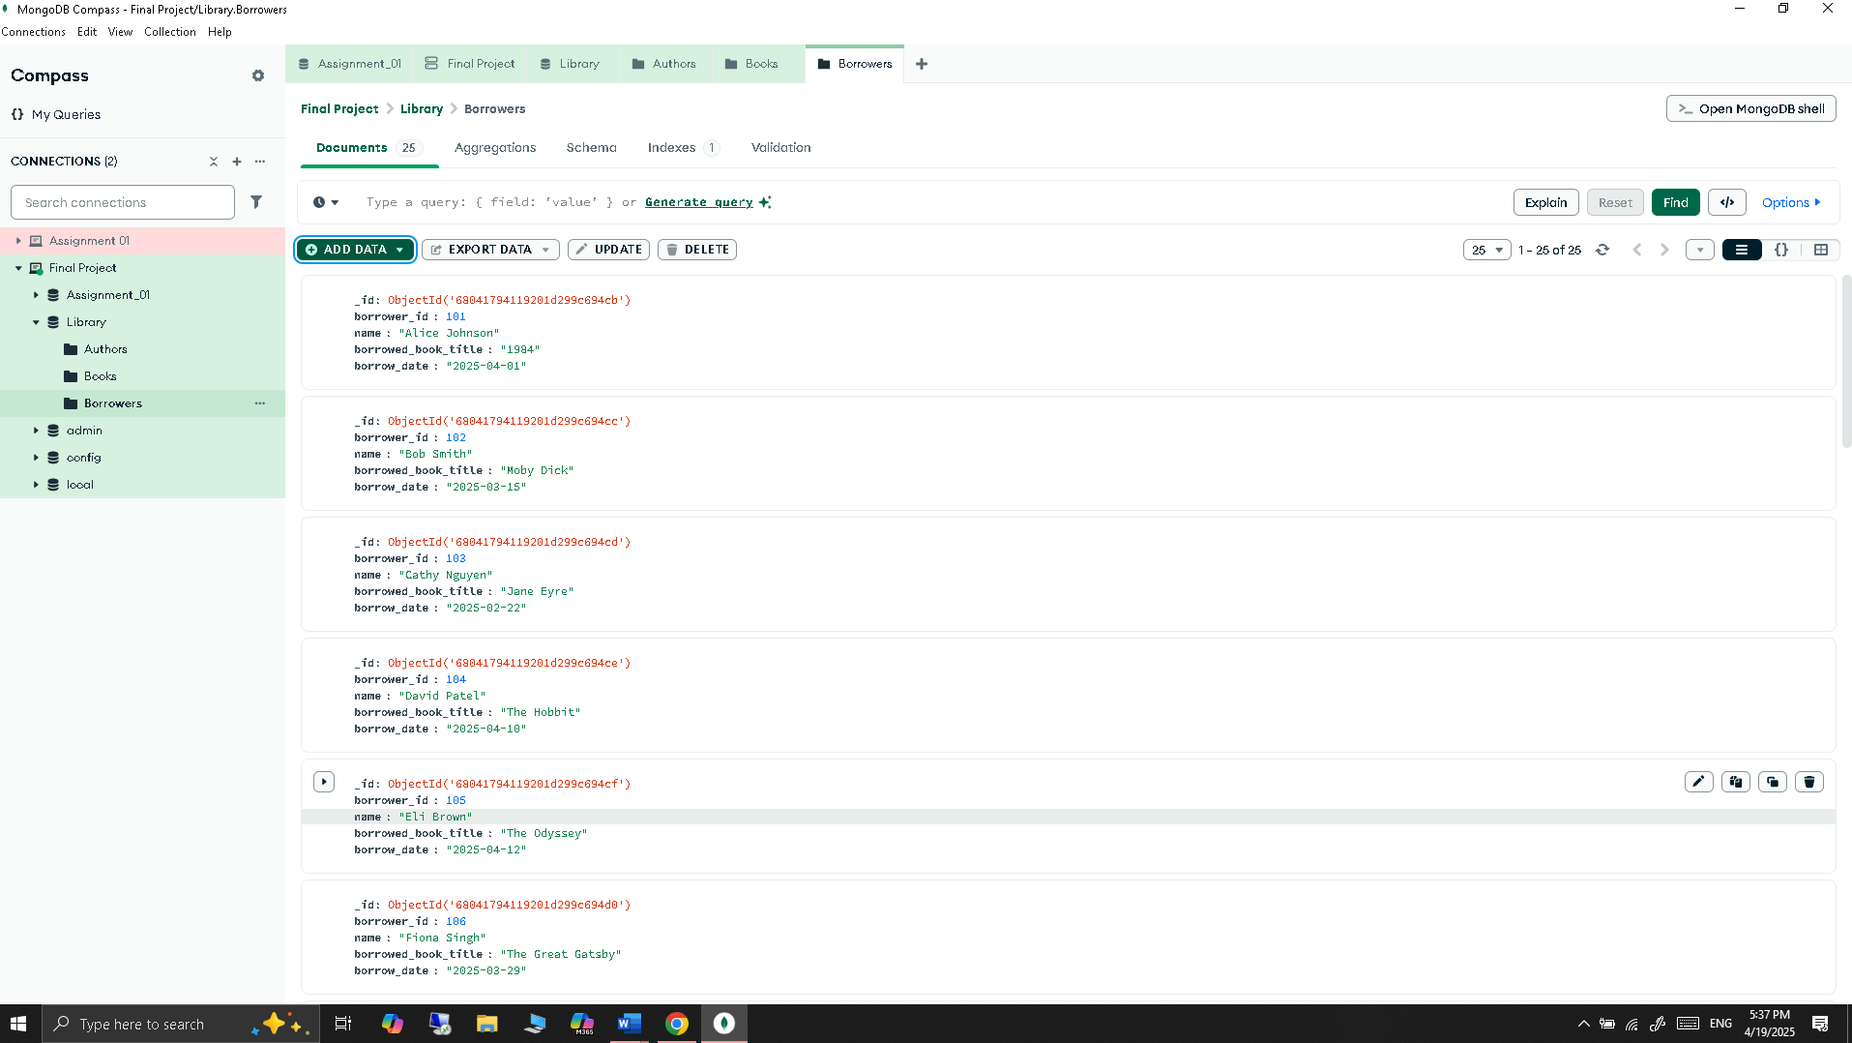

* + - Query the collections to retrieve documents based on specific criteria.

1. Find books published before the year 1900

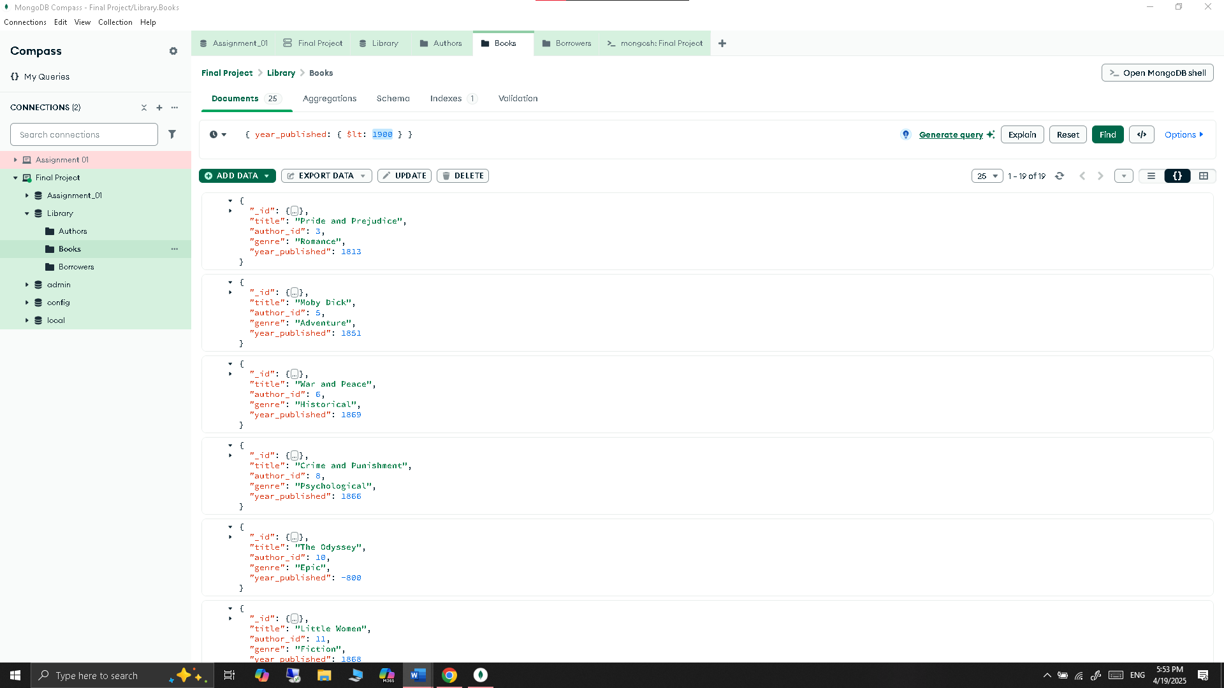

Fetch data using shell:

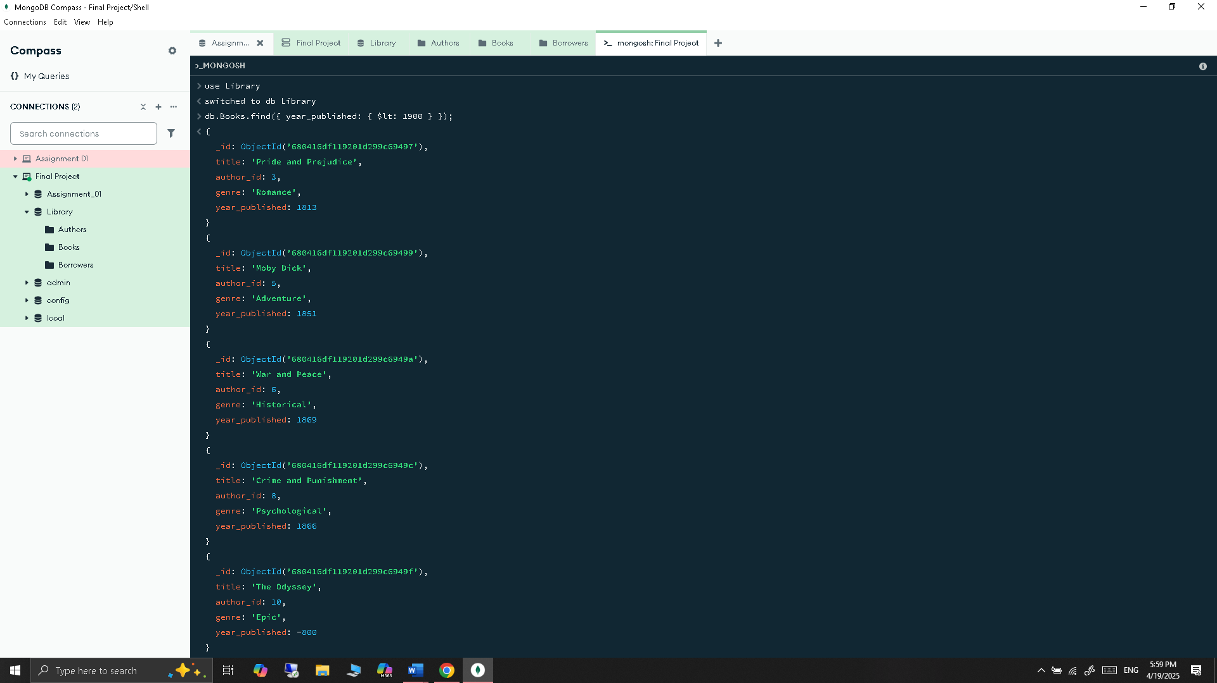

1. Find author by nationality = “American”

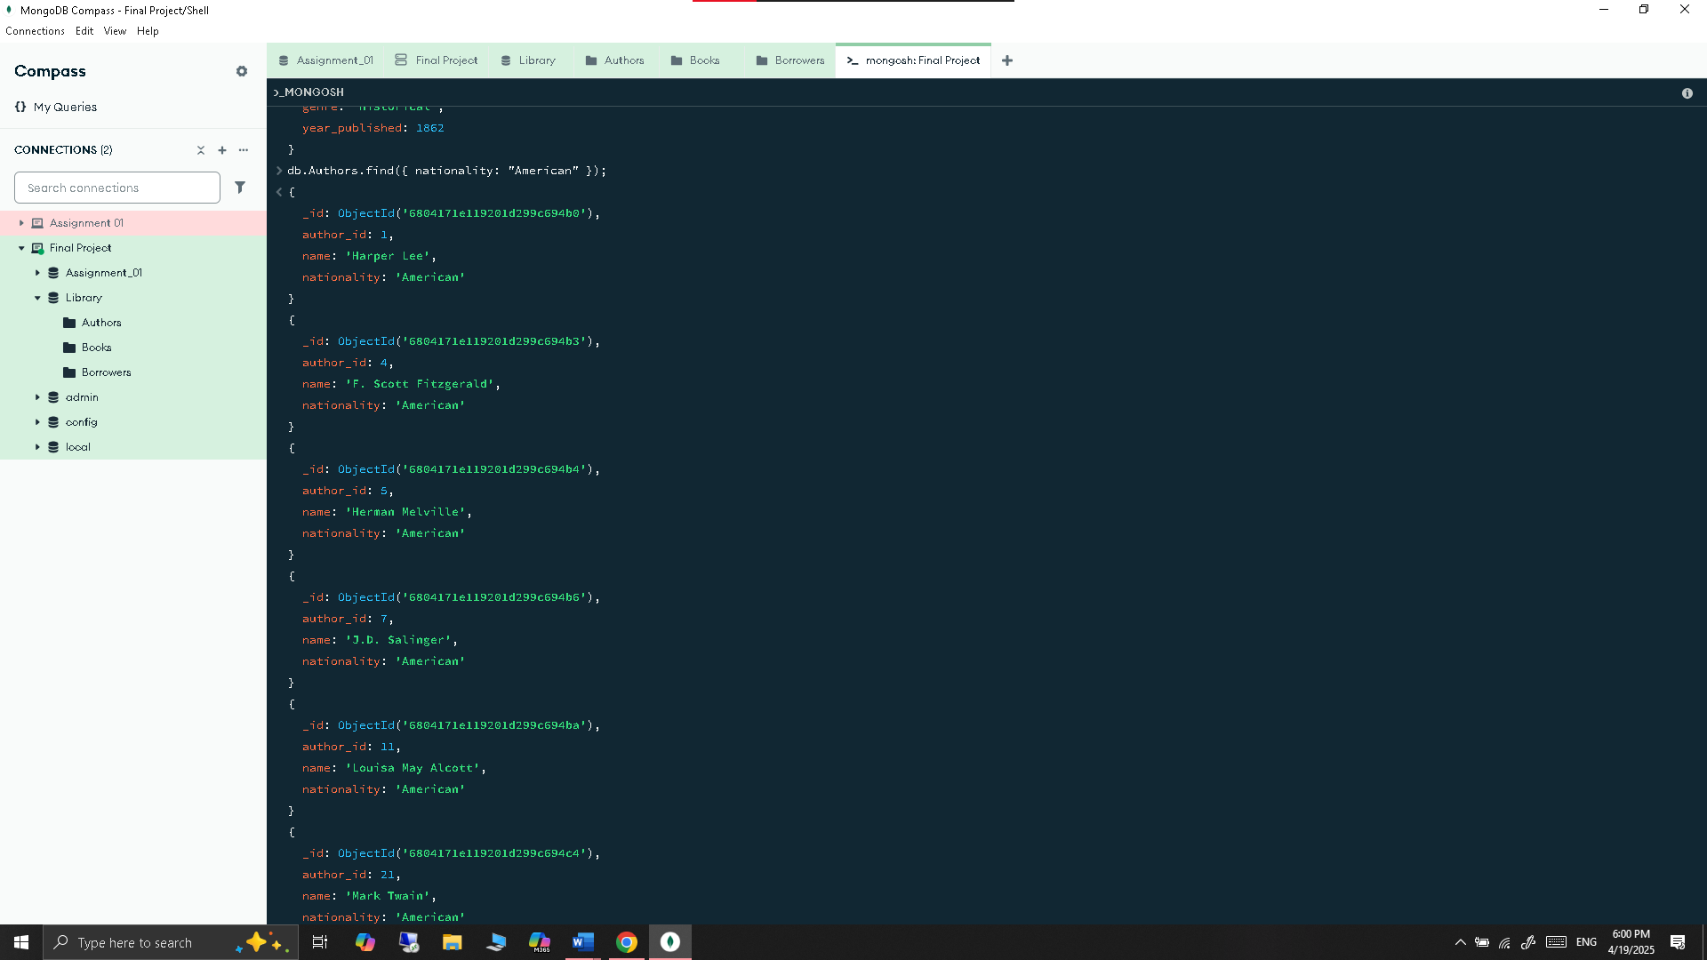

1. Find borrowers who borrowed the book titled “1984”

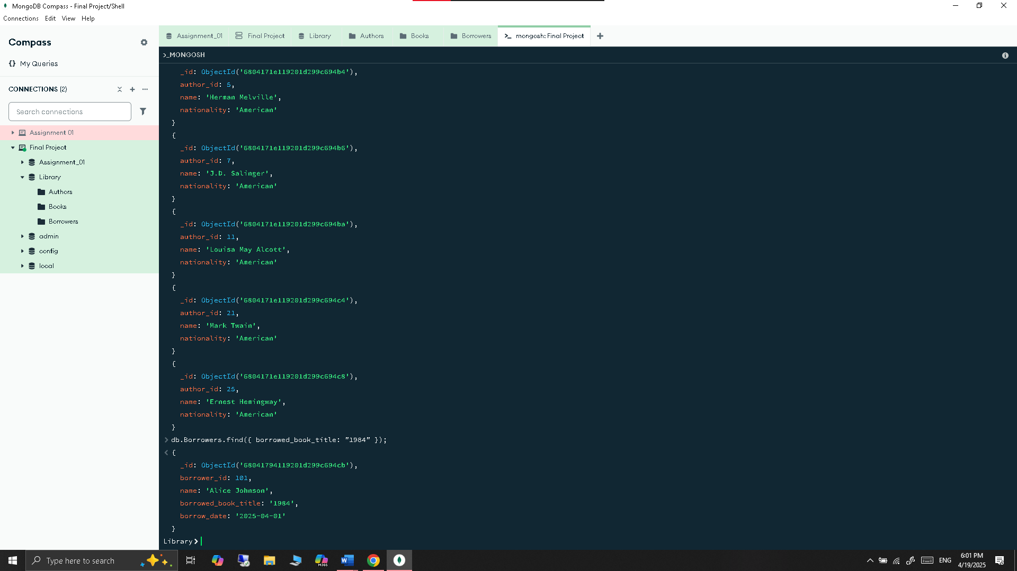

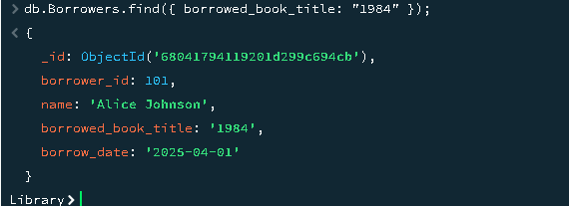

1. Find books by a specific author ID

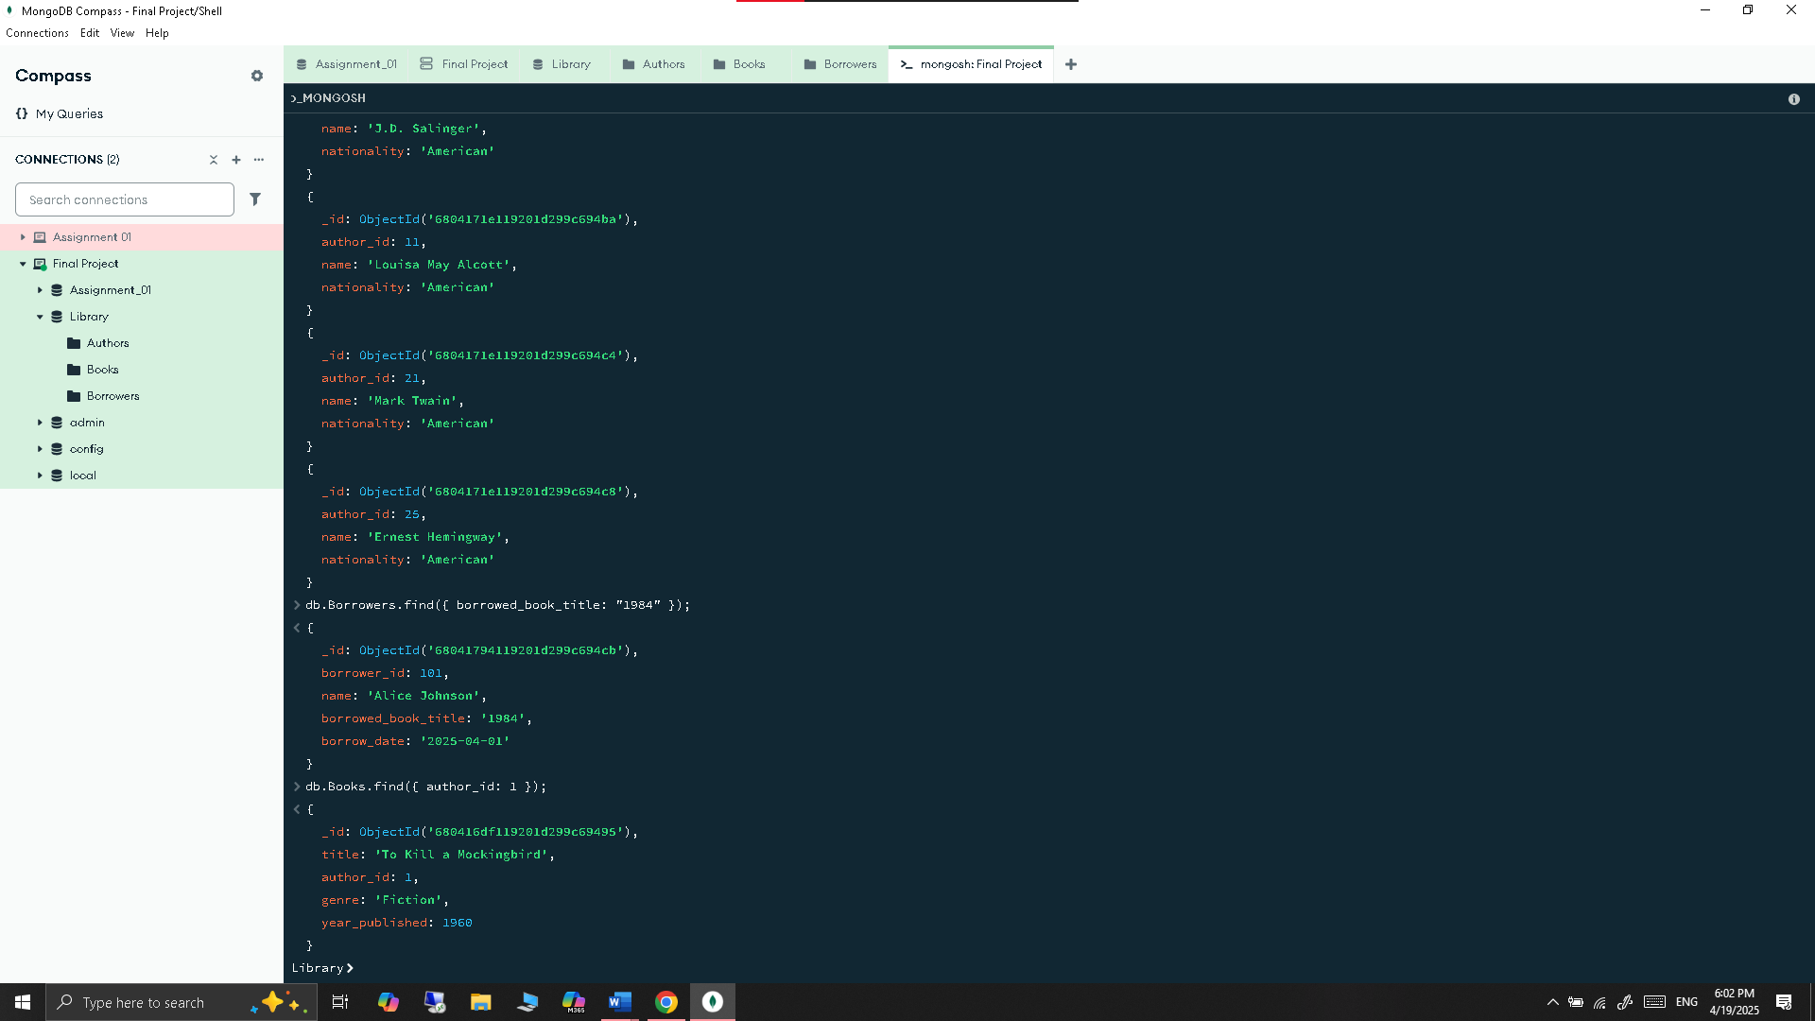

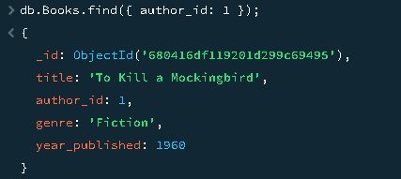

* + - Update and delete documents.

1. Update the genre of “To Kill a Mockingbird” to “Classic Literature”

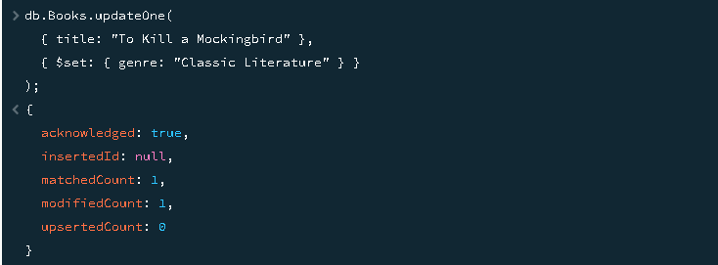

1. Update nationality of “Harper Lee” to “US”

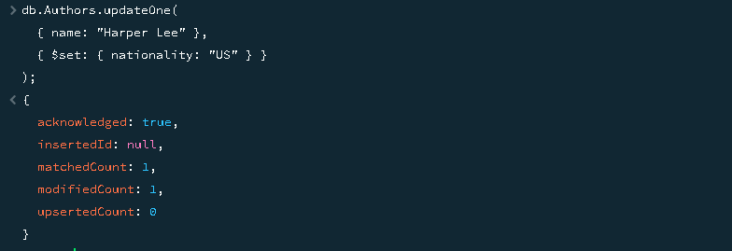

1. Change the borrowed book title for “Alice Johnson” to “To Kill a Mockingbird”

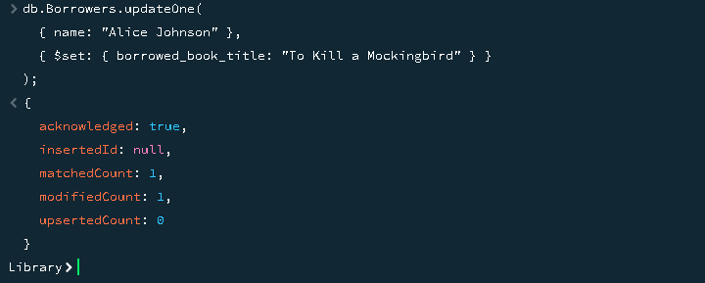

1. Delete the book “To Kill a Mockingbird”



1. Delete author with author_id = 1



1. Delete borrower named “Alice Johnson”

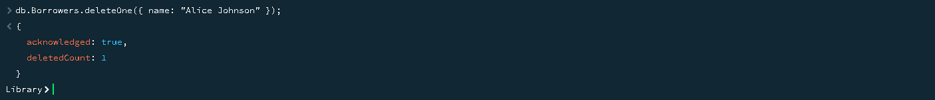

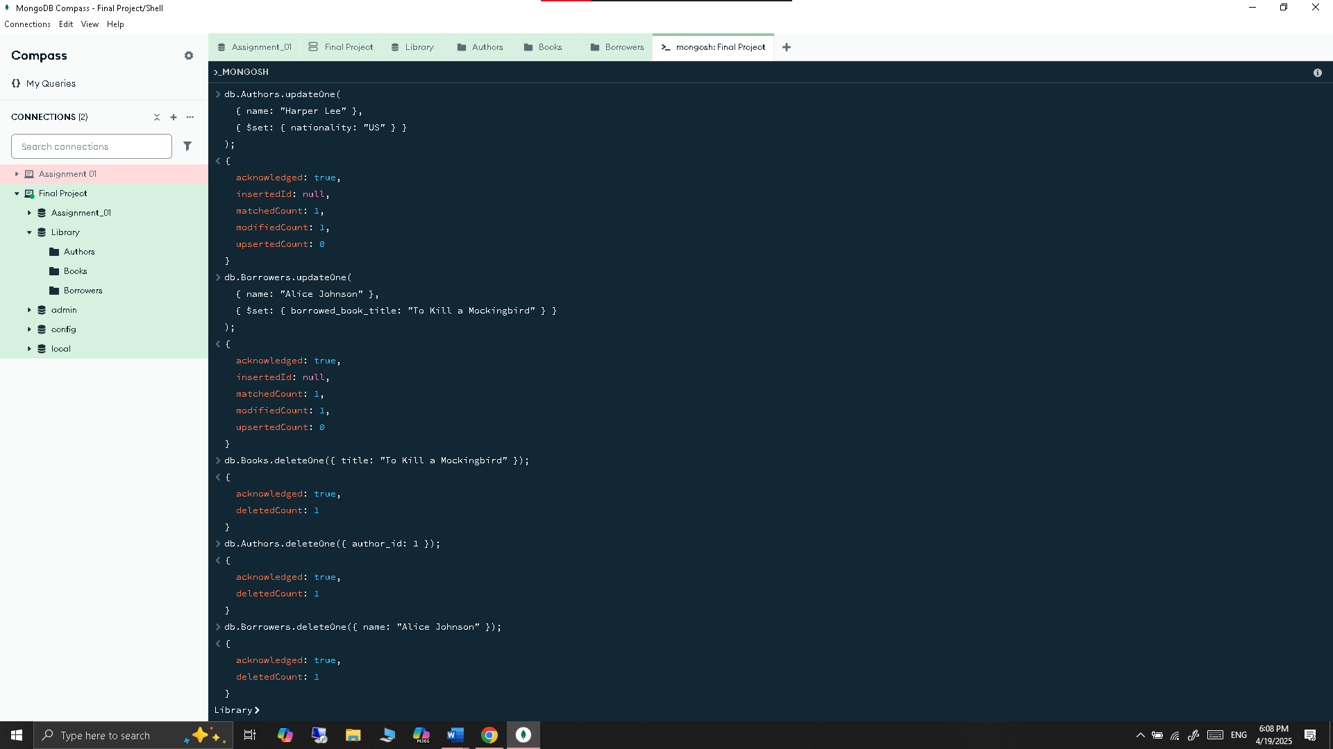

**Part 3: Comparative Analysis**

1. **Performance and Scalability**
   * **Exercise 13:** Compare the performance of each database by measuring the time taken for CRUD operations on a dataset of at least 1000 records. Use appropriate tools and methods to measure performance.

Let’s move first to neo4j 1000 rows insertion.

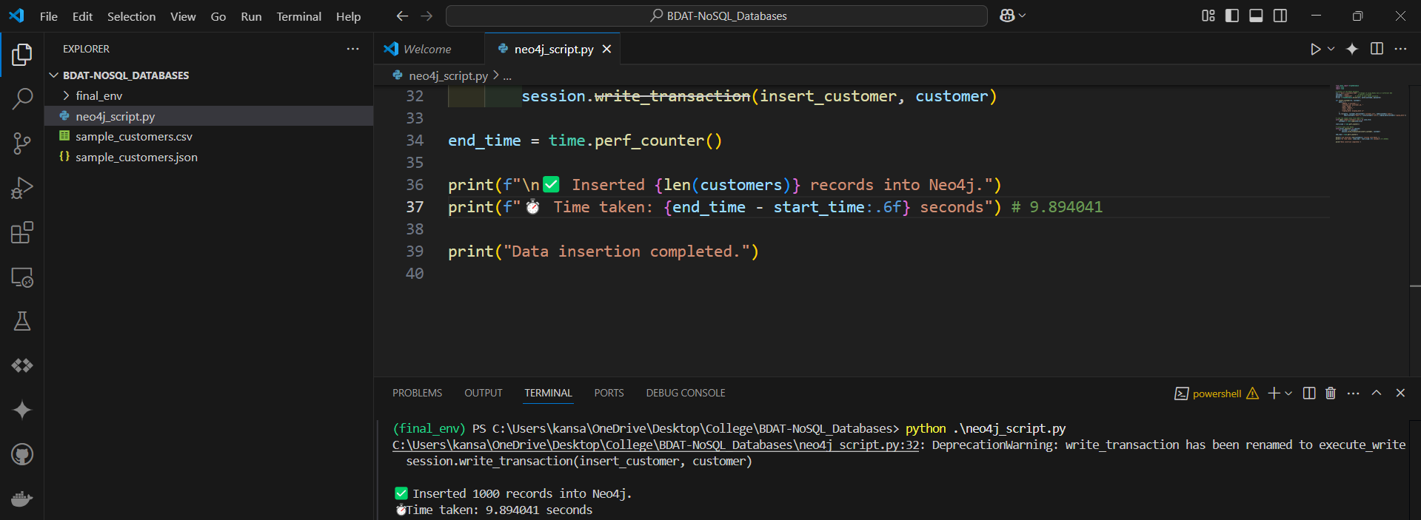

Time taken : 9.894041 Seconds. => 1000 records.

Second steps to mongodb 1000 rows insertion.



Time taken : 0.0270 Seconds. => 1000 records.

Third step for aws dynamodb

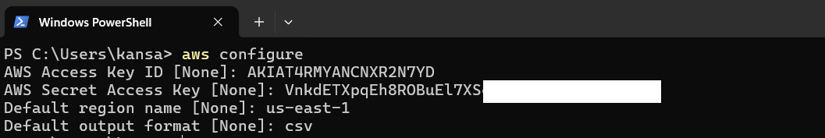



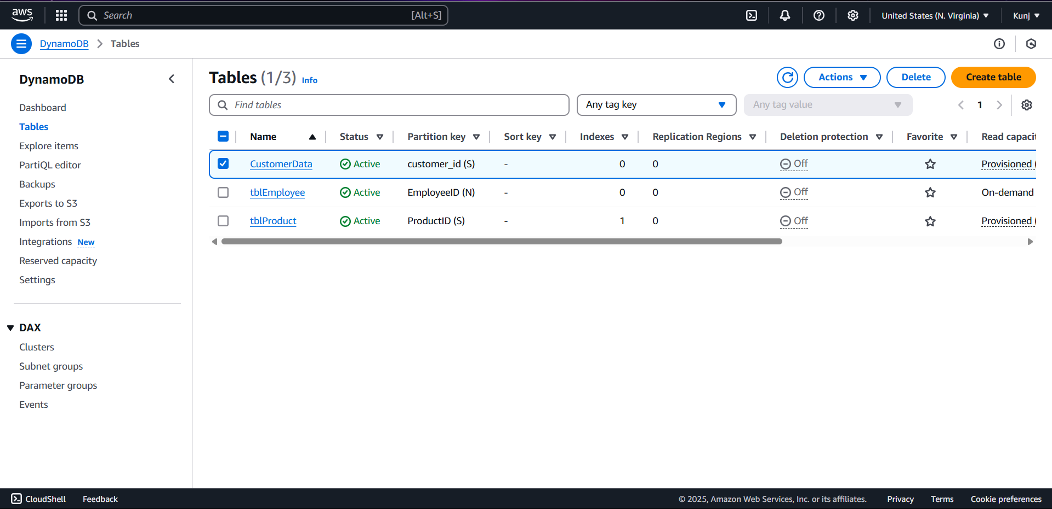



Time taken : 30.4528 Seconds. => 1000 records.

gcloud init

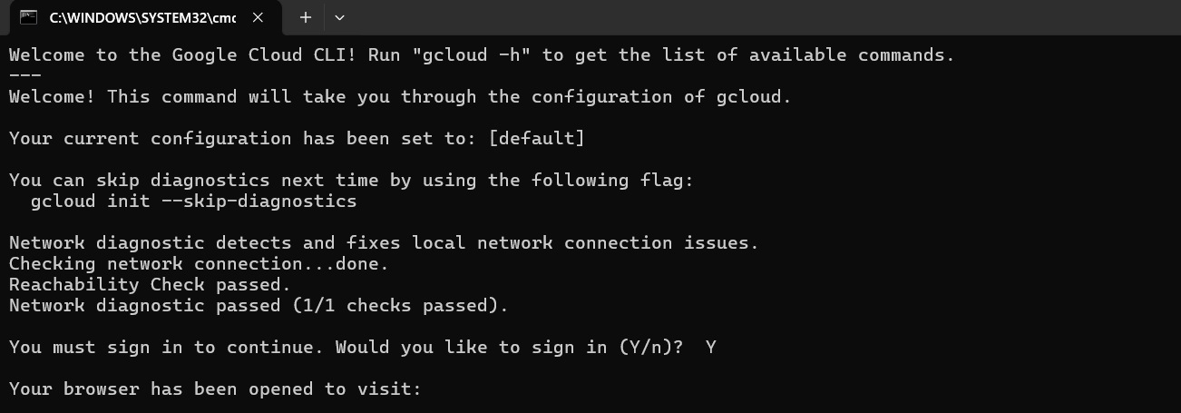

Selected the project in which I have instance and table created

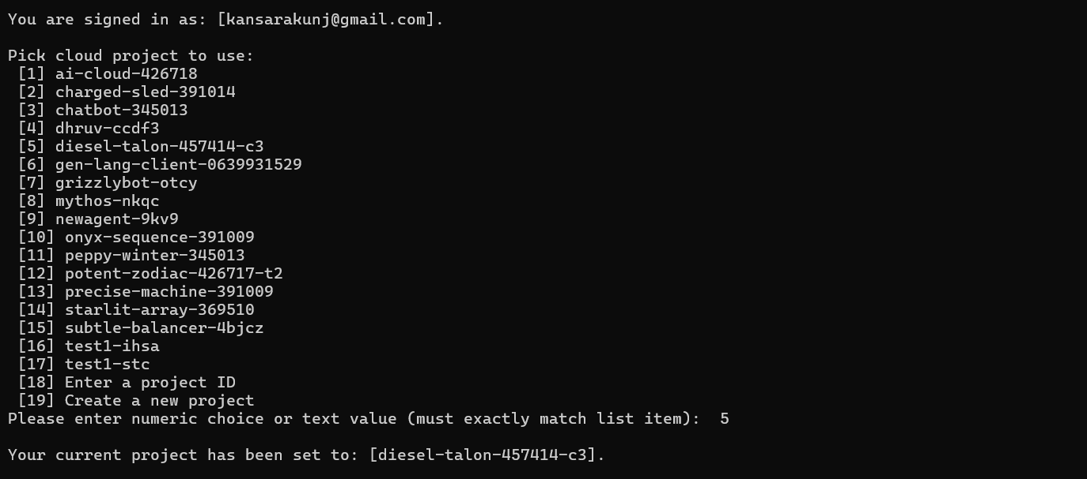



Time taken : 26.3094 Seconds. => 1000 records.

Insight to insert 1000 records and reading it.

MongoDB => 0.0270 Seconds

Neo4j => 9.894041 Seconds

Google Big table => 26.3094 Seconds

AWS DynamoDB => 30.4528 Seconds

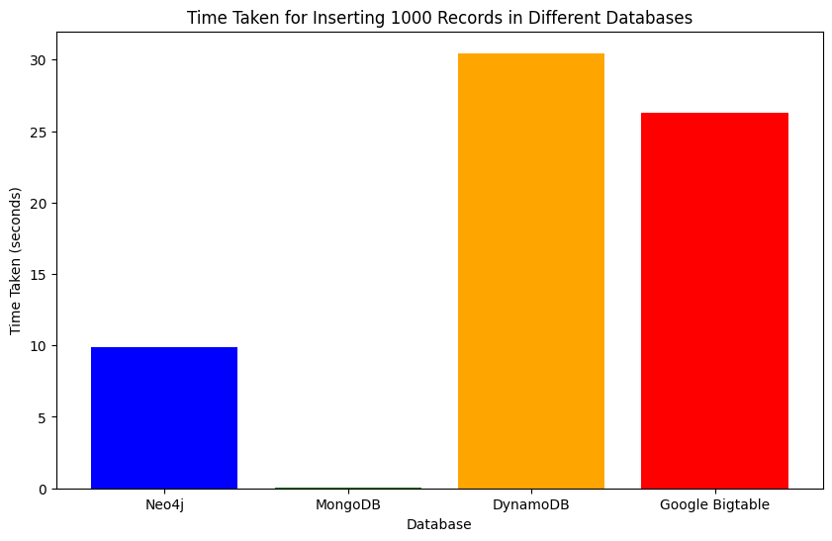

Performance Insight

**Fastest Database: MongoDB**

* **Insert Time**: **0.0270 seconds**
* **Insight**: MongoDB significantly outperformed all other databases in terms of insert speed. This is expected due to its in-memory storage and document-oriented structure, which allows for very fast writes.

**Neo4j (Graph Database)**

* **Insert Time**: **9.8940 seconds**
* **Insight**: Neo4j was much slower than MongoDB. This is typical for graph databases, as they maintain relationships and index structures that involve more complex operations during data insertion

**Google Bigtable**

* **Insert Time**: **26.3094 seconds**
* **Insight**: Google Bigtable showed slower performance compared to document and graph databases. Bigtable is optimized for massive-scale workloads, so it's not necessarily the best choice for small-scale or batch inserts of this size.

**AWS DynamoDB**

* **Insert Time**: **30.4528 seconds**
* **Insight**: DynamoDB had the highest time for data insertion. Being a fully managed NoSQL key-value store, it adds latency for provisioning throughput and network operations, which might be noticeable during bulk inserts
  + **Exercise 14:** Discuss the scalability features of each database, including how they handle horizontal and vertical scaling.
  + MongoDB
    - Horizontal Scaling: **Yes** via **Sharding**. MongoDB supports auto-sharding, which distributes data across multiple servers (shards). Each shard holds a subset of the data and acts as an independent database.
    - Vertical Scaling: **Yes**. MongoDB can run on more powerful machines (CPU, RAM) to handle increased load.
  + Neo4j
    - Horizontal Scaling: **Limited**. Native Neo4j Community Edition is **not horizontally scalable**. Enterprise Edition supports **Causal Clustering** for scaling reads and availability, but not seamless write scaling.
    - Vertical Scaling: **Yes**. Neo4j can utilize more powerful hardware (RAM, SSDs, CPU) to handle larger graphs.
  + Google Bigtable
    - Horizontal Scaling**: Yes**. Bigtable automatically scales horizontally across thousands of nodes. Data is split into tablets, and each tablet can be served by different nodes
    - Vertical Scaling: **Yes**, but less common. You can increase machine resources, but horizontal scaling is preferred and automatic.
  + AWS DynamoDB
    - Horizontal Scaling**: Yes**. DynamoDB is fully managed and automatically scales horizontally based on throughput and data volume. Uses **partitioning** under the hood.
    - Vertical Scaling: Not applicable directly — scaling is handled through **provisioned throughput** or **on-demand** settings, not by resizing servers.

**Summary**

* **MongoDB**: Great general-purpose NoSQL DB with good horizontal scaling via sharding.
* **Neo4j**: Best for graph-based queries, not ideal for large-scale horizontal writes.
* **Bigtable**: Extremely scalable for analytical and time-series workloads.
* **DynamoDB**: Highly scalable, serverless, best suited for high-throughput apps needing predictable performance.

Github Link for performance benchmark: https://github.com/Kunj-2206/benchmark_databases

1. **Ease of Use and Flexibility**
   * **Exercise 15:** Compare the ease of use for setting up and configuring each database. Discuss the learning curve and available documentation and community support.
     1. MongoDB
        1. Ease of Setup: **Very Easy**. MongoDB can be installed locally, via Docker, or used with MongoDB Atlas (cloud-hosted). Getting started is quick with minimal configuration
        2. Learning Curve: **Low to Moderate**. Uses intuitive JSON-like documents and familiar CRUD operations. Great for developers coming from SQL or NoSQL backgrounds
     2. Neo4j
        1. Ease of Setup: **Easy (Desktop)**. Neo4j Desktop is user-friendly and great for development. Cloud and Docker options available
        2. Learning Curve: **Moderate to Steep**. Requires learning **Cypher**, a graph query language, and understanding graph data modeling.
     3. Google Bigtable
        1. Ease of Setup: **Moderate to Complex**. Setup requires GCP configuration, IAM permissions, instance creation, and knowledge of column families. Local development is not straightforward.
        2. Learning Curve: **Moderate**. Uses a wide-column model similar to HBase. Requires understanding of row keys, column families, and performance optimization (hotspotting).
     4. AWS DynamoDB
        1. Ease of setup: **Easy (with AWS Console)**. Serverless, no infrastructure to manage. Tables can be created within minutes.
        2. Learning Curve: **Moderate**. Simple to start, but requires knowledge of partition keys, secondary indexes, and throughput settings for best performance.
   * **Exercise 16:** Analyze the flexibility of each database in handling different data models (e.g., key-value, document, graph) and use cases.

**Data Model Flexiblity**

|  |  |  |  |  |  |
| --- | --- | --- | --- | --- | --- |
| Database | |  | | --- | | Supported Data Model(s) |  |  | | --- | |  | | Flexibility Level | Ideal Use Cases |
| MongoDB | Document (BSON / JSON-like) | High | Content management, user profiles, real-time analytics, IoT, catalogs, mobile apps |
| Neo4j | Graph (Nodes, Relationships) | Low to Medium | |  | | --- | | Social networks, fraud detection, recommendation engines, knowledge graphs |  |  | | --- | |  | |
| Google Bigtable | Wide-column / Key-Value Hybrid | Medium | |  | | --- | | Time-series data, financial tickers, logs, sensor data, real-time analytics |  |  | | --- | |  | |
| AWS DynamoDB | Key-Value, Document | Medium to High | E-commerce, gaming leaderboards, serverless apps, session storage, IoT |

1. **Use Cases and Suitability**
   * **Exercise 17:** Identify suitable use cases for each database based on their strengths and weaknesses. Provide real-world examples where each database would be the preferred choice.

**MongoDB**

|  |  |
| --- | --- |
| Feature | Description |
| Strengths | - Schema-less JSON-like structure - Flexible & scalable document store - Rich query language - Great for agile and fast-changing data models |
| Weaknesses | |  | | --- | | - Less suited for complex transactions - Joins can be inefficient (though $lookup exists) |  |  | | --- | |  | |
| Best Use Cases | - Content management systems (CMS) - Product catalogs - Mobile apps - IoT platforms - Real-time analytics dashboards |
| Real-World Examples | - **Craigslist**: Uses MongoDB for archiving - **Forbes**: CMS and digital publishing |
|  |  |

Neo4j

|  |  |
| --- | --- |
| Feature | Description |
| Strengths | |  | | --- | | - Native graph database - Optimized for relationships and traversals - Intuitive query language (Cypher) - Efficient for deeply connected data |  |  | | --- | |  | |
| Weaknesses | - Not ideal for general-purpose storage - Requires graph modeling mindset |
| Best Use Cases | - Social networks - Fraud detection - Recommendation engines - Supply chain management - Knowledge graphs |
| Real-World Examples | |  | | --- | |  |  |  | | --- | | - **eBay**: Dynamic search recommendations - **DHL**: Supply chain logistics - **NASA**: Knowledge graph for research discovery | |

Google Bigtable

|  |  |
| --- | --- |
| Feature | Description |
| Strengths | |  | | --- | | - Scalable to petabytes - High throughput, low latency - Ideal for time-series data - Integration with GCP ecosystem |  |  | | --- | |  | |
| Weaknesses | |  | | --- | | - Limited query flexibility - Complex setup - Requires thoughtful schema design (e.g., row key design) |  |  | | --- | |  | |
| Best Use Cases | - Time-series data (IoT metrics, stock prices)  - Real-time analytics  - Sensor/telemetry data  - Monitoring systems |
| Real-World Examples | - **Spotify**: User listening history and metrics - **Snapchat**: Activity tracking - **Google Search**: Web indexing infrastructure (via Bigtable) |

AWS DynamoDB

|  |  |
| --- | --- |
| Feature | Description |
| Strengths | |  | | --- | | - Fully managed, serverless - Built-in high availability and durability - Scales automatically - Fast performance with predictable latency |  |  | | --- | |  | |
| Weaknesses | |  | | --- | | - Learning curve for data modeling (partitioning, indexes) - Write throughput limitations without optimization |  |  | | --- | |  | |
| Best Use Cases | |  | | --- | | - E-commerce apps (shopping cart, product availability) - Gaming leaderboards - Serverless applications - IoT device tracking - Session storage |  |  | | --- | |  | |
| Real-World Examples | - **Amazon**: E-commerce backend - **Netflix**: Metadata and playback info - **Samsung SmartThings**: IoT data management |

* + **Exercise 18:** Discuss the trade-offs involved in choosing one database over another for specific applications.

**Part 4: Conclusion**

* For **high-speed inserts**, **MongoDB** is the best choice.
* Use **Neo4j** if you need rich relationships and graph querying, but not necessarily for speed.
* **Bigtable** and **DynamoDB** are best suited for scalable, distributed workloads—performance improves with larger datasets and optimized schemas.
* **Real-world usage** might show different results depending on data size, schema complexity, indexing, and concurrency levels.